CFA CURRICULUM: FINANCIAL REPORTING AND ANALYSIS

Table of Contents

Reading 21: Financial Statement Analysis: An Introduction 1

2. Scope of Financial Statement analysis 1

3. Major financial statements and other information sources 1

3.1 Financial Statements 1

3.1.1 Balance sheet 1

3.1.2 Statement of comprehensive income 1

3.1.2.1 Income Statement 1

3.1.2.2 Other comprehensive income 2

3.1.3 Statement of Changes in Equity 2

3.1.4 Cash Flow Statement 2

3.1.5 Financial Notes and Supplementary Schedules 2

3.1.6 Management Commentary or Management’s Discussion and Analysis 2

3.1.7 Auditor’s Reports 2

3.2 Other Sources of Information 3

4. Financial Statement Analysis Framework 3

Reading 22: Financial Reporting Mechanics 5

2. The classification of Business Activities 5

3. Accounts and Financial Statements 5

3.1 Financial Statement Elements and Accounts 5

3.2 Accounting Equations 5

4. The accounting Process 5

4.1 An Illustration 5

4.2 The Accounting Records 5

4.3 Financial Statements 6

5. Accruals and Valuation Adjustments 6

5.1 Accruals 6

5.2 Valuation Adjustments 6

6. Accounting Systems 6

6.1 Flow of Information in an Accounting System 6

6.2 Debits and Credits 7

7. Using Financial Statements in Security Analysis 7

7.1 The Use of Judgement in Accounts and Entries 7

7.2 Misrepresentations 7

Reading 23: Financial Reporting Standards 9

2. The Objective of Financial Reporting 9

3. Standard-Setting Bodies and Regulatory Authorities 9

3.1 Accounting Standards Boards 9

3.1.1 International Accounting Standards Board 9

3.1.2 Financial Accounting Standards Board 9

3.1.3 Desirable Attributes of Accounting Standards Boards 9

3.2 Regulatory Authorities 10

3.2.1 International Organization of Securities Commissions 10

3.2.2 The Securities and Exchange Commission (US) 10

3.2.3 Capital Markets Regulation in Europe 11

4. Convergence of Global Financial Reporting Standards 11

5. The International Financial Reporting Standards Framework 11

5.1 Objective of Financial Reports 11

5.2 Qualitative Characteristics of Financial Reports 11

5.3 Constraints on Financial Reports 11

5.4 The Elements of Financial Statements 11

5.4.1 Underlying Assumptions in Financial Statements 11

5.4.2 Recognition of Financial Statement Elements 12

5.4.3 Measurement of Financial Statement Elements 12

5.5 General Requirements for Financial Statements 12

5.5.1 Required Financial statements 12

5.5.2 General Features of Financial Statements 12

5.5.3 Structure and Content Requirements 13

5.6 Convergence of Conceptual Framework 14

6. Effective Financial Reporting 15

6.1 Characteristics of an Effective Financial Reporting Framework 15

6.2 Barriers to a Single Coherent Framework 15

7. Comparison of IFRS with Alternative Reporting Systems 15

8. Monitoring Developments in Financial Reporting Standards 16

8.1 New Products or Types of Transactions 16

8.2 Evolving Standards and the Role of CFA Institute 16

8.3 Company Disclosures 16

8.3.1 Disclosures Relating to Critical and Significant Accounting Policies 16

8.3.2 Disclosures Regarding Changes in Accounting Policies 16

Reading 24: Understanding Income Statements 17

2. Components and Format of the Income Statement 17

3. Revenue Recognition 17

3.1 General Principles 17

3.2 Revenue Recognition Special Cases 17

3.2.1 Long-Term Contracts 18

3.2.2 Installment Sales 18

3.2.3 Barter 19

3.2.4 Gross versus Net Reporting 19

3.3 Implications for Financial Analysis 19

3.4 Revenue Recognition Accounting Standards Issued May 2014 19

4. Expense Recognition 19

4.1 General Principles 19

4.2 Issues in Expense Recognition 20

4.2.1 Doubtful Accounts 20

4.2.2 Warranties 20

4.2.3 Depreciation and Amortization 20

4.3 Implications for Financial Analysis 21

5. Non-Recurring Items and Non-Operating Items 21

5.1 Discontinued Operation 21

5.2 Extraordinary Items 21

5.3 Unusual or Infrequent Items 21

5.4 Changes in Accounting policies 21

5.5 Non-Operating Items 21

6. Earnings Per Share 21

6.1 Simple versus Complex Capital Structure 21

6.2 Basic EPS 22

6.3 Diluted EPS 22

6.3.1 Diluted EPS when a Company has Convertible Preferred Stock Outstanding 22

6.3.2 Diluted EPS when a Company has Convertible Debt Outstanding 22

6.3.3 Diluted EPS when a Company has Stock Options, Warrants or Their Equivalents Outstanding 22

6.3.4 Other Issues with Diluted EPS 23

6.4 Changes in EPS 23

7. Analysis of the Income Statement 23

7.1 Common-Size Analysis of the Income Statement 23

7.2 Income Statement Ratios 23

8. Comprehensive Income 24

Reading 25: Understanding Balance Sheets 25

2. Components and Format of the Balance Sheet 25

2.1 Balance Sheet Components 25

2.2 Current and Non-Current Classification 25

2.3 Liquidity-Based Presentation 25

3. Current Assets and Current Liabilities 25

3.1 Current Assets 25

3.1.1 Cash and Cash Equivalents 25

3.1.2 Marketable Securities 25

3.1.3 Trade Receivables 26

3.1.4 Inventories 26

3.1.5 Other Current Assets 26

3.2 Current Liabilities 26

4. Non-Current Assets 26

4.1 Property, Plant and Equipment 26

4.2 Investment Property 27

4.3 Intangible Assets 27

4.3.1 Identifiable Intangibles 27

4.4 Goodwill 27

4.5 Financial Assets 27

5. Non-Current Liabilities 28

5.1 Long Term Financial Liabilities 28

5.2 Deferred Tax Liabilities 28

6. Equity 28

6.1 Components of Equity 28

6.2 Statement of Changes in Equity 29

7. Analysis of the Balance Sheet 29

7.1 Common-Size Analysis of the Balance Sheet 29

7.2 Balance Sheet Ratios 29

Reading 26: Understanding Cash Flow Statements 30

2. Components and Format of the Cash Flow Statement 30

2.1 Classification of Cash Flows and Non-Cash Activities 30

2.2 A Summary of Differences between IFRS and US GAAP 30

2.3 Direct and Indirect Methods for Reporting Cash Flow from Operating Activities 30

2.3.1 An Indirect-Format Cash Flow Statement Prepared under IFRS 31

2.3.2 A Direct-Format Cash Flow Statement Prepared under IFRS 31

2.3.3 Illustration of Cash Flow Statements Prepared under US GAAP 31

3. The Cash Flow Statement: Linkages and Preparation 31

3.1 Linkages of the Cash Flow Statement with the Income Statement and Balance Sheet 31

3.2 Steps in preparing the Cash Flow Statement 31

3.2.1 Operating Activities: Direct Method 31

3.2.1.1 Cash Received from Costumers 31

3.2.1.2 Cash Paid to Suppliers 31

3.2.1.3 Cash Paid to Employees 31

3.2.1.4 Cash Paid for Other Operating Expenses 31

3.2.1.5 Cash Paid for Interest 31

3.2.1.6 Cash Paid for Income Taxes 32

3.2.2 Investing Activities 32

3.2.3 Financing Activities 32

3.2.3.1 Long Term Debt and Common Stock 32

3.2.3.2 Dividends 32

3.2.4 Overall Statement of Cash Flows: Direct Method 32

3.2.5 Overall Statement of Cash Flows: Indirect Method 32

3.3 Conversion of Cash Flows from the Indirect to the Direct Method 33

4. Cash Flow Statement Analysis 33

4.1 Evaluation of the Sources and Uses of Cash 33

4.2 Common-Size Analysis of the Statement of Cash Flows 34

4.3 Free Cash Flow to the Firm and Free Cash Flow to Equity 34

4.4 Cash Flow Ratios 34

Reading 27: Financial Analysis Techniques 35

2. The Financial Analysis Process 35

2.1 The Objectives of the Financial Analysis Process 35

2.2 Distinguish between Computations and Analysis 36

3. Analytical Tools and Techniques 37

3.1 Ratios 37

3.1.1 The Universe of Ratios 37

3.1.2 Value, Purposes and Limitations of Ratio Analysis 37

3.1.3 Sources of Ratios 37

3.2 Common-Size Analysis 37

3.2.1 Common-Size Analysis of the Balance Sheet 37

3.2.2 Common-Size Analysis of the Income Statement 37

3.2.3 Cross-Sectional Analysis 37

3.2.4 Trend Analysis 37

3.2.5 Relationships among Financial Statements 38

3.3 The Use of Graphs as an Analytical Tool 38

3.4 Regression Analysis 38

4. Common Ratios Used in Financial Analysis 38

4.1 Interpretation and Context 38

4.2 Activity Ratios 38

4.2.1 Calculation of Activity Ratios 38

4.2.2 Interpretation of Activity Ratios 39

4.3 Liquidity Ratios 40

4.3.1 Calculation of Liquidity Ratios 40

4.3.2 Interpretation of Liquidity Ratios 40

4.4 Solvency Ratios 41

4.4.1 Calculation of Solvency Ratios 41

4.4.2 Interpretation of Solvency Ratios 41

4.5 Profitability Ratios 41

4.5.1 Calculation of Profitability Ratios 41

4.5.2 Interpretation of Profitability Ratios 42

4.6 Integrated Financial Ratio Analysis 42

4.6.1 The Overall Ratio Picture: Examples 42

4.6.2 DuPont Analysis: The Decomposition of ROE 42

5. Equity Analysis 43

5.1 Valuation Ratios 43

5.1.1 Calculation of Valuation Ratios and Related Quantities 43

5.1.2 Interpretation of Earnings per Share 44

5.1.3 Dividend-Related Quantities 45

5.2 Industry-Specific Ratios 45

5.3 Research on Ratios in Equity Analysis 46

6. Credit Analysis 46

6.1 The Credit Rating Process 46

6.2 Research on Ratios in Credit Analysis 47

7. Business and Geographic Segments 47

7.1 Segment Reporting Requirements 47

7.2 Segment Ratios 48

8. Model Building and Forecasting 48

Reading 28: Inventories 49

2. Cost of Inventories 49

3. Inventory Valuation Methods 49

3.1 Specific Identification 49

3.2 First-In, First-Out (FIFO) 49

3.3 Weighted Average Cost 49

3.4 Last-In, First-Out (LIFO) 49

3.5 Calculation of Cost of Sales, Gross Profit and Ending Inventory 49

3.6 Periodic versus Perpetual Inventory Systems 50

3.7 Comparison of Inventory Valuation Methods 50

4. The LIFO Method 50

4.1 LIFO Reserve 50

4.2 LIFO Liquidations 50

5. Inventory Method Changes 50

6. Inventory Adjustments 50

7. Evaluation of Inventory Management 51

7.1 Presentation and Disclosure 51

7.2 Inventory Ratios 51

7.3 Financial Analysis Illustrations 51

Reading 29: Long-Lived Assets 52

2. Acquisition of Long-Lived Assets 52

2.1 Property, Plant and Equipment 52

2.2 Intangible Assets 52

2.2.1 Intangible Assets Purchased in situations Other Than Business Combinations 52

2.2.2 Intangible Assets Developed Internally 52

2.2.3 Intangible Assets Acquired in a Business Combination 53

2.3 Capitalizing versus Expensing: Impact on Financial Statements and Ratios 53

2.4 Capitalization of Interest Costs 53

2.5 Capitalization of Internal Development Costs 53

3. Depreciation and Amortization of Long-Lived Assets 54

3.1 Depreciation Methods and Calculation of Depreciation Expense 54

3.2 Amortization Methods and Calculation of Amortization Expense 55

4. The Revaluation Model 55

5. Impairment of Assets 55

5.1 Impairment of Property, Plant and Equipment 56

5.2 Impairment of Intangible Assets with a Finite Life 56

5.3 Impairment of Intangibles with Indefinite Lives 56

5.4 Impairment of Log-lived Assets Held for Sale 56

5.5 Reversals of Impairments of Long-Lived Assets 56

6. Derecognition 56

6.1 Sale of Long-Lived Assets 57

6.2 Long-Lived Assets Disposed of Other Than by a Sale 57

7. Presentation and Disclosures 57

8. Investment Property 58

9. Leasing 58

9.1 The Lease versus Buy Decision 59

9.2 Finance versus Operating Leases 59

9.2.1 Accounting and Reporting by the Lessee 59

9.2.2 Accounting and Reporting by the Lessor 59

Reading 30: Income Taxes 61

2.Differences between Accounting Profit and Taxable Income 61

2.1 Current Tax Assets and Liabilities 61

2.2 Deferred Tax Assets and Liabilities 61

3. Determining the Tax Base of Assets and Liabilities 62

3.1 Determining the Tax Base of an Asset 62

3.2 Determining the Tax Base of a Liability 62

3.3 Changes in Income Tax Rates 62

4. Temporary and Permanent Differences Between Taxable and Accounting Profit 62

4.1 Taxable Temporary Differences 62

4.2 Deductible Temporary Differences 62

4.3 Examples of Taxable and Deductible Temporary Differences 62

4.4 Temporary Differences at Initial Recognition of Assets and Liabilities 63

4.5 Business Combinations and Deferred Taxes 63

4.6 Investments in Subsidiaries, Branches, Associates and Interests in Joint Ventures 63

5. Unused Tax Losses and Tax Credits 63

6. Recognition and Measurement of Current and Deferred Tax 64

6.1 Recognition of a Valuation Allowance 64

6.2 Recognition of Current and Deferred Tax Charged Directly to Equity 64

7. Presentation and Disclosure 64

8. Comparison of IFRS and US GAAP 65

Reading 31: Non-Current (Long Term) Liabilities 67

2. Bonds Payable 67

2.1 Accounting for Bond Issuance 67

2.2 Accounting for Bond Amortization, Interest Expense and Interest Payments 67

2.3 Current Market Rates and Fair Value Reporting Option 68

2.4 Derecognition of Debt 68

2.5 Debt Covenants 68

2.6 Presentation and Disclosure of Long-Term Debt 68

3. Leases 68

3.1 Advantages of Leasing 68

3.2 Finance (or Capital) Leases versus Operating Leases 69

3.2.1 Accounting and Reporting by the Lessee 69

3.2.2 Accounting and Reporting by the Lessor 70

4. Introduction to Pensions and Other Post-Employment Benefits 71

5. Evaluating Solvency: Leverage and Coverage Ratios 72

Reading 32: 74

Reading 33: Financial Statement Analysis Applications 75

2. Application: Evaluating Past Financial Performance 75

3. Application: Projecting Future Financial Performance 75

3.1 Projecting Performance: An Input to Market-Based Valuation 75

3.2 Projecting Multiple-Period Performance 75

# Reading 21: Financial Statement Analysis: An Introduction

Consists in examine the performance of the company in its context.

## 2. Scope of Financial Statement analysis

Cash flow and profit are not the same. The first one takes into account the disbursements and receivables that where actually paid and received while the second one only takes into account what it is recognized for the period.

* Liquidity- short term obligations.
* Solvency- long term obligations.

Difference between an earnings release by a company and one made by an analyst.

## 3. Major financial statements and other information sources

### 3.1 Financial Statements

3.1.1 Balance sheet: resources that the company controls, obligations and owners.

IFRS- it does not stablish a particular order for balance sheet accounts.

3.1.2 Statement of comprehensive income**:** in IFRS, it can be presented as a single statement (including the income statement and the other comprehensive income) or as two separated statements.

##### 3.1.2.1 Income Statement

It is reported on a consolidated basis (including results of subsidiaries from which it owns more than 50% of the shares). The rest of the shares holders are referred to minority interests or non-controlling interests. This is why, at the end of the income statement an adjustment is made to end up just with the profit attributable to shareholders of the company. It is subtracted from the profit.

Basic earnings per share- is calculated with the weighted average number of common shares that were outstanding in the period and the profit attributable to the common shares.

Diluted earnings per share- the number of shares used here considers the shares that could be outstanding if every potential diluted claim, like convertible bonds or stock options, were claimed.

Preferred earnings information is not mandatory.

##### 3.1.2.2 Other comprehensive income

It considers all of the items that affect equity but are not consider in the income statement.

IFRS- it can be presented combined with the income statement or separated, beginning with the profit.

GAAP- they permit the companies to present this part in the statement of changes in equity.

3.1.3 Statement of Changes in Equity**:** Shows the changes in balance of every item of equity.

Paid-in capital: Represents the capital of investors and increases with new issuances and decreases when the company repurchases stocks.

Retained earnings: changes with payments of dividends and the result of the net income.

3.1.4 Cash Flow Statement**:** Helps to determine liquidity, solvency and financial flexibility (the ability to react and adapt towards financial adversities).

Methods for reporting the cash from operations:

* Direct method: Simply put all of the receipts and disbursements.
* Indirect method: From the net income, adjustments are made.

3.1.5 Financial Notes and Supplementary Schedules**:** Are used for clarifications and disclosures. Accounting methods, policies, estimates, basis of preparation, risk, legal factors, events, acquisitions, performance, commitments and contingencies. They are also used to determine the comparability of companies and make adjustments.

3.1.6 Management Commentary or Management’s Discussion and Analysis**:** nature of the business, past results and future outlook. Critical points that it must include:

1. Nature of business
2. Management’s objectives and strategies
3. Significant resources, risks and relationships
4. Results of operation
5. Critical performance measurements.

3.1.7 Auditor’s Reports**:** Written opinion of the financial statements.

Objectives: obtain a reasonable assurance to affirm that the reports are free of errors or fraud.

Parts of the report:

1. Introduction: describes financial statement and responsibilities of management and the auditor.
2. Scope: nature of the audit process and provides the basis of the judgement of fairness that the auditor makes.
3. Opinion: expresses the opinion.

Types of opinions:

1. Unqualified: high probability that statements are free from material error, fraud or illegal acts. Statements give a fair and true view. Clean opinion.
2. Qualified: There is some limitation or exception to accounting standards. In this case, an explanatory paragraph is included.
3. Adverse: the statements depart from accounting standards and are not fairly presented. The statements cannot be trusted.
4. Disclaimer of opinion: for some reason, the auditor is unable to issue an opinion.

3.2 Other Sources of Information**:**

1. Interim reports: not audited, the four statements.
2. Web site
3. Press releases: periodic earnings
4. Conference calls: senior executives describe the performance of the company and answers questions.
5. Other external information

## 4. Financial Statement Analysis Framework

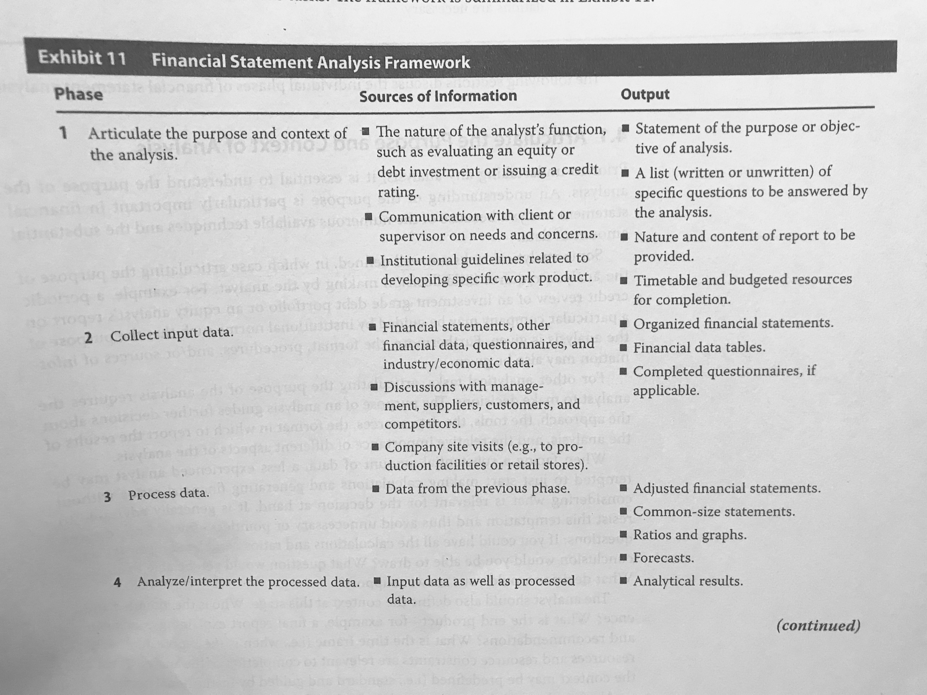

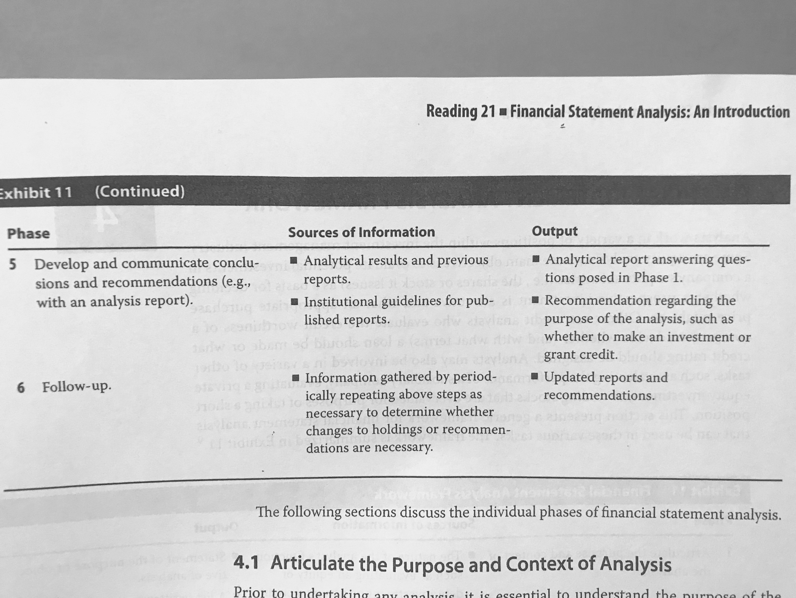

Notes:

1. Consider the audience, time frame.
2. Key<- understand the company’s business. Top-down: macro environment -> industry based on macro-> company based on macro and industry.
3. In general, any calculation, simulation or statistical transformation.
4. NO DATA TRANSFORMATION AT ALL. Interpretations. Supports the conclusion.
5. Components of an equity analysis report: Summary and investment conclusion, earnings projections, valuation, business summary, risk, industry and competitive analysis, historical performance and, forecasts.
6. Be aware.

# Reading 22: Financial Reporting Mechanics

## 2. The classification of Business Activities

Business activities are classified into three groups:

* Operating activities: day-to-day business functioning activities
* Investing activities: acquisition and disposal of long-term assets.
* Financing activities: obtain or repaying capital.

## 3. Accounts and Financial Statements

3.1 Financial Statement Elements and Accounts**:** Accounts are used to determine increases and decreases in the different concepts.

Chart of accounts: the actual accounts that the company uses.

Contra account: account that if offset or deducted from another account.

3.2 Accounting Equations**:** Basic financial statements and its equations:

Balance Sheet: Assets = Liabilities + Equity. Equity is the residual claim as it is what is “left over” after complying with the company’s obligations.

Income statement: Revenue – Expenses = Net Income. It is also known as statement of operations, of income or of profit and loss.

Statement of Retained Earnings: it shows the linkage between the balance sheet and the income statement. It is simply the change in this account. Normally it goes like this: Beginning balance-> Net income-> Dividends-> Ending balance.

Double-entry accounting: “a todo cargo corresponde un abono”

## 4. The accounting Process

4.1 An Illustration**:** Investment Advisers, Ltd. EXAMPLE.

4.2 The Accounting Records**:** In order to establish accounting transactions, the following steps should be met:

1. Identify the account, the amount and if it is decreasing or increasing.
2. Determine the element type.
3. Enter data.
4. Verify the equivalences of debit and credit.

It is a really clear example of the accounting process.

4.3 Financial Statements**:** Simply explains the different statements and how they are related.

## 5. Accruals and Valuation Adjustments

5.1 Accruals**:** Both revenue and expenses must be recorded when earned and incurred, no without taking into account whether or not there was an actual cash receipt or disbursement. Some cases when this happens:

* Unearned revenue: also called deferred revenue, it arises when the company receives cash prior to earning the revenue. It is a liability and when it is really, it might bring questions towards the ability of the company to meet the obligation. It can also be a sign of future revenues.
* Unbilled revenue: also called accrued revenue, it arises when the company earns revenue before it receives any cash. It is an asset.
* Prepaid expense: arises when a payment of an expense is made prior to its recognition. It is an asset.
* Accrued expenses: arises when the company incurs in an expense but it has not yet pay it. It is a liability.

5.2 Valuation Adjustments**:** they are made so that the accounting records show a market value rather than a historical cost.

## 6. Accounting Systems

6.1 Flow of Information in an Accounting System**:**

1. Journal entries and adjusting entries: The journal is a file collecting all the transactions made by the business. These entries need to be correctly made in order to define the nature of each transaction. At the end of the accounting period, the applicable adjustments must be done.
2. General ledger and T- accounts: The ledger includes all the movements by account. Transactions from the journal are classified into this format.
3. Trial balance and adjusted trial balance: Different from the prior step, in this one, the balances of each account are calculated. After checking it, adjustment can be made.
4. Financial statements: Lastly, the information is organized into financial statements.

6.2 Debits and Credits**:** the sum of all debits must be equal to the one of all the credits.

## 7. Using Financial Statements in Security Analysis

7.1 The Use of Judgement in Accounts and Entries**:** It is important to consider that some accounts are subject of judgement. Therefore, the analyst must take this into consideration and be in the lookout for irregularities (WorldCom registered its expenses as investments in capital assets, inflating the net income) such as low expenses, high assets, among others.

7.2 Misrepresentations**:** Although accounting computer system does not permit recording a movement without both a debit and credit, people could record operations in an unethical way: record a fictitious revenue with a fictitious asset, instead of recording an expense it can be recorded a prepaid asset, etc.

Some accounts:

* Allowance for bad debts: estimated uncollectable receivables.
* Accumulated depreciation.
* Sales returns and allowances: returns and discounts.
* Trade receivables: is the same as commercial or accounts receivables.
* Cash equivalents: usually mature in 90 days or less.
* Unearned fees: is unearned revenue, which is a liability. I owe my clients.
* Unrealized gains: when my portfolio increases value (it is revenue).

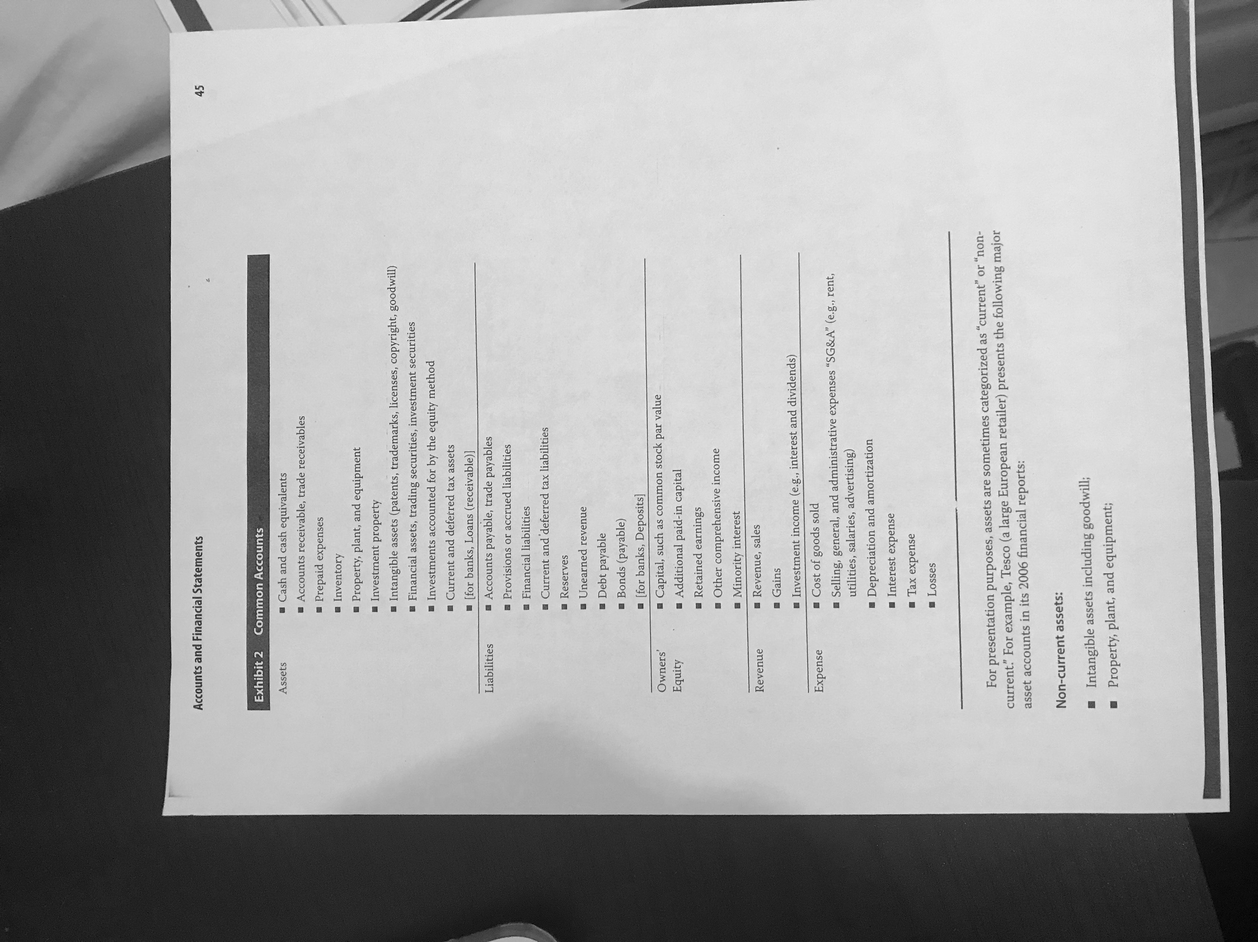

# Reading 23: Financial Reporting Standards

## 2. The Objective of Financial Reporting

To provide financial information useful to investors, lenders and stakeholders. The Conceptual Framework (2010) is the newest standards placed by the International Accounting Standards Board (IASB). It replaced the Framework for the Preparation and Presentation of Financial Statements (1989).

Rule-based standards: comprehensive and complex.

Principles-based standards: more general.

This makes companies comparable.

## 3. Standard-Setting Bodies and Regulatory Authorities

Standard-Setting Bodies: like the IASB or the Financial Accounting Standards Board (FASB), they are private and self-regulated.

Regulatory Authorities: oversee that financial reports are in accordance with specified standards, they enforce them. They can overrule the private bodies. Example: SEC.

3.1 Accounting Standards Boards: independent, private and not-for-profit organizations. When they issue standards, the regulatory body decides whether or not to adopted.

3.1.1 International Accounting Standards Board**:** Is the body in charge of setting the IFRS standards. It has two related entities:

* IFRS Interpretations Committee: They review issues that arise when applying the IFRS that are not specified.
* IFRS Advisory Council: Its members are people whose interest are affected by the IFRS and give advice to the IASB.

3.1.2 Financial Accounting Standards Board**:** It has a similar structure as the IASB. Its related entities are:

* The Financial Accounting Foundation: It oversees, administers and finances the organization. It ensures the independence of the FASB.
* Financial Accounting Standards Advisory Council.

The steps for approving the standards are in the reading, page 105.

3.1.3 Desirable Attributes of Accounting Standards Boards**:**

* Clear functions of the members.
* High professional, ethical and confidentiality standards.
* Adequate authority, resources and competences.
* Clear and consistent processes.
* Clear objectives.
* Independent.

3.2 Regulatory Authorities**:** Their responsibility consists in requiring the compliance of the accounting standards. They have legal power.

3.2.1 International Organization of Securities Commissions**:** Are the governmental regulatory authorities from different countries (90% of world’s financial markets). They look for investors protection; fair, efficient and transparent market development; and the reduction of systemic risk.

3.2.2 The Securities and Exchange Commission (US)**:** rules and regulates financial markets. Significant legislations:

* Securities Act of 1993: defines the information investors must receive, prohibits misrepresentations and initial registration requirements.
* Securities Exchange Act of 1934: created the SEC.
* Sarbanes-Oxley Act of 2002: created the Public Company Accounting Oversight Board (PCAOB) to oversee auditors. It strengthens the corporate responsibility when reporting.

Most common information sources used by analysts:

* Securities Offerings Registration Statement: it’s a registration statement that includes disclosures of the securities offered, the relationship with other securities offered by the same issuer, the typical information provided in annual filings, audited financial statements and risk factors involved in the business.
* Forms 10-K (US companies), 20-F (non-US companies) and 40-F (Canadian registrants): these are file annually and include a comprehensive overview with information about the business, financial disclosures (10-year financial data summary, MD&A), legal proceedings and information related to management.
* Annual Report: it is not required by the SEC. Companies do it to present it to the shareholders. It is not as formal as a 10-K.
* Proxy Statement/Form DEF-14A: Is a statement where the shareholders give the power of their rights to others. Besides, it includes the proposal, details of the ownership, among other details.
* Forms 10-Q (Quarterly for US companies) and 6-K (semiannually for non-US companies): requires unaudited financial statements and the MD&A for the period. If an extraordinary event takes place, it must be reported.

Other filings:

* Form 8-K (US companies and 6-K (non-US companies): it is fused when issuers announce major events (acquisitions, assets changes, security changes…).
* Form 144: must be filled to notice a proposed sale of restrictive securities.
* Forms 3, 4 and 5: required by any director of the company or major owner (more than 10%) to report beneficial ownership. 3 is the initial state, 4 reports any changes and 5 is the annual report.
* Form 11-K: annual report of employee stock purchase, savings and similar plans.

3.2.3 Capital Markets Regulation in Europe**:** Regulations that are adopted at the EU level.

## 4. Convergence of Global Financial Reporting Standards

The different accounting standards are converging over time, so it is important to pay attention to any relevant change that might affect the analysis.

## 5. The International Financial Reporting Standards Framework

5.1 Objective of Financial Reports**:** “The provision of financial information that is useful to current and potential providers of resources (primary users) in making decisions.” Although the objective of each user might differ, there are some needs that are common across all users: financial position, financial performance and cash flows.

5.2 Qualitative Characteristics of Financial Reports**:** There are two fundamental characteristics that make the information useful:

* Relevance: it potentially makes a difference in users’ decisions. This also implies materiality (if the information is omitted, it might influence decisions).
* Faithful representation: complete, neutral and free of error information.

There are also some characteristics that enhance the usefulness of the information:

* Comparability: allows users to identify and understand similarities and differences of items.
* Verifiability: other knowledgeable and independent users agree that the information is presented faithfully.
* Timeliness: the information is given every certain time.
* Understandability: the information is clear and concise.

5.3 Constraints on Financial Reports**:** There is some information that because of its nature, it cannot be reported accurately.

5.4 The Elements of Financial Statements**:** Measurement of financial position: assets, liabilities and equity. Measurement of financial performance: income and expenses.

5.4.1 Underlying Assumptions in Financial Statements**:**

* Accrual accounting: transactions are recorded on the period that the occurred, not when the movements of cash were made.
* Going concern: the company will continue operating for the foreseeable future.

5.4.2 Recognition of Financial Statement Elements**:** Refers to the fact that an item can be included in a financial statement if it is probable that any future economic benefit associated to the item will generate a cash flow and, the item has a value than can be measured with reliability.

5.4.3 Measurement of Financial Statement Elements**:** Bases of measurement that are used:

* Historical cost: the amount of cash originally paid for the asset. In terms of liabilities, it would be the amount of proceeds received in exchange of the obligation.
* Amortized cost: historical cost adjusted by amortization, depreciation, depletion or impairment.
* Current cost: the amount of cash that would be paid for the asset today. For the liabilities, it would be the undiscounted amount of cash needed to settle the obligation today.
* Realizable (settlement) value: the current amount of cash that could be obtained from selling or disposing the asset currently. For liabilities, it would be the settlement value, which is the undiscounted amount of cash expected to be paid to satisfy the obligation in the normal course of business.
* Present value (PV): for assets, it would consider the discount expected net cash flows that the asset would generate in the normal course of the business. For the liabilities, this would be the required present value of the expected net cash flows that would be needed to settle an obligation in the normal course of the business.
* Fair value: the amount at which the assets could be exchanged or, a liability, settled, between willing parties in a transaction.

5.5 General Requirements for Financial Statements**:**

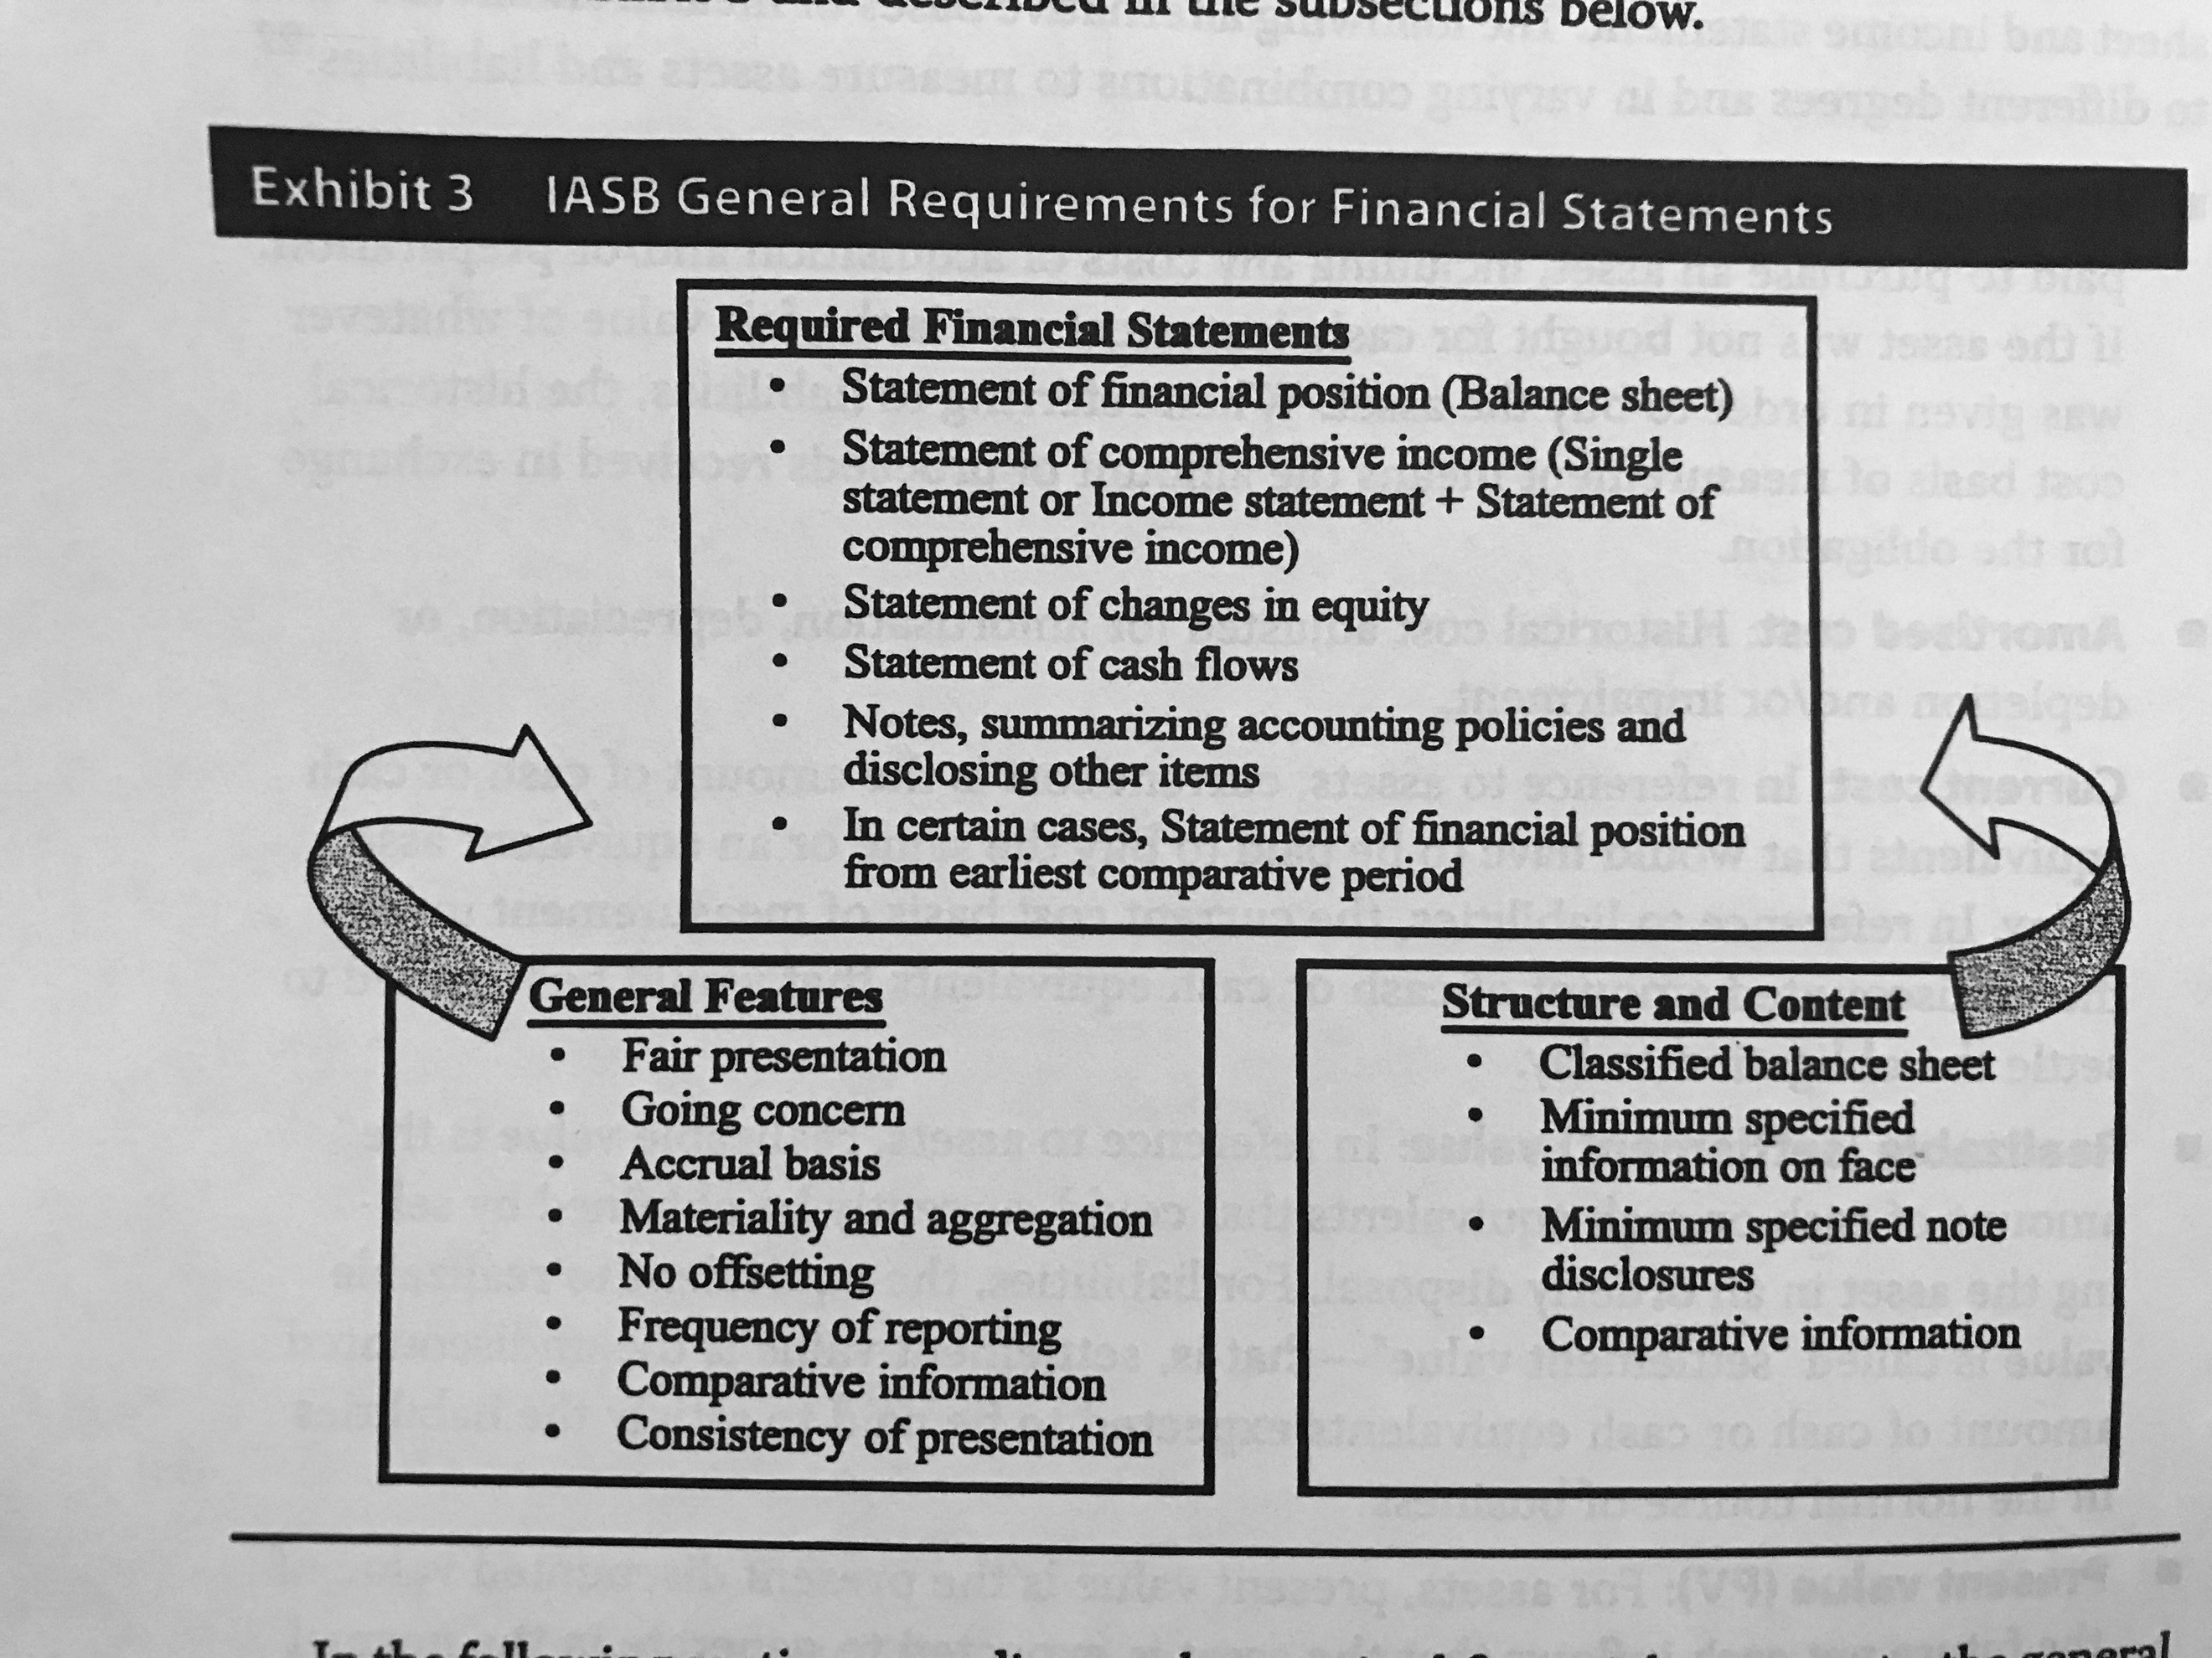

5.5.1 Required Financial statements**:** as stated in the point 5.5.

5.5.2 General Features of Financial Statements**:**

* Fair presentation: faithful representations of the effects of transactions and events or conditions.
* Going concern: statements are prepared on a going basis unless there are plans for liquidate its assets.
* Accrual basis: except for cash flow information.
* Materiality and aggregation: each material class of similar elements is presented separately. Immaterial items can be aggregated.
* No offsetting.
* Frequency of reporting: at least annually.
* Comparative information: information from previous periods
* Consistency: the presentation and classification of items should be retained from one period to another.

5.5.3 Structure and Content Requirements**:** structure is required by the IFRS:

* Classified balance sheet: distinguish between current and non-current assets and liabilities, unless a classification based on liquidity is more reliable (like in banks).
* Minimum information on the face of the financial statements:

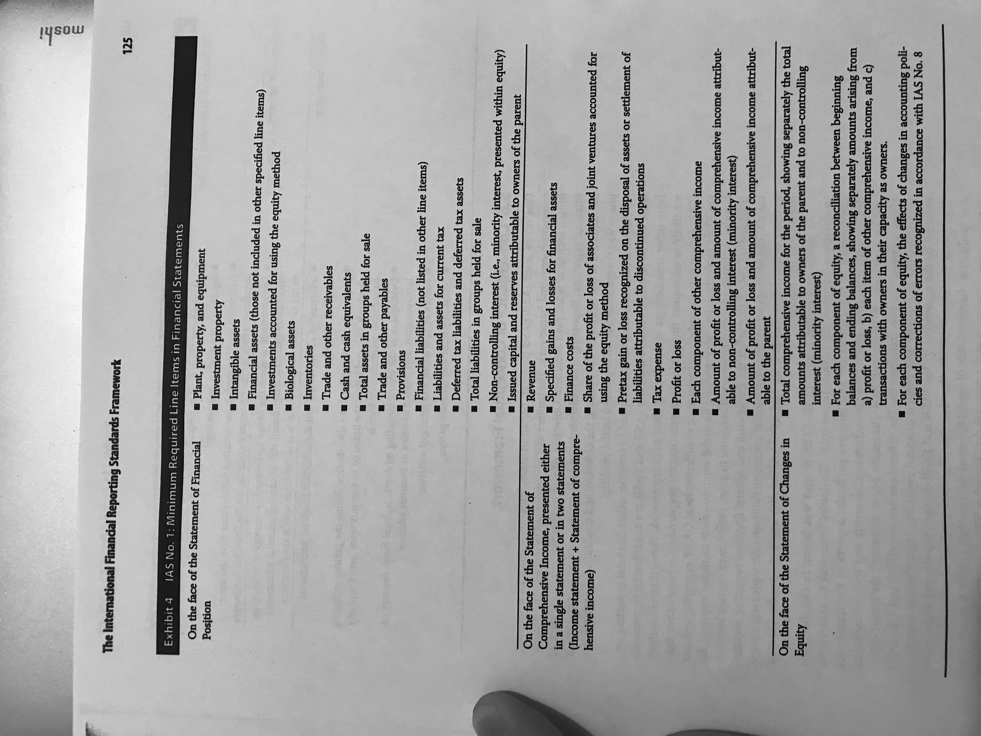

* Minimum information in the notes:

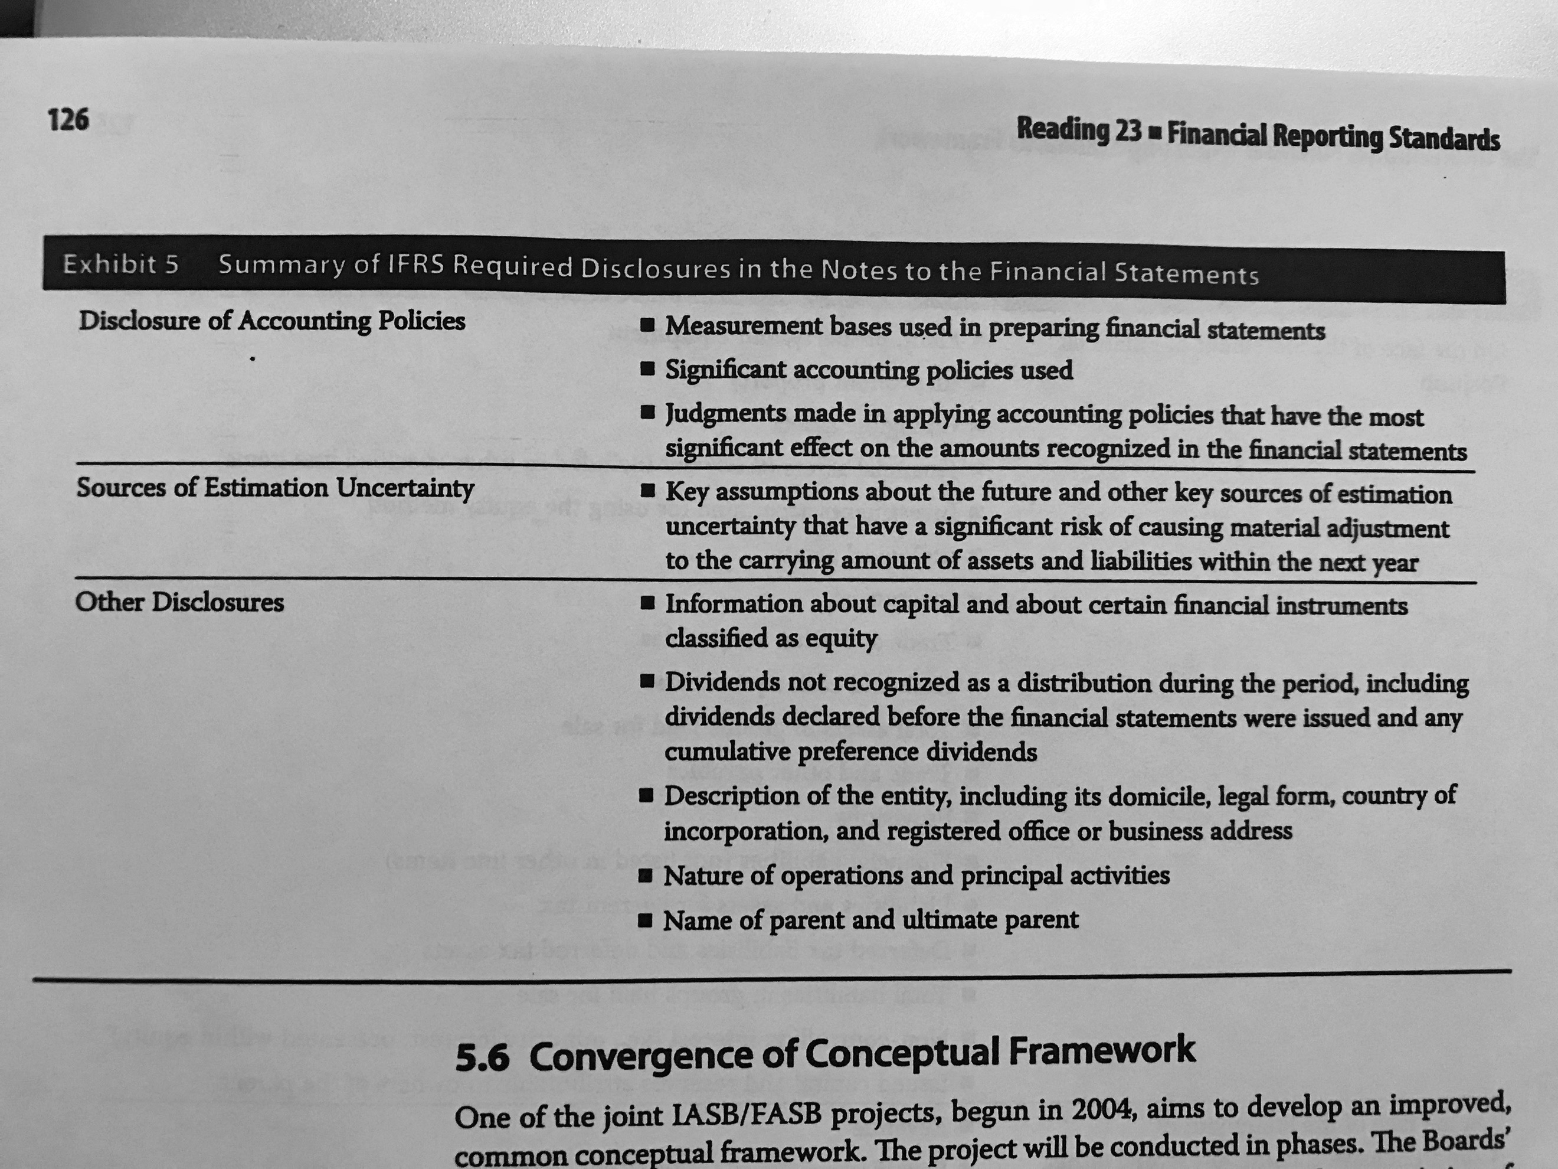

* Comparative information: for all of the amounts reported in the financial statement, previous information must be presented.

5.6 Convergence of Conceptual Framework: Although they are trying to converge, IFRS and GAAP are still different. Some of the differences are:

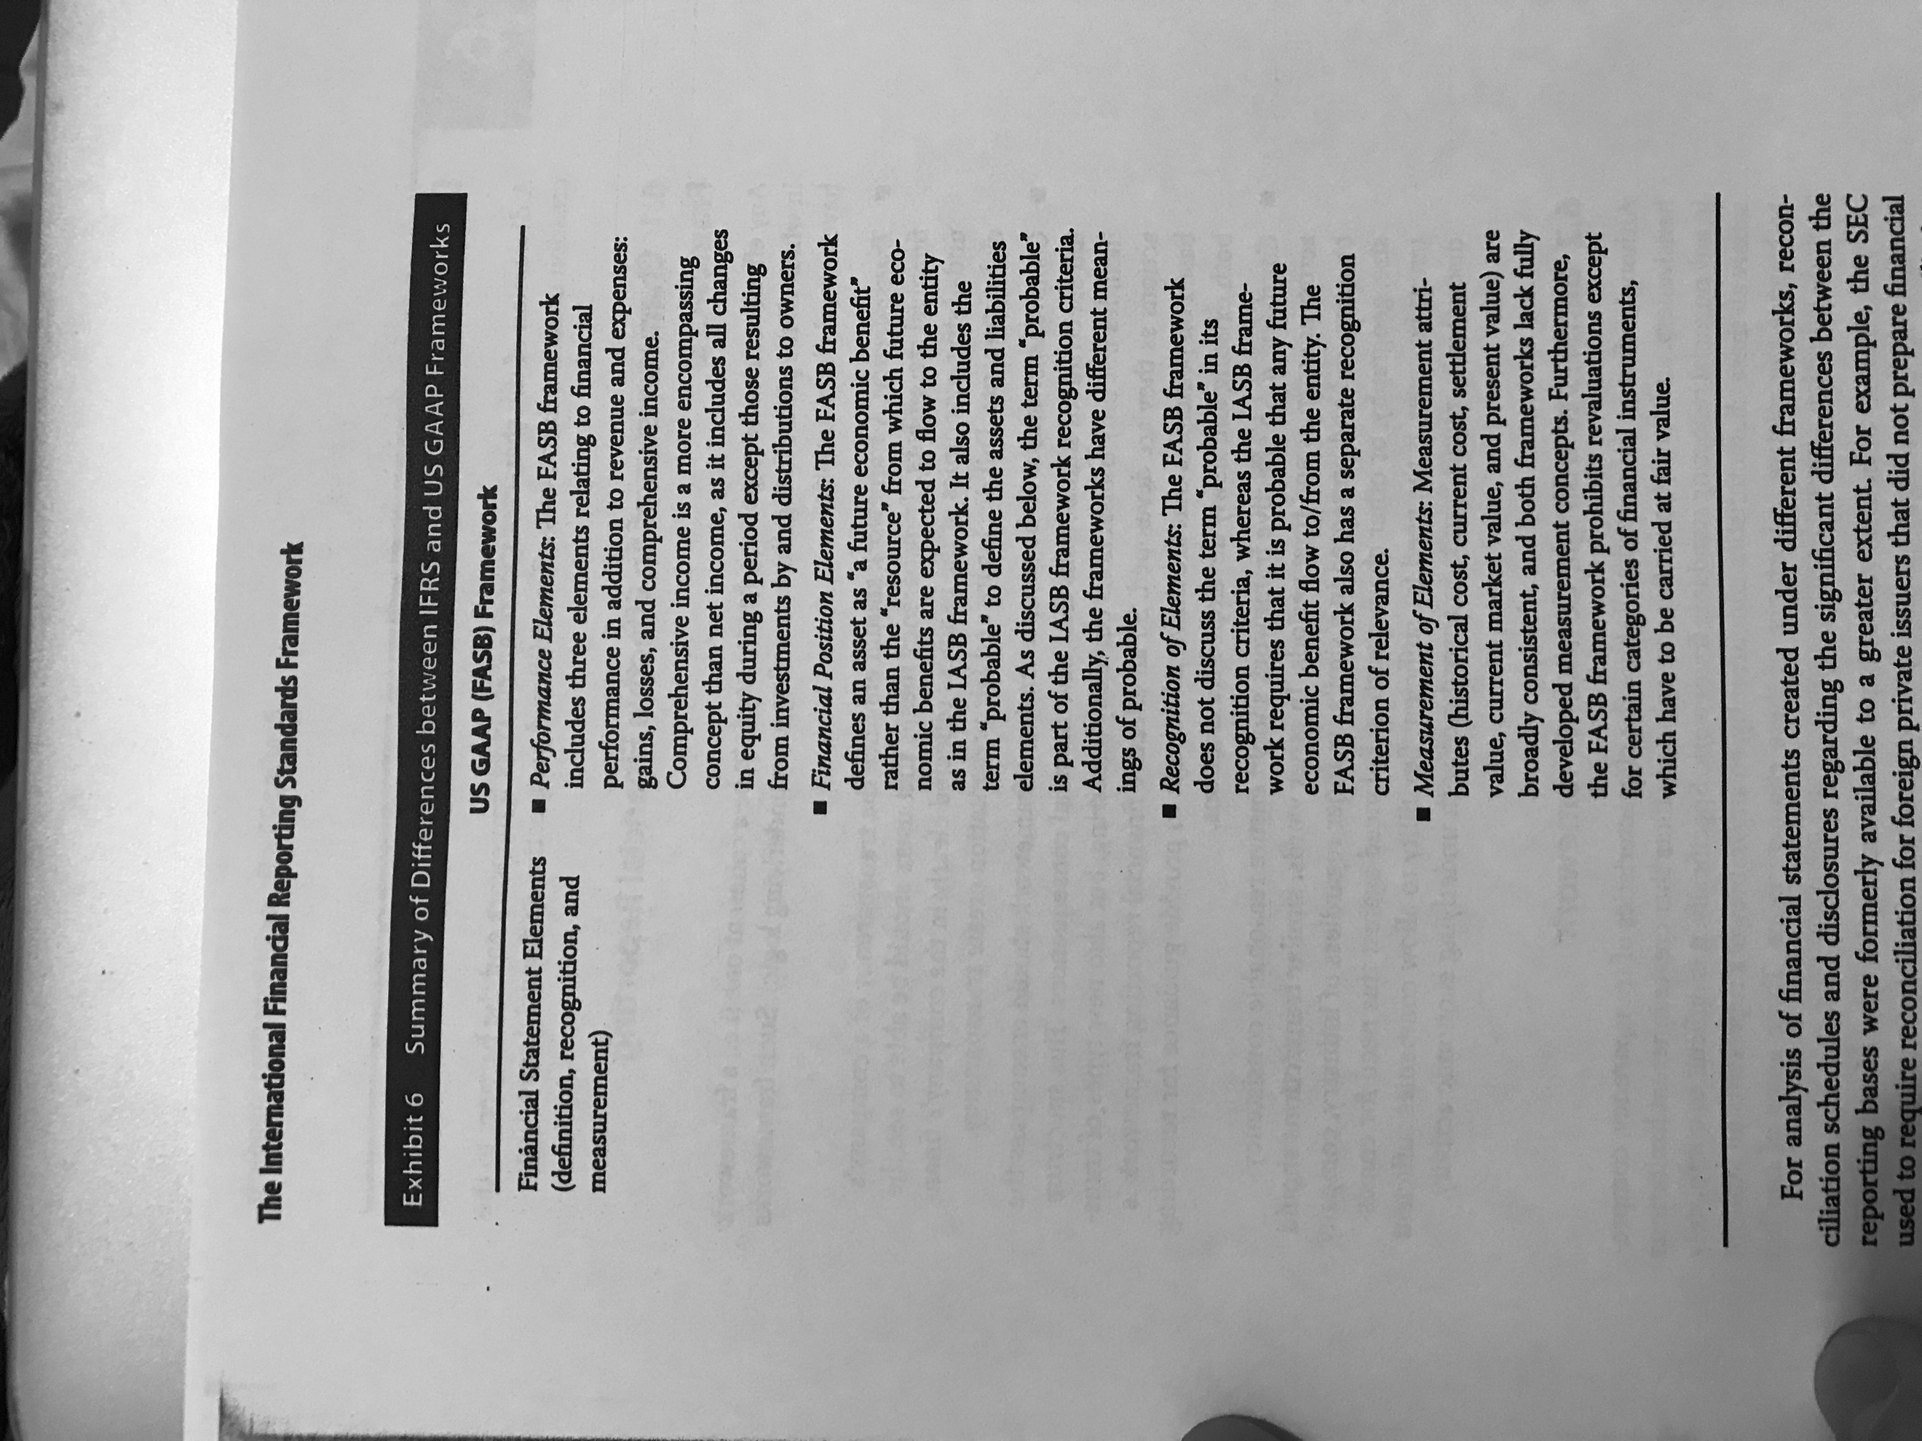

## 6. Effective Financial Reporting

6.1 Characteristics of an Effective Financial Reporting Framework**:**

* Transparency: full disclosure and fair presentation.
* Comprehensiveness: includes existing and newly developed transactions.
* Consistency: measure and presentation should be similar through periods.

6.2 Barriers to a Single Coherent Framework**:** there are three main areas that create limitations among frameworks (opposite to the last three):

* Valuation: when determining the value of the assets, for instance, there is a minimal issue regarding valuation when using the historical cost. However, with other techniques, the use of judgement is needed making it less coherent through the framework.
* Standard-Setting Approach: It can be principles based, rules based or a combination of both (objective oriented). Principles based refers to a not so specific approach, it requires considerable judgement. Rules based, on the other hand, requires lots of specific guidance. The objective oriented is the most commonly used.
* Measurement: as financial reporting includes both the balance sheet and the income statement, the time frame makes it difficult to be accurate in both statements. There are two methods to approach this issue, the asset/liability (gives preference to a proper valuation of the balance sheet) and the revenue/expense approach (gives preference to the income statement). The most commonly used is the asset/liability approach.

*LIFO is not allowed in IFRS.

## 7. Comparison of IFRS with Alternative Reporting Systems

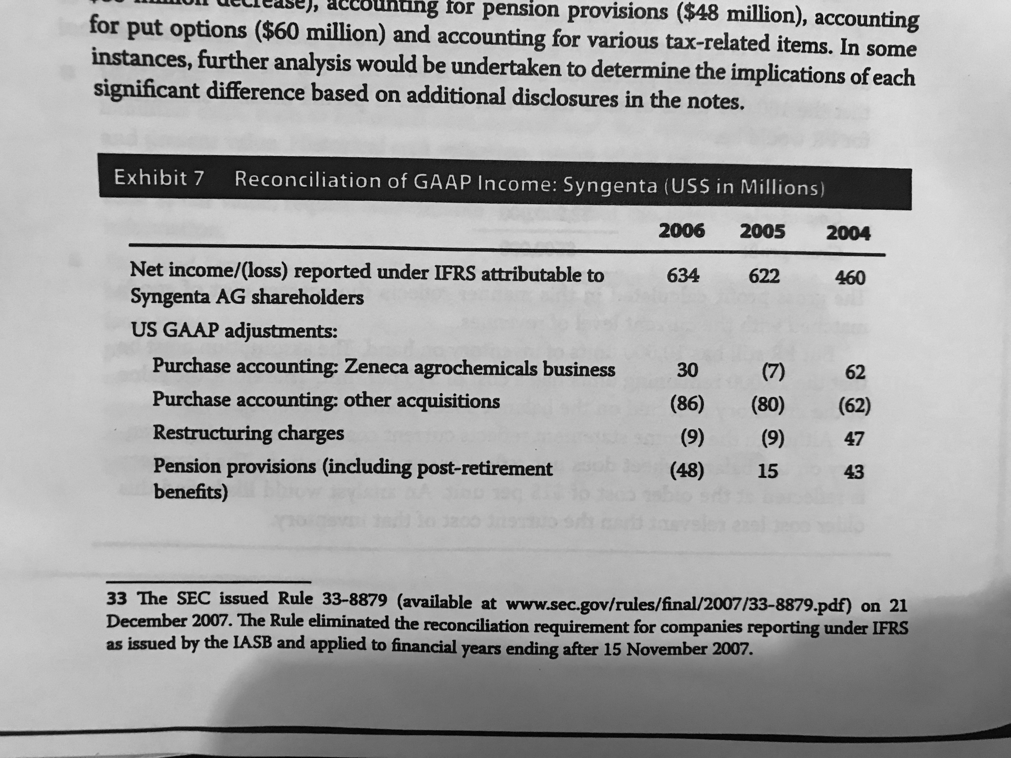

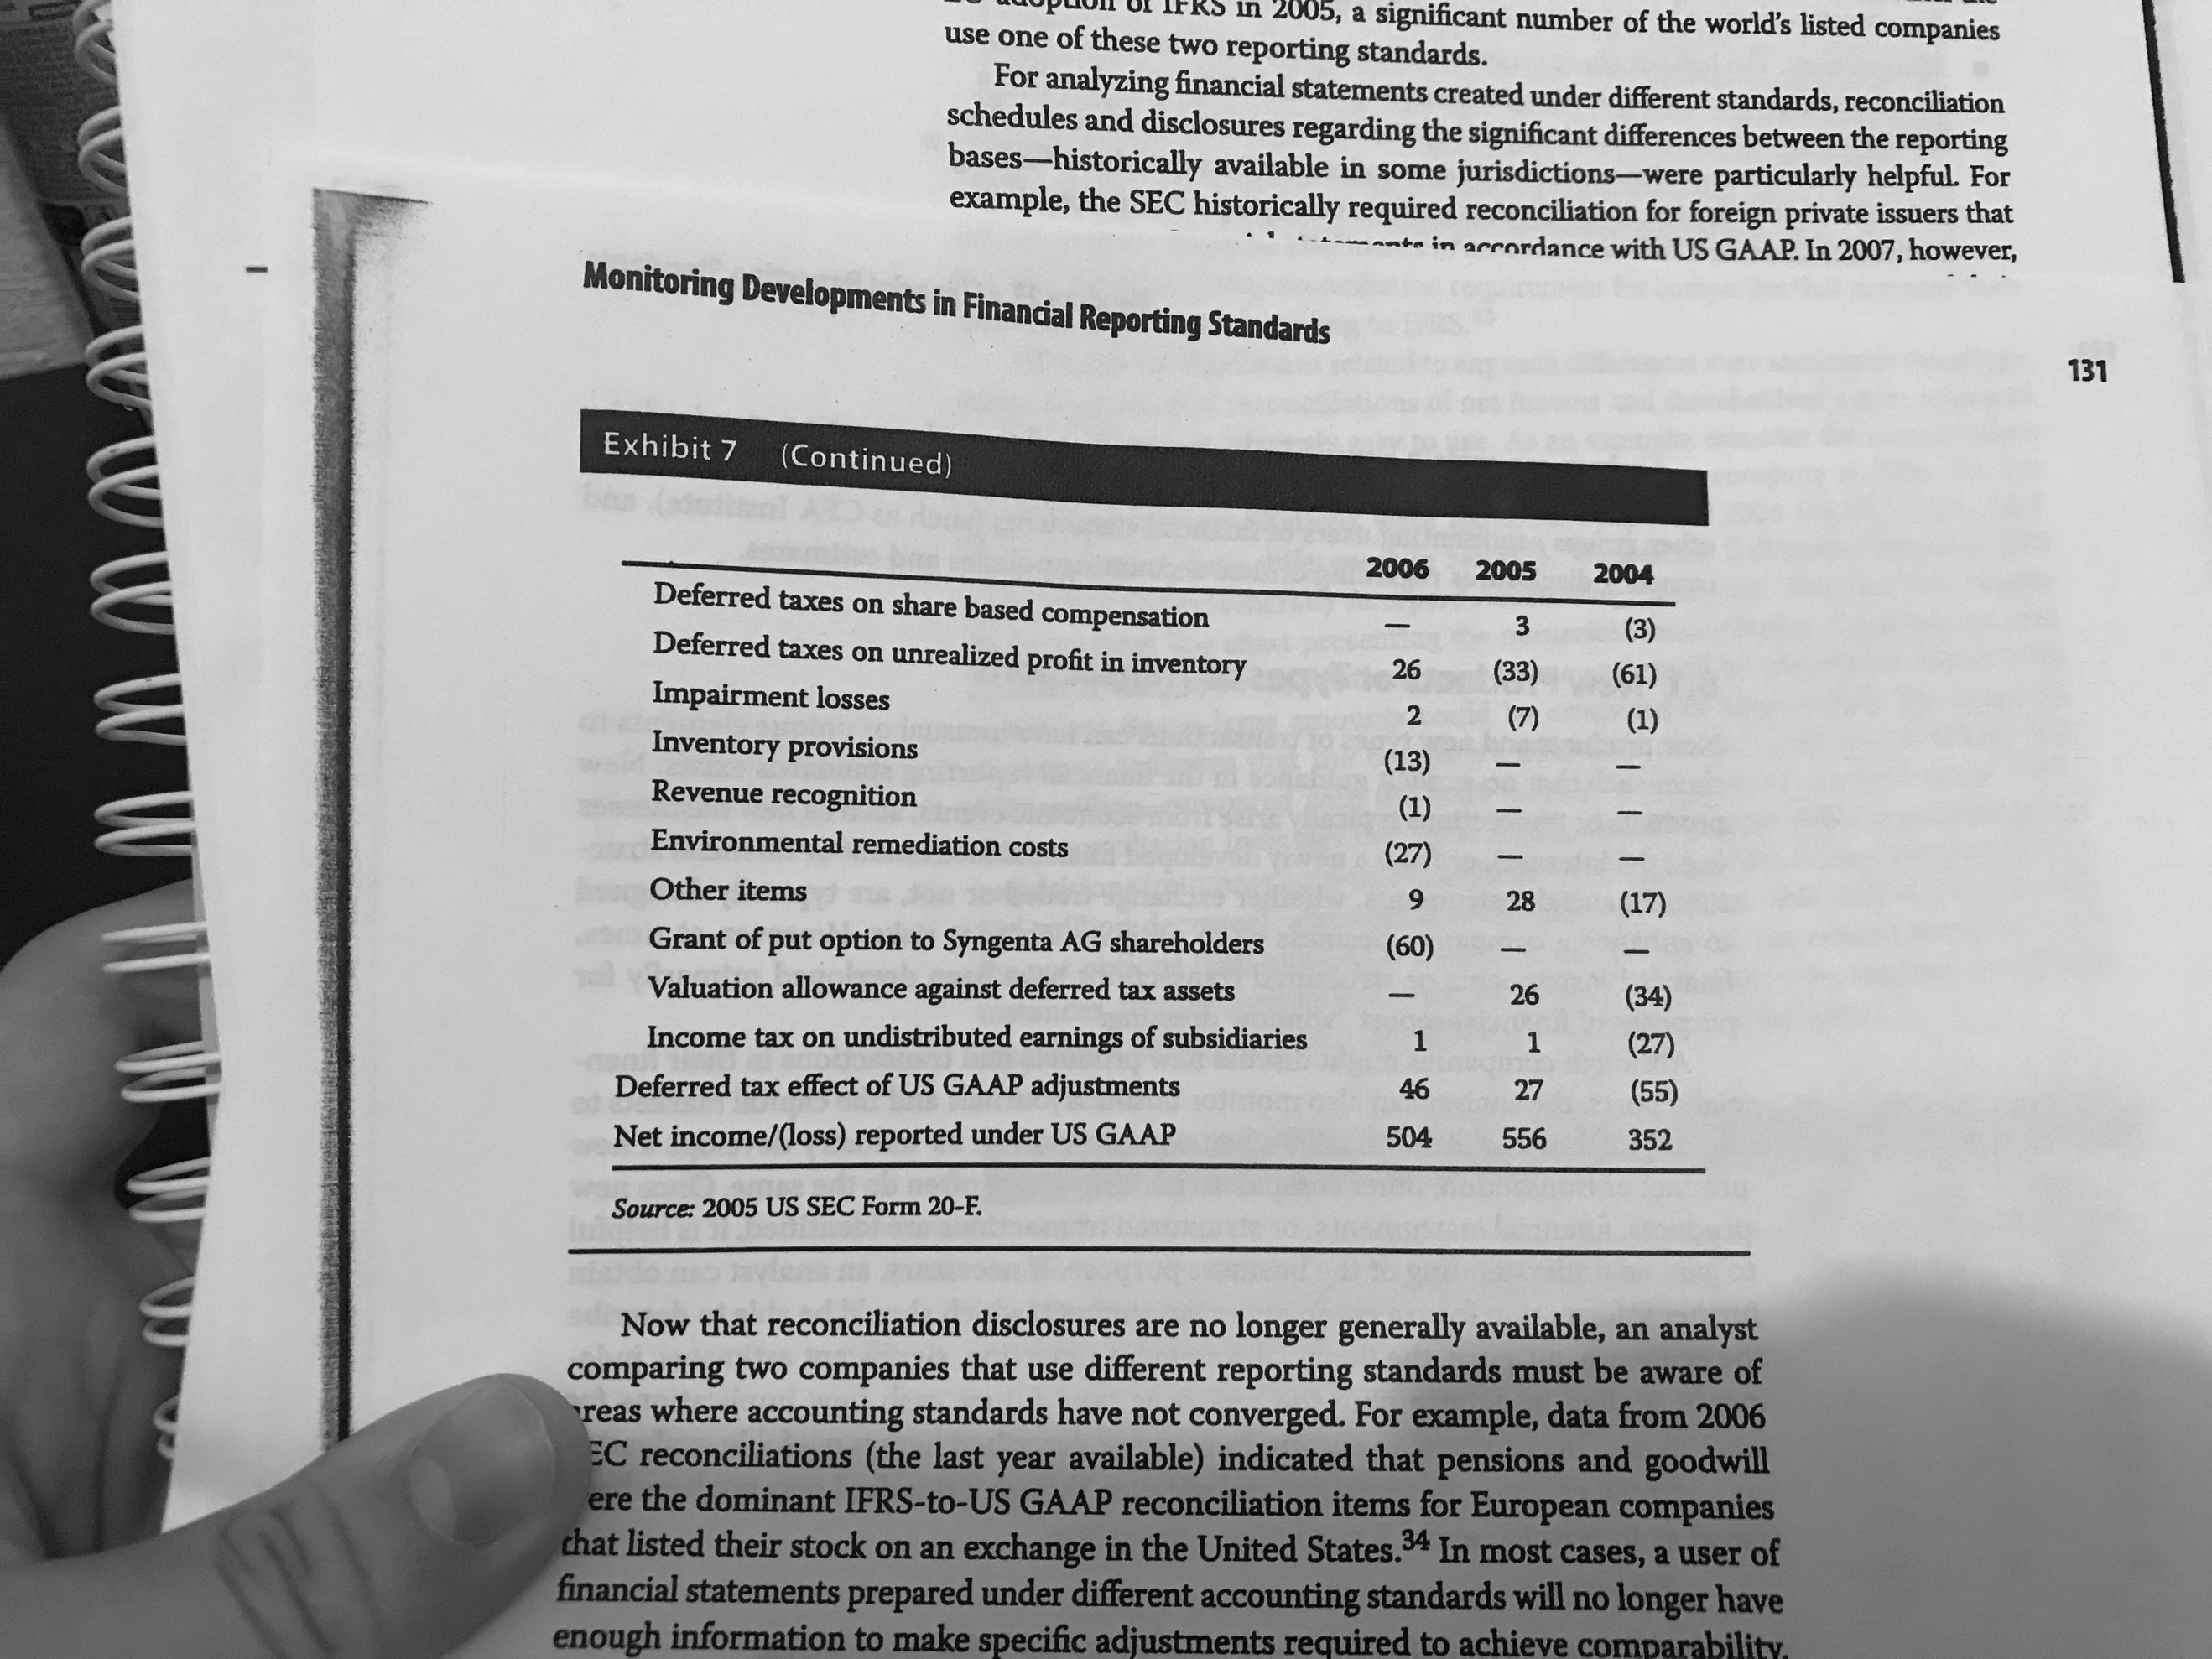

## 8. Monitoring Developments in Financial Reporting Standards

8.1 New Products or Types of Transactions**:** Towards these cases, it might happen that no reporting standards exists. When this happens, the analyst should understand clearly the economic event in order to make the respective analysis.

### 8.2 Evolving Standards and the Role of CFA Institute

8.3 Company Disclosures**:** The notes of statements provide information about the effect of accounting standards in the companies’ statements.

8.3.1 Disclosures Relating to Critical and Significant Accounting Policies**:** Here the analyst is able to see the effect of the accounting policies in its statements.

8.3.2 Disclosures Regarding Changes in Accounting Policies**:** Companies must disclose any change due to either new standards or voluntary changes. The report includes a conclusion that can be:

* The standard does not apply.
* The standard will have no material impact.
* Management is still evaluating the impact.
* The impact of adoption is discussed.

# Reading 24: Understanding Income Statements

## 2. Components and Format of the Income Statement

* Revenue is also known as sales or turnover.
* Items in the income statement might appear with certain sign. The point is that the analyst checks the nature of the account to determine its effect in the net income.
* Consolidation means that they include ALL of the revenues and expenses of the subsidiaries even if they own less than 100 percent.
* Grouping by nature: for instance, all the different depreciations.
* Grouping by function: for example, all the items of the COGS.
* Multi-step format: it includes the subtotal of the gross profit.
* Single-step format: it does not include the gross profit.

## 3. Revenue Recognition

Income comes from the businesses’ main activity while gains arise from secondary activities.

3.1 General Principles**:** Revenues is recognized when its earned, when the risk and reward of ownership is transferred, when the tittle is transferred. The revenue recognition policies must be disclosed in the notes.

IFRS establish that revenue is recognized when the following conditions are satisfied:

* There has been a transfer of risks and rewards of ownership of the goods.
* The entity has no effective control over the good.
* The amount of revenue can be measure reliable.
* It is probable that there will be cash inflows from the transaction.
* Costs due to the transaction are measurable.

US GAAP specify the following guidance for revenue recognition:

* There is evidence of an arrangement between buyer and seller.
* The product has been delivered or the service has been rendered.
* The price is determined or determinable.
* The seller is reasonably sure of collecting money.

3.2 Revenue Recognition Special Cases**:**

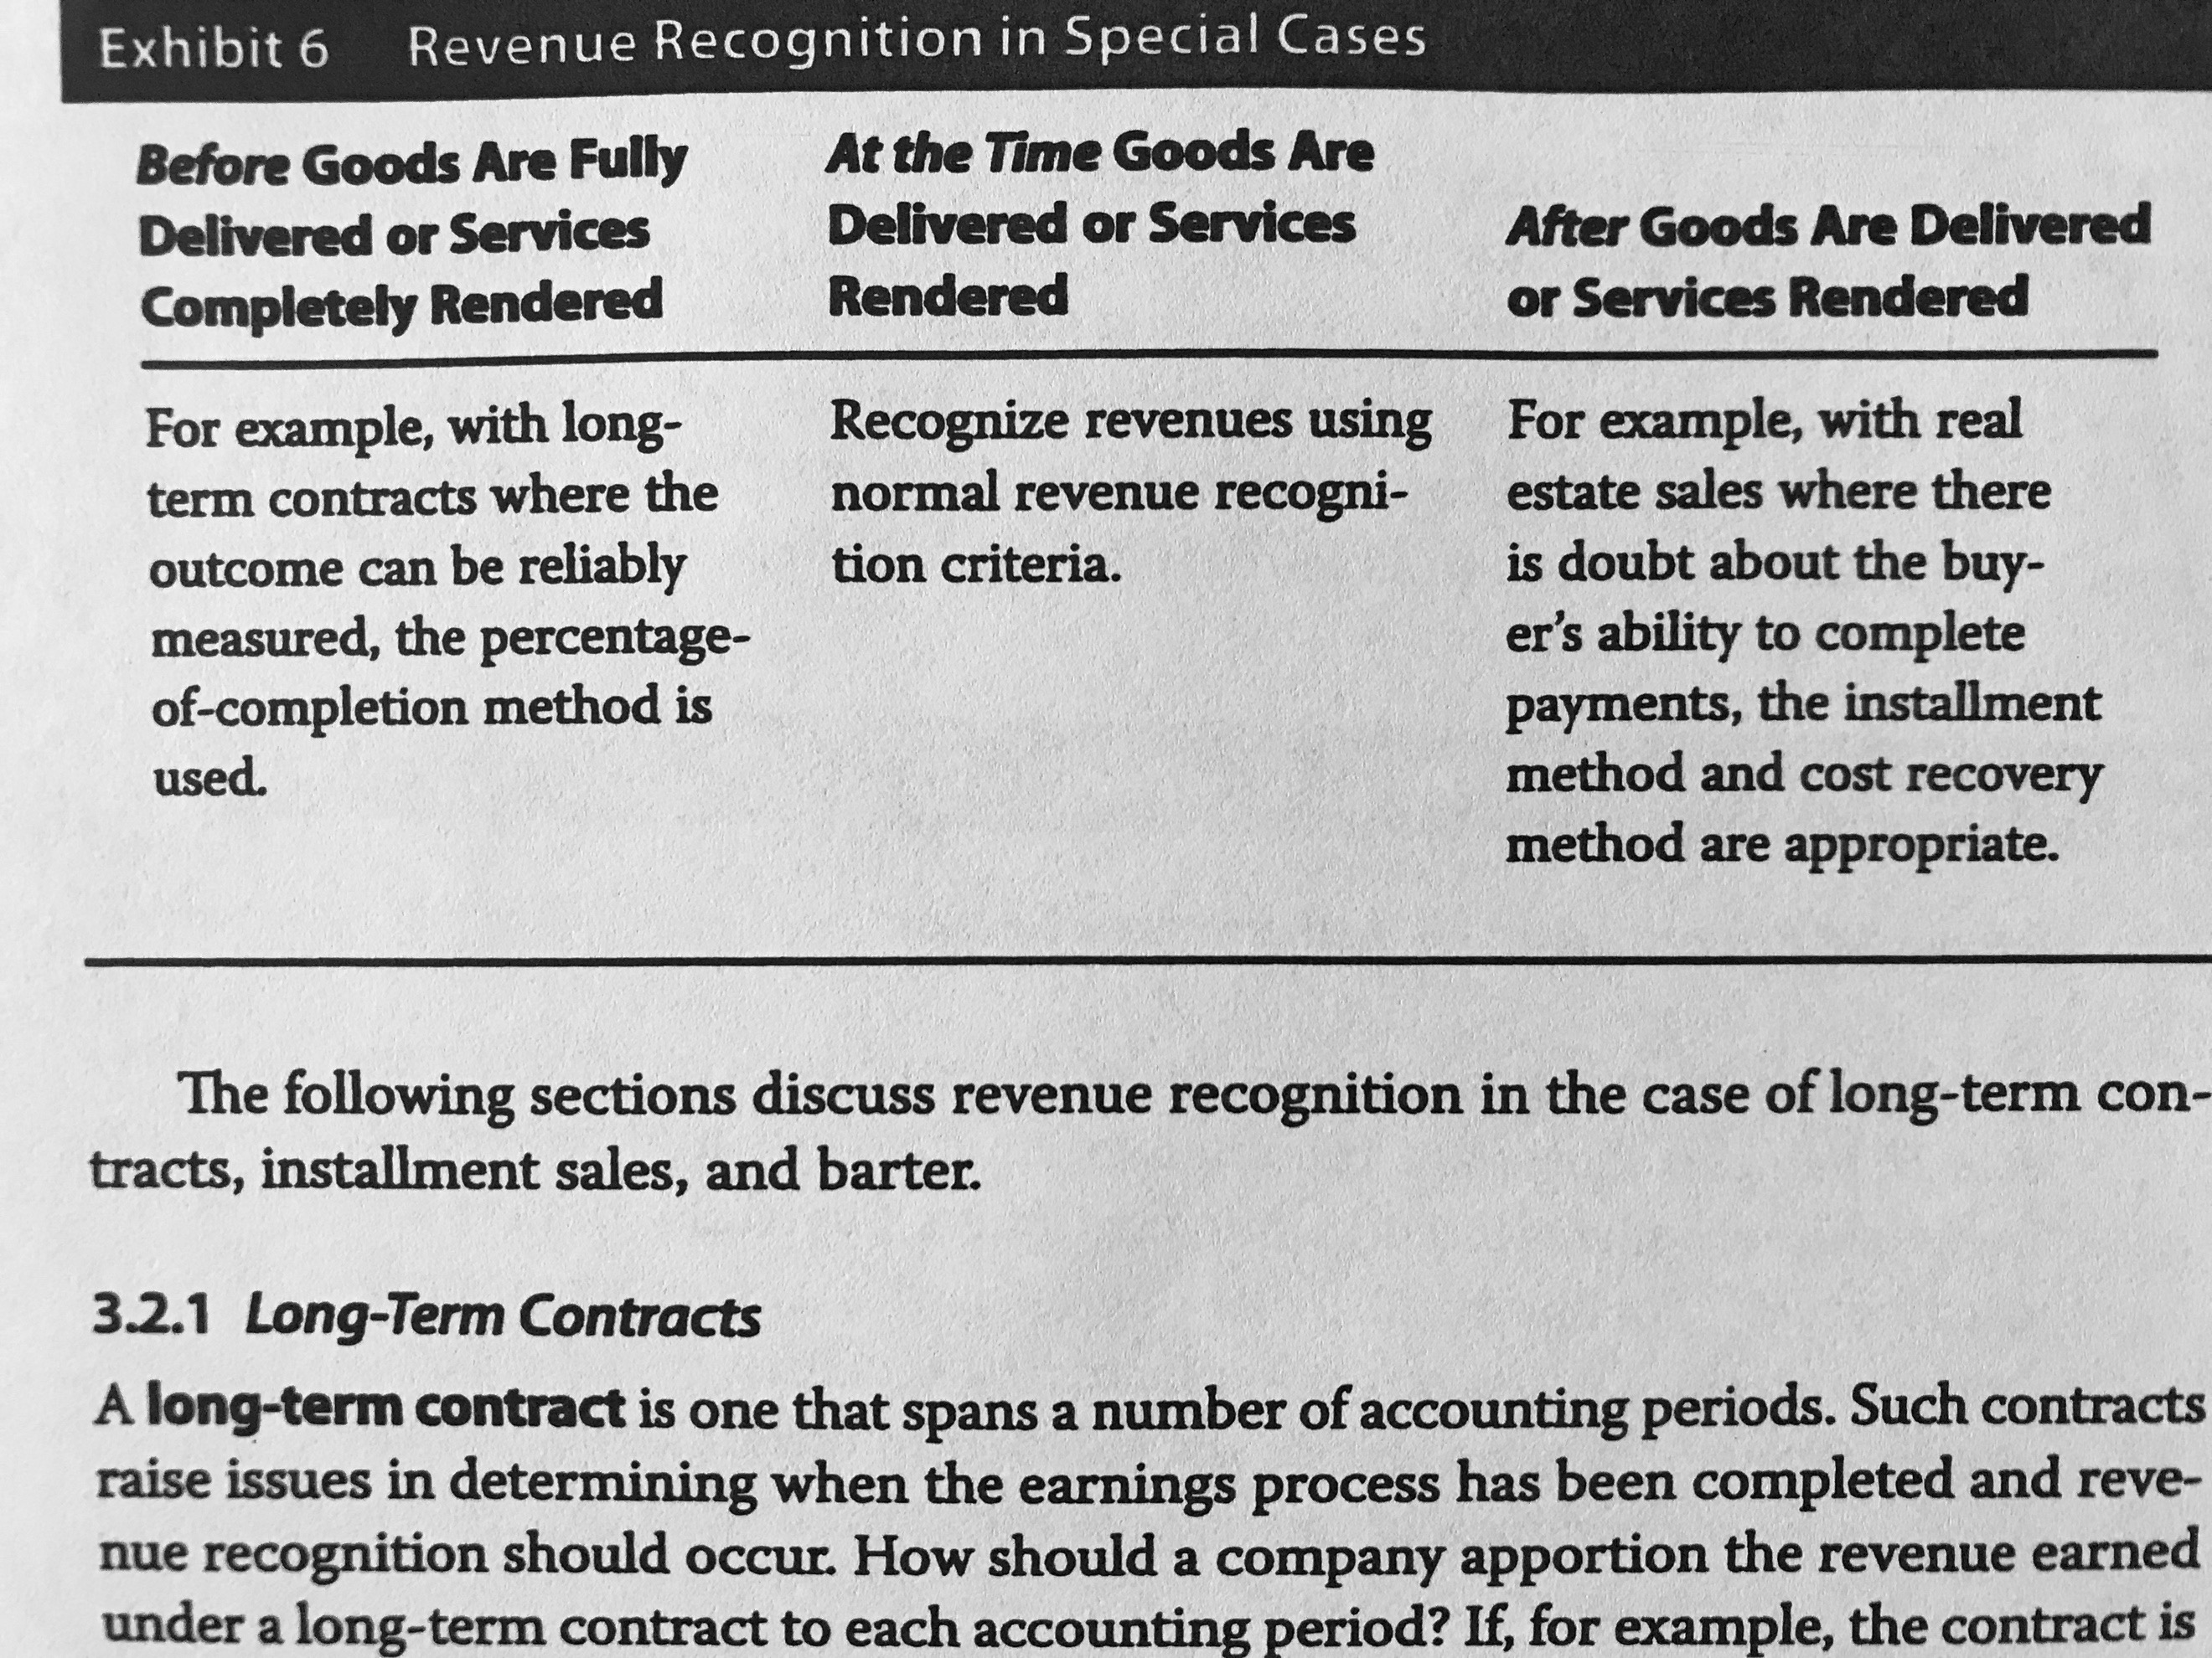

3.2.1 Long-Term Contracts**:** IFRS and US GAAP allow the usage of **percentage-of-completion** method when confronting these cases. So, to recognize revenue, the company estimates what percentage of the contract is completed in the reported time frame and then reports the percentage of the total revenue (the expense will be assigned in the percentage that income I assigned). However, it can be based on expenditure incurred (if I spent 50% of the total expenditures, I recognize 50% of my total revenue).

Under IFRS, if this method is not reliable, revenue can be recognized to the extent of the contract costs incurred in the period (only if these costs are recoverable). Then, there will not be any profit until all costs are recovered. If I spend 3, I recognize only 3 until all the cost are incurred.

US GAAP uses the **completed contract method** (when the revenue cannot be measured reliably) where the income is not reported until the contract is substantially finished. Provisions should be made in case of loses. Costs and billings are accumulated in the balance sheet as an increase in inventory, for instance, and a decrease in cash. So, costs and revenues will be cero until the project ends.

*In both cases, if a loss is expected, it should be reported immediately.

3.2.2 Installment Sales**:** (ventas a plazos). Here, the principles of accrued accounting still apply.

Under IFRS, installments are separated into the discounted present value of each payment and an interest component. So, revenue attributable to the price is recognized the date that it was sold and the interest component is recognized over time (WHERE IT IS RECOGNIZED?).

Under US GAAP, when the seller has completed the significant activities in earnings process and is either assured to collect the earnings or able to estimate the uncollectable earning, revenue recognition is made as in normal conditions. When these conditions are not fully met, two methods are used:

* **Installment method:** the portion assigned for each period’s profit is assigned considering the percentage of the profit out of the sales multiplied by the installment.
* **Cost recovery method:** the seller does not recognize profit until the amount paid by the buyer exceed the cost of the product.

3.2.3 Barter**:** Non-monetary exchanges. Under IFRS, these transactions must be measured based on their fair value of the revenue from similar non-barter transactions made by third parties. Under US GAAP, it can be recorded at its fair value only if the company received, in its past history, cash payment for such services (if not, it is recorded at the carrying amount or book value of the asset surrendered).

3.2.4 Gross versus Net Reporting**:** As they are companies that do not hold inventory (e-commerce), US GAAP establishes that gross revenues must be reported (proceeds from their costumers) when the company is the primary obligor under the contract, it bears inventory and credit risk, can choose the supplier and has reasonable latitude to establish price. If not, revenues must be reported net (difference between its proceeds and their cost).

3.3 Implications for Financial Analysis**:** it is important to check notes in order to understand the level of conservatism of the policies.

3.4 Revenue Recognition Accounting Standards Issued May 2014**:** The core principle states that that revenue should be recognized in an amount that reflects what the entity expects to receive. They propose five steps to recognize the revenue:

1. Identify the contract with a costumer.
2. Identify the performance obligations in the contract (promises to transfer goods).
3. Determine the transaction price.
4. Allocate the transaction price to the performance obligations in the contract.
5. Recognize revenue when the entity satisfies a performance obligation.

## 4. Expense Recognition

4.1 General Principles**:** Expenses are recognized on the period that it is consumed.

**Matching principle:** expenses associated with revenues are recognized in the same period as the revenues are reported.

**Period costs:** are costs that do not match the revenue and are reflected in the period when expenditure is made.

**Inventory costing methods:** Specific identification method, FIFO method, LIFO method and Weighted average cost method.

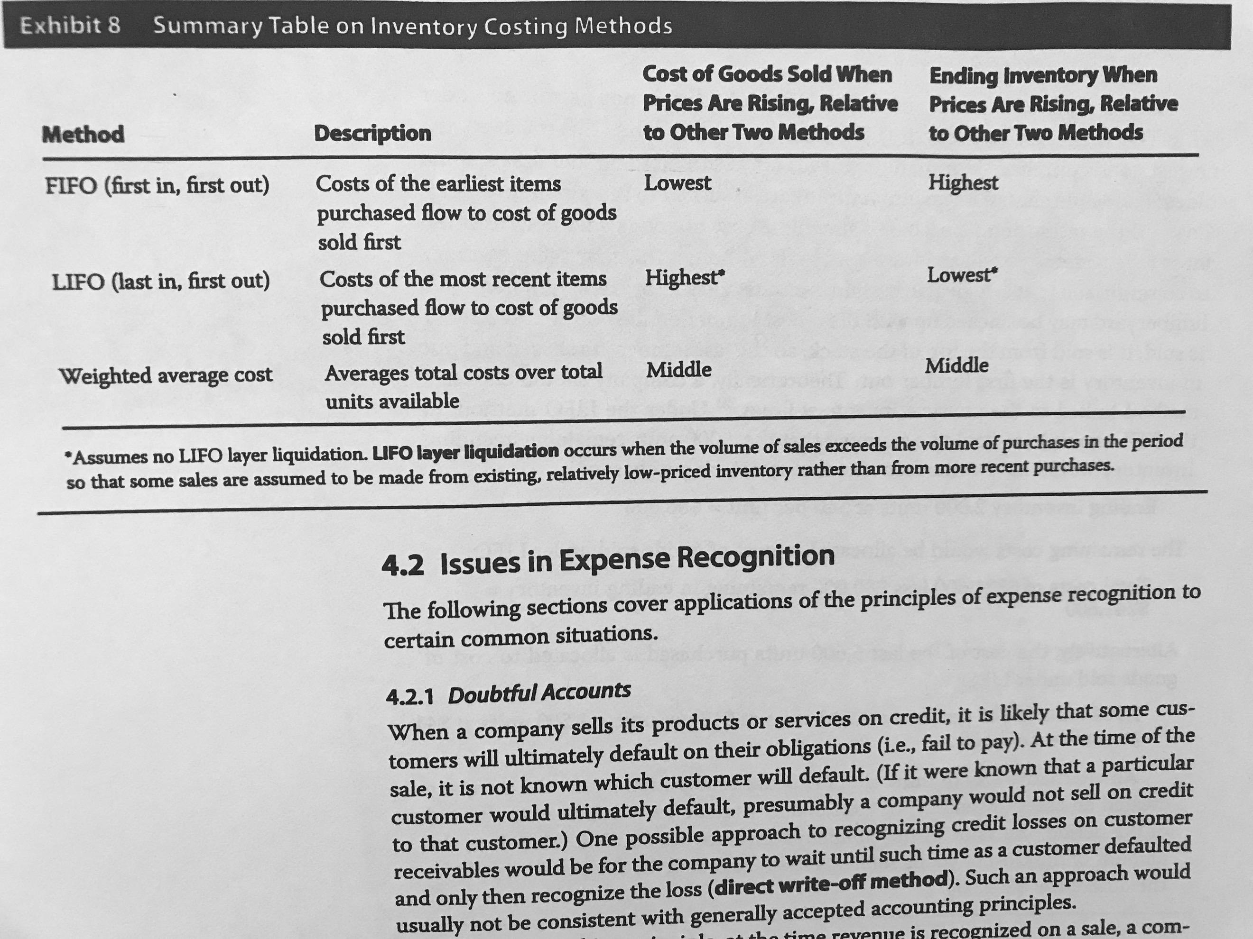

4.2 Issues in Expense Recognition:

4.2.1 Doubtful Accounts: the **direct write-off method** is not accepted (where the company waits until the costumer defaults to recognize the loss). Therefore, it is required for the company to estimate how much of the revenue will be uncollectable. This estimate will be recorded as an expense with a credit in the balance sheet account of estimates for doubtful accounts.

4.2.2 Warranties: the company has to estimate the amount of future expenses related to warranties to recorded in the period of sale.

4.2.3 Depreciation and Amortization: Depreciation is applied for physical long-lived assets while amortization is applied to intangible assets.

Under IFRS, two models are authorized for valuating property, plant and equipment:

* The cost model: the asset is reported at it cost minus the accumulated depreciation.
* The revaluation model: the asset is reported at its fair value (not permitted under US GAAP).

*IFRS requires that each component of an asset is depreciated separately while US GAAP does not require it.

*IFRS require annual review of the residual value and the useful life while US GAAP does not require it.

Commonly used methods to compute depreciation:

* **The straight-line method**: allocates evenly per period the cost of the asset considering a residual value (the amount expected to receive when the asset is sold).
* **The diminishing balance method**: this one is an **accelerated method**, which allocates more depreciation to the early years (it is correct to use it when the usage of the asset will follow this behavior). For this method, first the rate of depreciation under straight line method for the useful life should be defined. Next, an acceleration factor must be determined (when is 200% is known as **double declining balance depreciation**) and multiplied by the original straight-line method rate (under this method, normally, the residual value is not taken into consideration). Using this rate, the depreciation is calculated until it reaches to the residual value (the last period just subtracts the remaining difference).

*IFRS states that if a clear pattern of depreciation cannot be established, the straight-line method should be used.

Assets with indefinite life are not depreciated nor amortized.

4.3 Implications for Financial Analysis: Policies that recognize expenses sooner and revenues later is more conservative.

## 5. Non-Recurring Items and Non-Operating Items

Under US GAAP, discontinued operations and extraordinary should be reported separately (“extraordinary items” is not permitted in IFRS and in US GAAP after 2015).

5.1 Discontinued Operation: is the effect of the disposal of a set of operations from the company. An analyst should not consider this set of operations for his future expectations.

5.2 Extraordinary Items: items of unusual nature. The new guidance towards this point is explained in 5.3.

5.3 Unusual or Infrequent Items: These are items which reoccurrence is unlikely. They must be presented separately and are determined with an assisted judgement from an analyst.

5.4 Changes in Accounting policies: Retrospective application refers to applying the changes in accounting policies to all the fiscal years presented in the annual report and specifying the change in the notes. Also, if there are changes made in the accounting estimates that significantly affect the result, it should be disclosed in a note. Also, corrections to an error for prior periods might be made and need to be disclosed.

5.5 Non-Operating Items: this includes gains from interest and dividends, interest expenses. They can be displayed in a net basis but disclosed in the notes.

## 6. Earnings Per Share

IFRS and US GAAP require to present EPS on the face of the income statement for net income and profit from continuing operations.

6.1 Simple versus Complex Capital Structure: Under IFRS, EPS are presented considering the ordinary equity, which include the shares that are subordinated to all other types of equity and are the holders who are paid last in a liquidation and are the ones who benefit the most when the company does well. It is also known as common stock.

When a company has instruments that are potentially convertible to common stock, it has a complex capital structure. These instruments are convertible bonds, convertible preferred stock, employee stock options and warrants. In this case, the EPS is diluted by the inclusion of this instruments.

So, the diluted EPS assumes that al convertible instruments are converted. Basic EPS, instead, considers the available income for common shareholders and uses the weighted average number of shares outstanding. Companies must report both.

6.2 Basic EPS:

$$Basic EPS= \frac{Net Income-Preferred Dividends}{Weighted Average Number of Shares Outstanding}$$

The weighted average is calculated based on the time frame that each number of shares was valid during the period. When a stock split is made, it is treated as if it occurred at the beginning of the period.

6.3 Diluted EPS: If the capital structure is not complex, it is equal to the basic EPS.

6.3.1 Diluted EPS when a Company has Convertible Preferred Stock Outstanding: For the calculation, it is used the **if-converted method**. What it is done is that it is assume that all of the convertible stocks were converted at the beginning of the period. Assuming this implies that the common shares outstanding increases and the preferred dividends decreases. Then the formula would be:

$$Diluted EPS= \frac{Net Income}{W.A.N.S.O+ New common shares due to conversion}$$

6.3.2 Diluted EPS when a Company has Convertible Debt Outstanding: the if-converted method is also used and it is considered that the conversion is made at the beginning of the period. The effects of this consideration imply that the number of common shares outstanding increases and the net income increases because the company will not pay interest on the convertible debt. The formula would then be:

$$Diluted EPS= \frac{Net Income+After tax interest on covertible debt+Preferred div.}{W.A.N.S.O+ New common shares due to conversion}$$

$$After tax interest on covertible debt=Interest exp. saved × (1-tax rate)$$

6.3.3 Diluted EPS when a Company has Stock Options, Warrants or Their Equivalents Outstanding: For this case, the **treasury stock method** is used. It is calculated considering that all the instruments were exercised and the proceeds obtain were used to repurchase stocks at the average price of the period. An important difference with the other method is that in this one, it is consider the date the financial instrument was issued (in the case it was between the period).

$$Diluted EPS= \frac{Net Income+Preferred div.}{W.A.N.S.O+ New common shares due to conversion}$$

$$New common shares due to conversion=\left(Shares resulting from the exercise of the options- repurchase due to conversion\right) × proportion of the year during which the instruments were outstanding$$

For the case of IFRS changes the way of calculation but the result is the same:

$$New common shares due to conversion=\left(Shares resulting from the exercise of the options- \frac{Proceeds from excercise}{Avg. price}\right) × proportion of the year during which the instruments were outstanding$$

*The division is known as inferred shares.

6.3.4 Other Issues with Diluted EPS: There are some convertible securities that are antidilutive (increases the diluted EPS) which should not be included according in the calculation to IFRS and US GAAP. This can happen when, for instance, convertible preferred stocks increase the denominator in too few stocks.

6.4 Changes in EPS: It might happen due to changes in any of the variables involved in its calculation. However, it is important to dig further into the reason of the changes on these variables.

## 7. Analysis of the Income Statement

7.1 Common-Size Analysis of the Income Statement: Each line of the income statement is represented as the percentage of the revenue. It helps to make both time series and cross-sectional analysis, it evaluates performance, strategies…

In some cases, it is more meaningful to compare the lines with other variables: In the case of taxes, the pretax income can be used.

7.2 Income Statement Ratios: Profit margin or return on sales evaluates profitability:

$$Net Profit Margin=\frac{Net Income}{Revenue}$$

Gross profit margin also evaluates profitability:

$$Gross Profit Margin=\frac{Gross Profit}{Revenue}$$

Operating margin:

$$Operating Profit Margin=\frac{Operating Profit}{Revenue}$$

Pretax margin:

$$Pretax Margin=\frac{Pretax Profit}{Revenue}$$

## 8. Comprehensive Income

It includes net income and other revenue and expense items excluded from the income statement. Items treated as other comprehensive income:

* Foreign currency translation adjustments when consolidating financial statements of foreign subsidiaries.
* Unrealized gains or losses on derivatives accounted for as hedges (changes in fair value).
* Unrealized holdings gains and losses on **available-for-sale** (not trade, **trading securities** will be reported in the income statement) securities.
* Certain costs of a company’s defined benefit post-retirement plans that are not recognized in the current period.

*For IFRS, changes in the value of fixed assets measured by the revaluation model are also included.

After 2018, available-for-sale securities will not exist for the IFRS. Instead, the company makes an irrevocable election determining the assets that would be measured at fair value and include then in other comprehensive income.

IFRS allows two separate statements or only one. US GAAP gives these two alternatives plus including it as a column in the shareholder’s equity statement.

# Reading 25: Understanding Balance Sheets

## 2. Components and Format of the Balance Sheet

* **Assets:** What the company owns.
* **Liabilities:** What the company owes.
* **Equity:** Residual interest of the owners.

2.1 Balance Sheet Components: The balance sheet is composed of the three described elements. The accounts are classified in current and non-current due to liquidity. IFRS enables companies to disregard this standard if a liquidity-based presentation is more reliable.

2.2 Current and Non-Current Classification:

* **Current assets**: Are expected to be sold or use for trading. Realized in cash within one operating cycle of the business (or one year if the operation cycle is less than a year). Are usually related to the direct operation of the company.
* **Non-current assets**: Are expected to have a lifespan in the company for more than a year or an operating cycle.
* **Current liabilities**: Are expected to be settled in less than a year or an operating cycle.
* **Non-current liabilities**: All other liabilities.

Working capital: the excess of current assets over current liabilities.

Classified balance sheet: it refers to an organized and categorized balance sheet.

2.3 Liquidity-Based Presentation: All of the accounts of the balance sheet are presented in order of liquidity. Banks are usually the ones that use it the most.

## 3. Current Assets and Current Liabilities

3.1 Current Assets: There are some required line items which are: cash and cash equivalents, trade and other receivables, inventories and financial assets (with short maturity).

3.1.1 Cash and Cash Equivalents: Are assets which are so short from maturity that the risk if their value changes with interest rates is minimum. They are measured and reported at:

* **Amortized cost**: historical cost adjusted for amortization and impairment.
* **Fair value**: the amount at which the asset could be exchanged between willing parties (under IFRS). Under US GAAP, it would be the price received for selling the asset.

3.1.2 Marketable Securities: Investment in debt or equity securities that are publicly traded.

3.1.3 Trade Receivables: It is a financial asset that represents the amounts owed to the company from its costumers for products which are already delivered. They are reported at the net realizable value, which is based on estimates of collectability (by the allowance for doubtful accounts).

3.1.4 Inventories: Inventories are measured at the lower cost and net realizable value under IRFS and the lower cost or market under US GAAP. This value does not include abnormal amounts of wasted resources, storage costs, administrative cost and selling costs. Techniques to measure the cost of inventories:

* **Standard cost**: which takes into account normal levels of resources used.
* **Retail Method:** sales are reduced by the gross margin to calculate the cost.

Net realizable value (NRV) (under IFRS): is the estimated selling price minus the estimated costs of competition to make the sale.

Market value (under US GAAP): current replacement cost. However, it cannot be higher than the NRV nor lower than the NRV minus the normal profit margin.

For valuation of the COGS, IFRS allows FIFO, weighted average cost and specific identification methods. US GAAP allows the same ones but also LIFO.

3.1.5 Other Current Assets: This are assets that are not material enough (individually) to have a separate line in the statement. Some of the elements are:

* **Prepaid expenses**: Expenses paid in advanced.
* **Deferred tax assets**:

3.2 Current Liabilities: Common types of current liabilities can be trade payables (accounts payable), notes payable (which are financial liabilities, including loans), accrued expenses (non-paid expenses that have already been recognized) and deferred income (uncollected income).

## 4. Non-Current Assets

4.1 Property, Plant and Equipment: Are tangible assets that are used in the company for more than one fiscal period. IFRS allow to report it either using a cost model, which it is net of depreciation and impairment losses and includes all the cost incurred to make the asset operable, or a revaluation model, which considers the fair value minus the accumulated depreciation and any change is reported in the income statement or equity. (the one that is chose needs to be applied to all of the assets from the same class). US GAAP only allows the cost model.

Impairment: Happens when the recoverable amount is less than the carrying amount. This loss is recognized in the income statement in IFRS.

4.2 Investment Property: Refers to the property that is not used for the production of goods or for administrative purposes. In the IFRS, these assets are recognized while in US GAAP there is not a specific definition for investment property. This asset can be reported either using the cost model or a fair value model (again, the one that is chosen needs to be applied for every investment property asset).

4.3 Intangible Assets: Are non-monetary assets without physical substance. IFRS permits to report them either using a cost model or a revaluation model (only if there is an active market for the asset). US GAAP only permits the cost model. Amortization and impairment principles are applied:

* When the asset has a finite lifespan, the asset is amortized on a systematic basis reviewing the life estimate at least annually.
* Impairment principles are applied as in PPE.
* If it has an infinite lifespan, the asset is no amortized but, however, at least annually the assumption of a perpetual lifespan must be reviewed. The asset should also be tested for impairment.

There some intangible assets that are not identifiable because of their nature. In theory, these assets are considered in the market price of the company.

4.3.1 Identifiable Intangibles: Intangibles are only recognized if there are probable future benefits and the cost of the asset can be measured reliably. There are some intangibles that are created internally, so US GAAP and IFRS indicate that those identifiable intangibles are recognized as expenses.

4.4 Goodwill: When a company is acquired, the purchase price is allocated to identifiable assets and the acquire liabilities based on fair value. When there is an excess between the price and the allocated values, the excess is then the goodwill. The economic goodwill (different from the accounting goodwill) refers to the performance of the entity and it is reflected in the stock’s price.

Goodwill is not amortized but it is tested for impairment annually.

So, to determine the company’s goodwill:

1. Determine the purchasing cost.
2. Measure the identifiable assets at fair value as well as the liabilities. The difference between these two equals the net identifiable assets acquired.
3. The excess of cost of purchase and net identifiable assets acquired is the goodwill.

Analyst use to exclude the goodwill and the impairment losses when making ratio and trend analysis.

4.5 Financial Assets: Financial instruments are recognized when the entity becomes a party to the contractual provisions of the instrument. They can be measured at its fair value or its amortized cost (it considers principal repayments, impairments and amortization).

The assets are measured at amortized cost if the cash flows happen on certain date, only consider principal and interest payments and are planned to be held until it matures. Loans are also measured following this principle. These types of assets have no unrealized gains recognized in the financial statements because they are reported at amortized cost.

Changes in financial assets that are measured at fair value are recognized as a profit or loss in the income statement or as other comprehensive income. These changes are unrealized gains or losses, also known as holding period gains and losses. When the asset is sold, the gain or loss (the difference between the carrying value and the price it was sold) must be reported in the income statement.

For trading assets, the unrealized gains or losses are always reported at fair value in the income statement. Mark to market refers to the adjustment made so that the asset reflects the current fair value based in market prices. Available for sale assets are also measured at fair value and its unrealized gains are recognized as other comprehensive income.

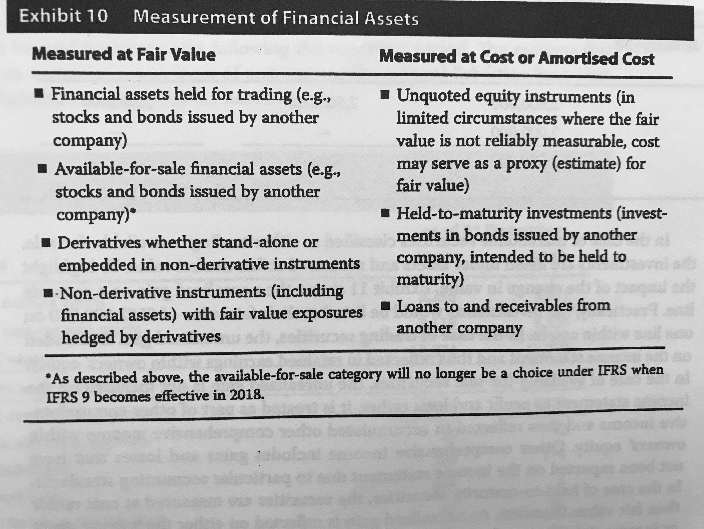

## 5. Non-Current Liabilities

5.1 Long Term Financial Liabilities: They can be loans and bonds payable. They are usually reported at amortized cost (so, for a bond, at maturity the value will equal its face value). When the liabilities are one held for trading, they are reported at fair value.

5.2 Deferred Tax Liabilities: Result due to the difference between the reported income and the taxable income. They are normally due to taxable temporary differences.

## 6. Equity

6.1 Components of Equity:

1. **Capital contributed by owners**: what owners contributed, common shares. Authorized shares are the ones that may be sold by the company, issued shares are the ones that have been sold and outstanding shares are the issued shares minus the treasury shares.
2. **Preferred shares**: these shares can be classified as liabilities (when they have mandatory redemption at a fixed amount) or as equity (like perpetual non-redeemable preferred shares). They have rights over common stockholders in terms of dividends and receipt of assets if the company is liquidated.
3. **Treasury shares**: shares that have been repurchased by the company which have not been cancelled. They can be sold again. Are non-voting and do not receive any dividends.
4. **Retained Earnings**: cumulative amount of earnings.
5. **Accumulated other comprehensive income**: cumulative amount of other comprehensive income.
6. **Non-controlling interest**: the interest of minority shareholders in the subsidiary that have been consolidated by the controlling company but are not wholly owned by the parent company.

6.2 Statement of Changes in Equity: IFRS requires the following information:

* Total comprehensive income of the period.
* Effects of any accounting changes that have retrospectively applied to previous periods.
* Capital transactions with owners and distributions.
* Reconciliation of the carrying amount of each component of equity.

US GAAP also require companies to provide and analysis of the changes.

## 7. Analysis of the Balance Sheet

7.1 Common-Size Analysis of the Balance Sheet: Involves stating each item of the balance sheet item as a percentage of the total assets. It helps comparing different sized companies. It also helps to take a fast look at the capital structure of the company (long-term financing).

7.2 Balance Sheet Ratios: Are the ones that only involve items of the Balance Sheet. When making cross-sectional analysis, it is important to look up for differences in accounting standards.

# Reading 26: Understanding Cash Flow Statements

## 2. Components and Format of the Cash Flow Statement

2.1 Classification of Cash Flows and Non-Cash Activities: Classifications of activities according to the IFRS and the US GAAP:

* **Operating Activities**: day-to-day activities to create revenue. This include payments for inventory, salaries, taxes and other operating expenses. Dealing or trading securities receipts and payments are also included.
* **Investing Activities**: relates to purchasing and selling long term assets. It also includes investments in equity or debt from other companies both long and short term when they are not considered cash equivalents and are not held simply for trading purposes.
* **Financing Activities**: repaying or obtaining equity or long-term debt. Stock repurchase and issuing, debt payments and issuing are financing activities. Accounts payable is not a financing activity, is operating.

Under IFRS, interest and dividend payment and receipts may be either financing or operating activities, depending on the nature. In US GAAP, interest paid and received and dividends received are reported as operating activities. Dividends payed, however, are considered financing activities.

2.2 A Summary of Differences between IFRS and US GAAP:

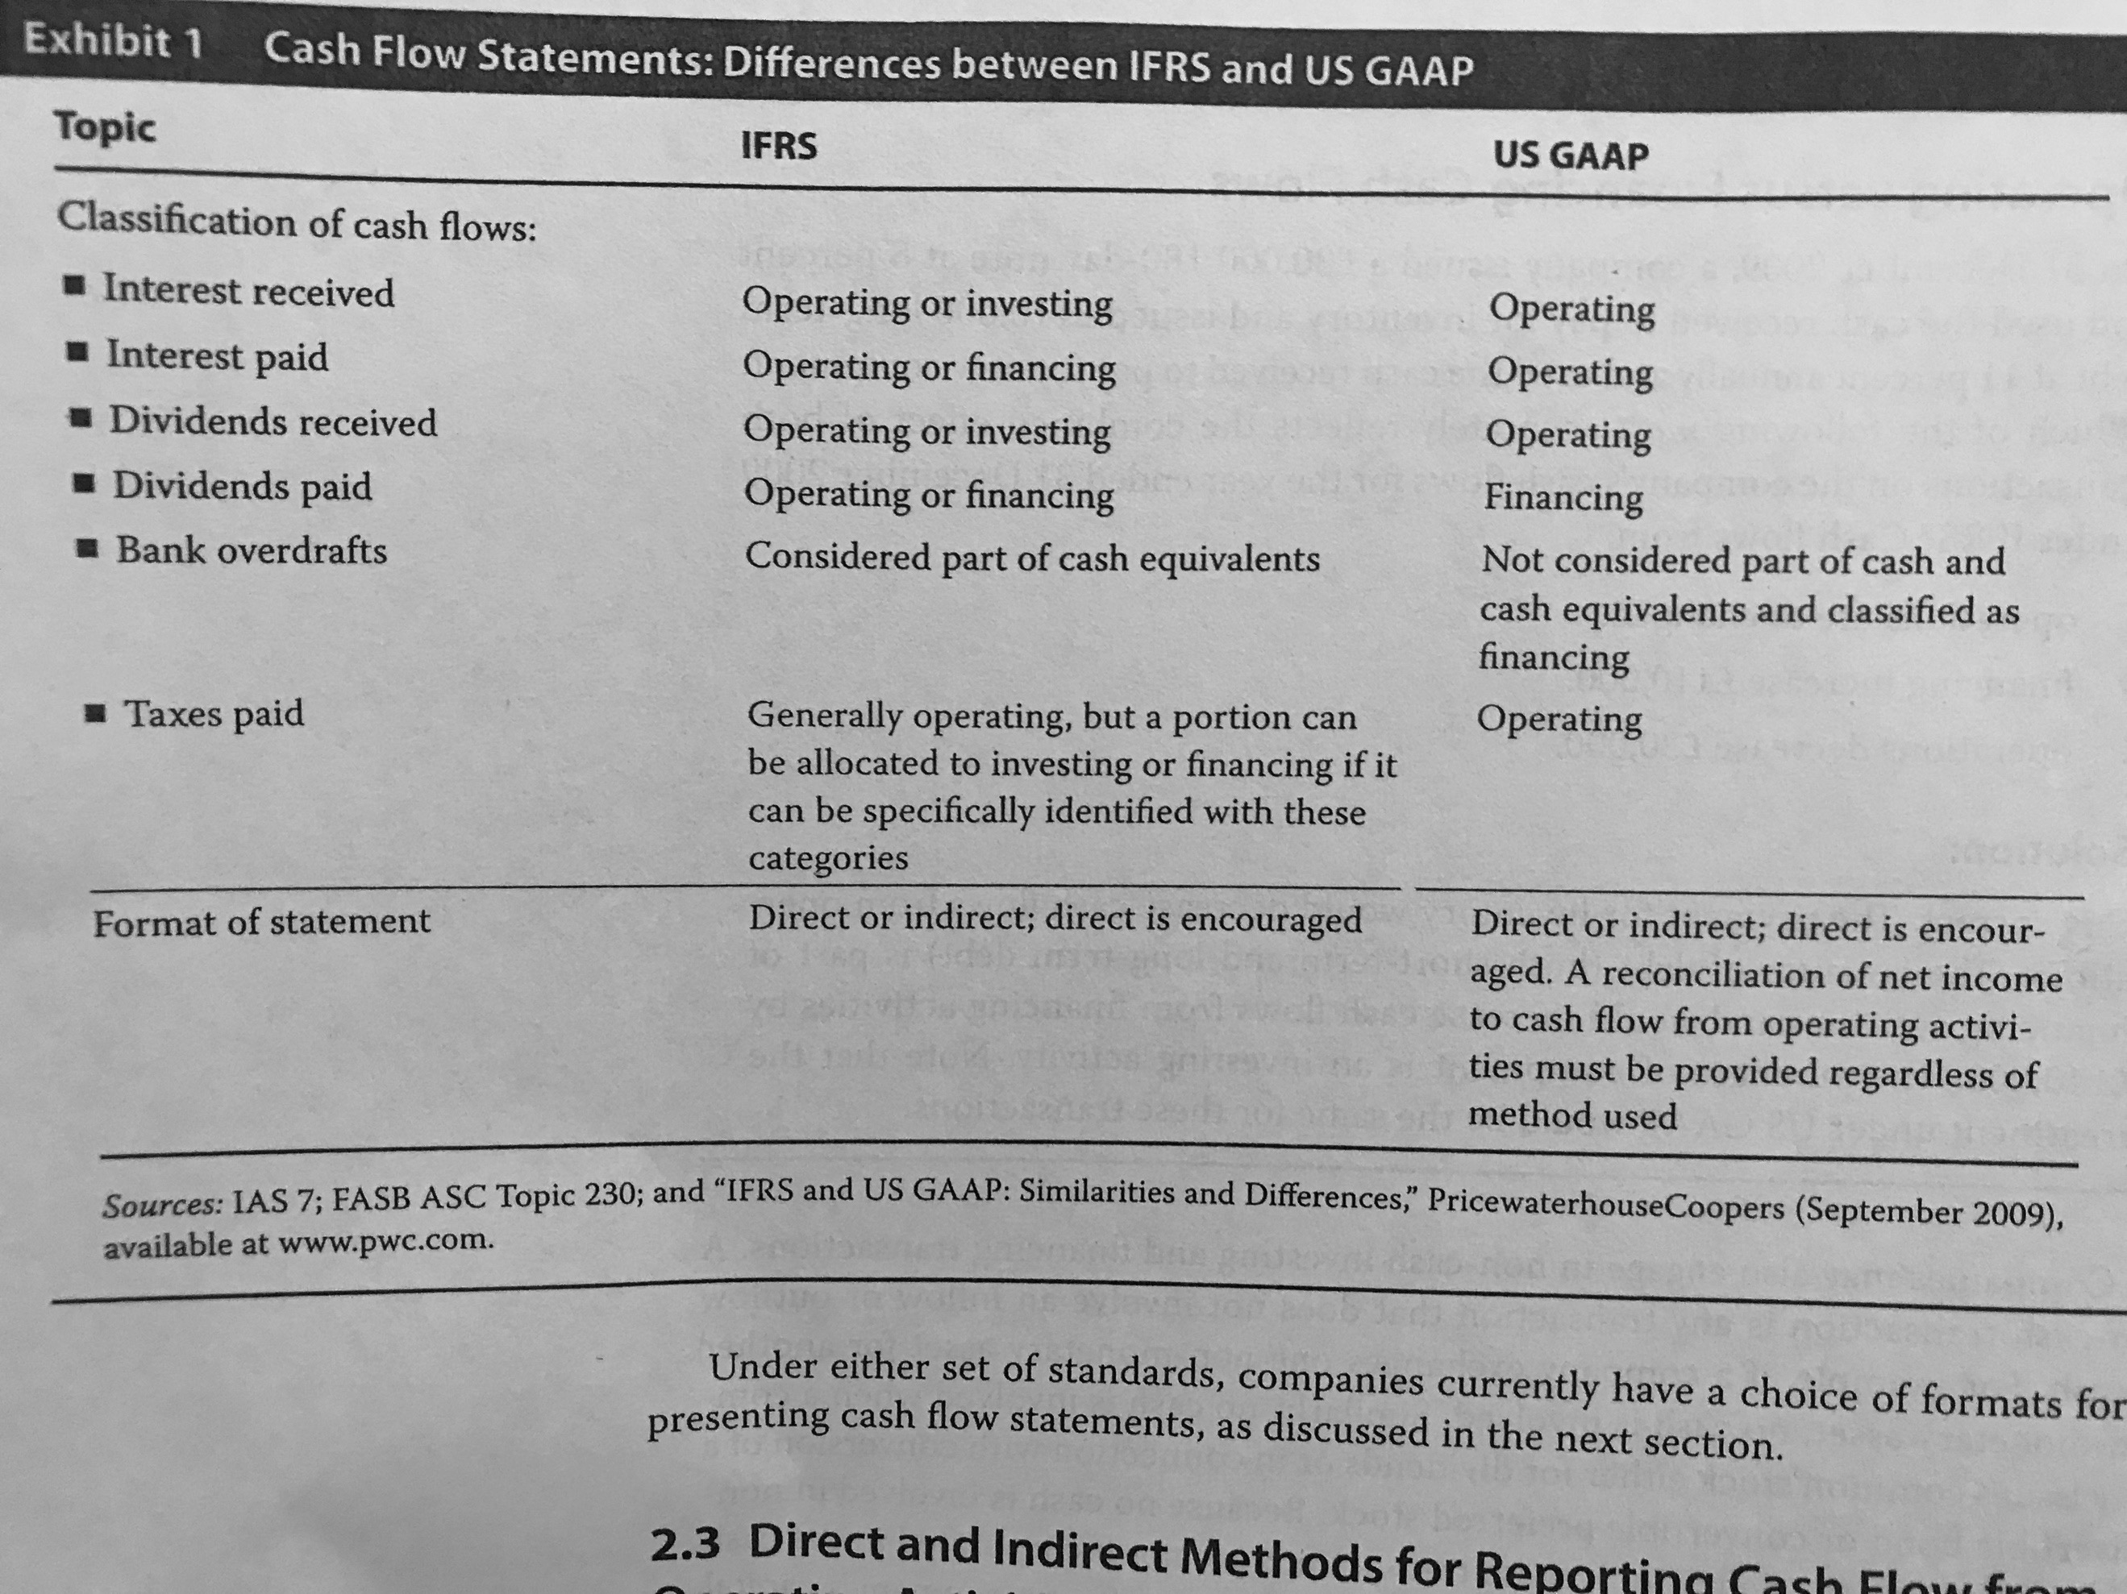

2.3 Direct and Indirect Methods for Reporting Cash Flow from Operating Activities:

* **Direct method:** Show the specific cash movements for operating activities. Here, the user gets more information than in the indirect method as specific information of cash receipts and disbursements is presented.
* **Indirect methods:** Out of a series of adjustments to the net income, the net cash flow from operating activities.

Both the IFRS and the US GAAP encourage to use the direct method over the indirect. However, the US GAAP requires a reconciliation of the net cash flow out from the net income (which is the indirect method).

2.3.1 An Indirect-Format Cash Flow Statement Prepared under IFRS:

2.3.2 A Direct-Format Cash Flow Statement Prepared under IFRS:

2.3.3 Illustration of Cash Flow Statements Prepared under US GAAP: When using the indirect method. The company must disclose how much cash was paid for interest and income taxes.

## 3. The Cash Flow Statement: Linkages and Preparation

3.1 Linkages of the Cash Flow Statement with the Income Statement and Balance Sheet: Cash flow ending balance is explained by the movements of the cash flow statement.

3.2 Steps in preparing the Cash Flow Statement:

3.2.1 Operating Activities: Direct Method:

3.2.1.1 Cash Received from Costumers: To determine an estimation of this value, revenues can be adjusted by subtracting the net change in receivables.

3.2.1.2 Cash Paid to Suppliers: To calculate it, the COGS are adjusted by adding the change in inventories and subtracting the change of the accounts payable.

3.2.1.3 Cash Paid to Employees: Salary and wages expense need to be adjusted by the change of the account of salary and wages payable, subtracting its changes.

3.2.1.4 Cash Paid for Other Operating Expenses: The adjustments are made by adding the change in prepaid expenses and subtracting the change of other accrued liabilities.

3.2.1.5 Cash Paid for Interest: (They need to be included in the operating cash flows under US GAAP. IFRS allows the company to determine it). Interest expense must be adjusted by subtracting the net change of interest payable.

3.2.1.6 Cash Paid for Income Taxes: The adjustment needs to be, income tax expense adding the net changes in taxes receivables and subtracting changes in tax payable.

3.2.2 Investing Activities: In order to determine the changes, it is important to determine if there were assets bought or sold. To do this, the notes need to be checked and the

3.2.3 Financing Activities:

3.2.3.1 Long Term Debt and Common Stock: A decrease in long term debt implies a disbursement such as a decrease in common stock.

3.2.3.2 Dividends: Dividend paid present a cash disbursement and can be calculated from the formula:

$$Beg. Ret. Earnings+Net Income-Dividends=End. Ret. Earnings$$

3.2.4 Overall Statement of Cash Flows: Direct Method: After adding all of the net cash used for every set of activities, the net increase or decrease of cash of the period can be added to the beginning cash balance to get to the ending balance.

3.2.5 Overall Statement of Cash Flows: Indirect Method: To perform the adjustment of the net income, non-operating activities (like selling an asset, among others), non-cash expenses (depreciation for instance) and changes in working capital (subtracting an increase in current operating assets and adding an increase in current operating liabilities) items help to get to the net change in operating cash flow.

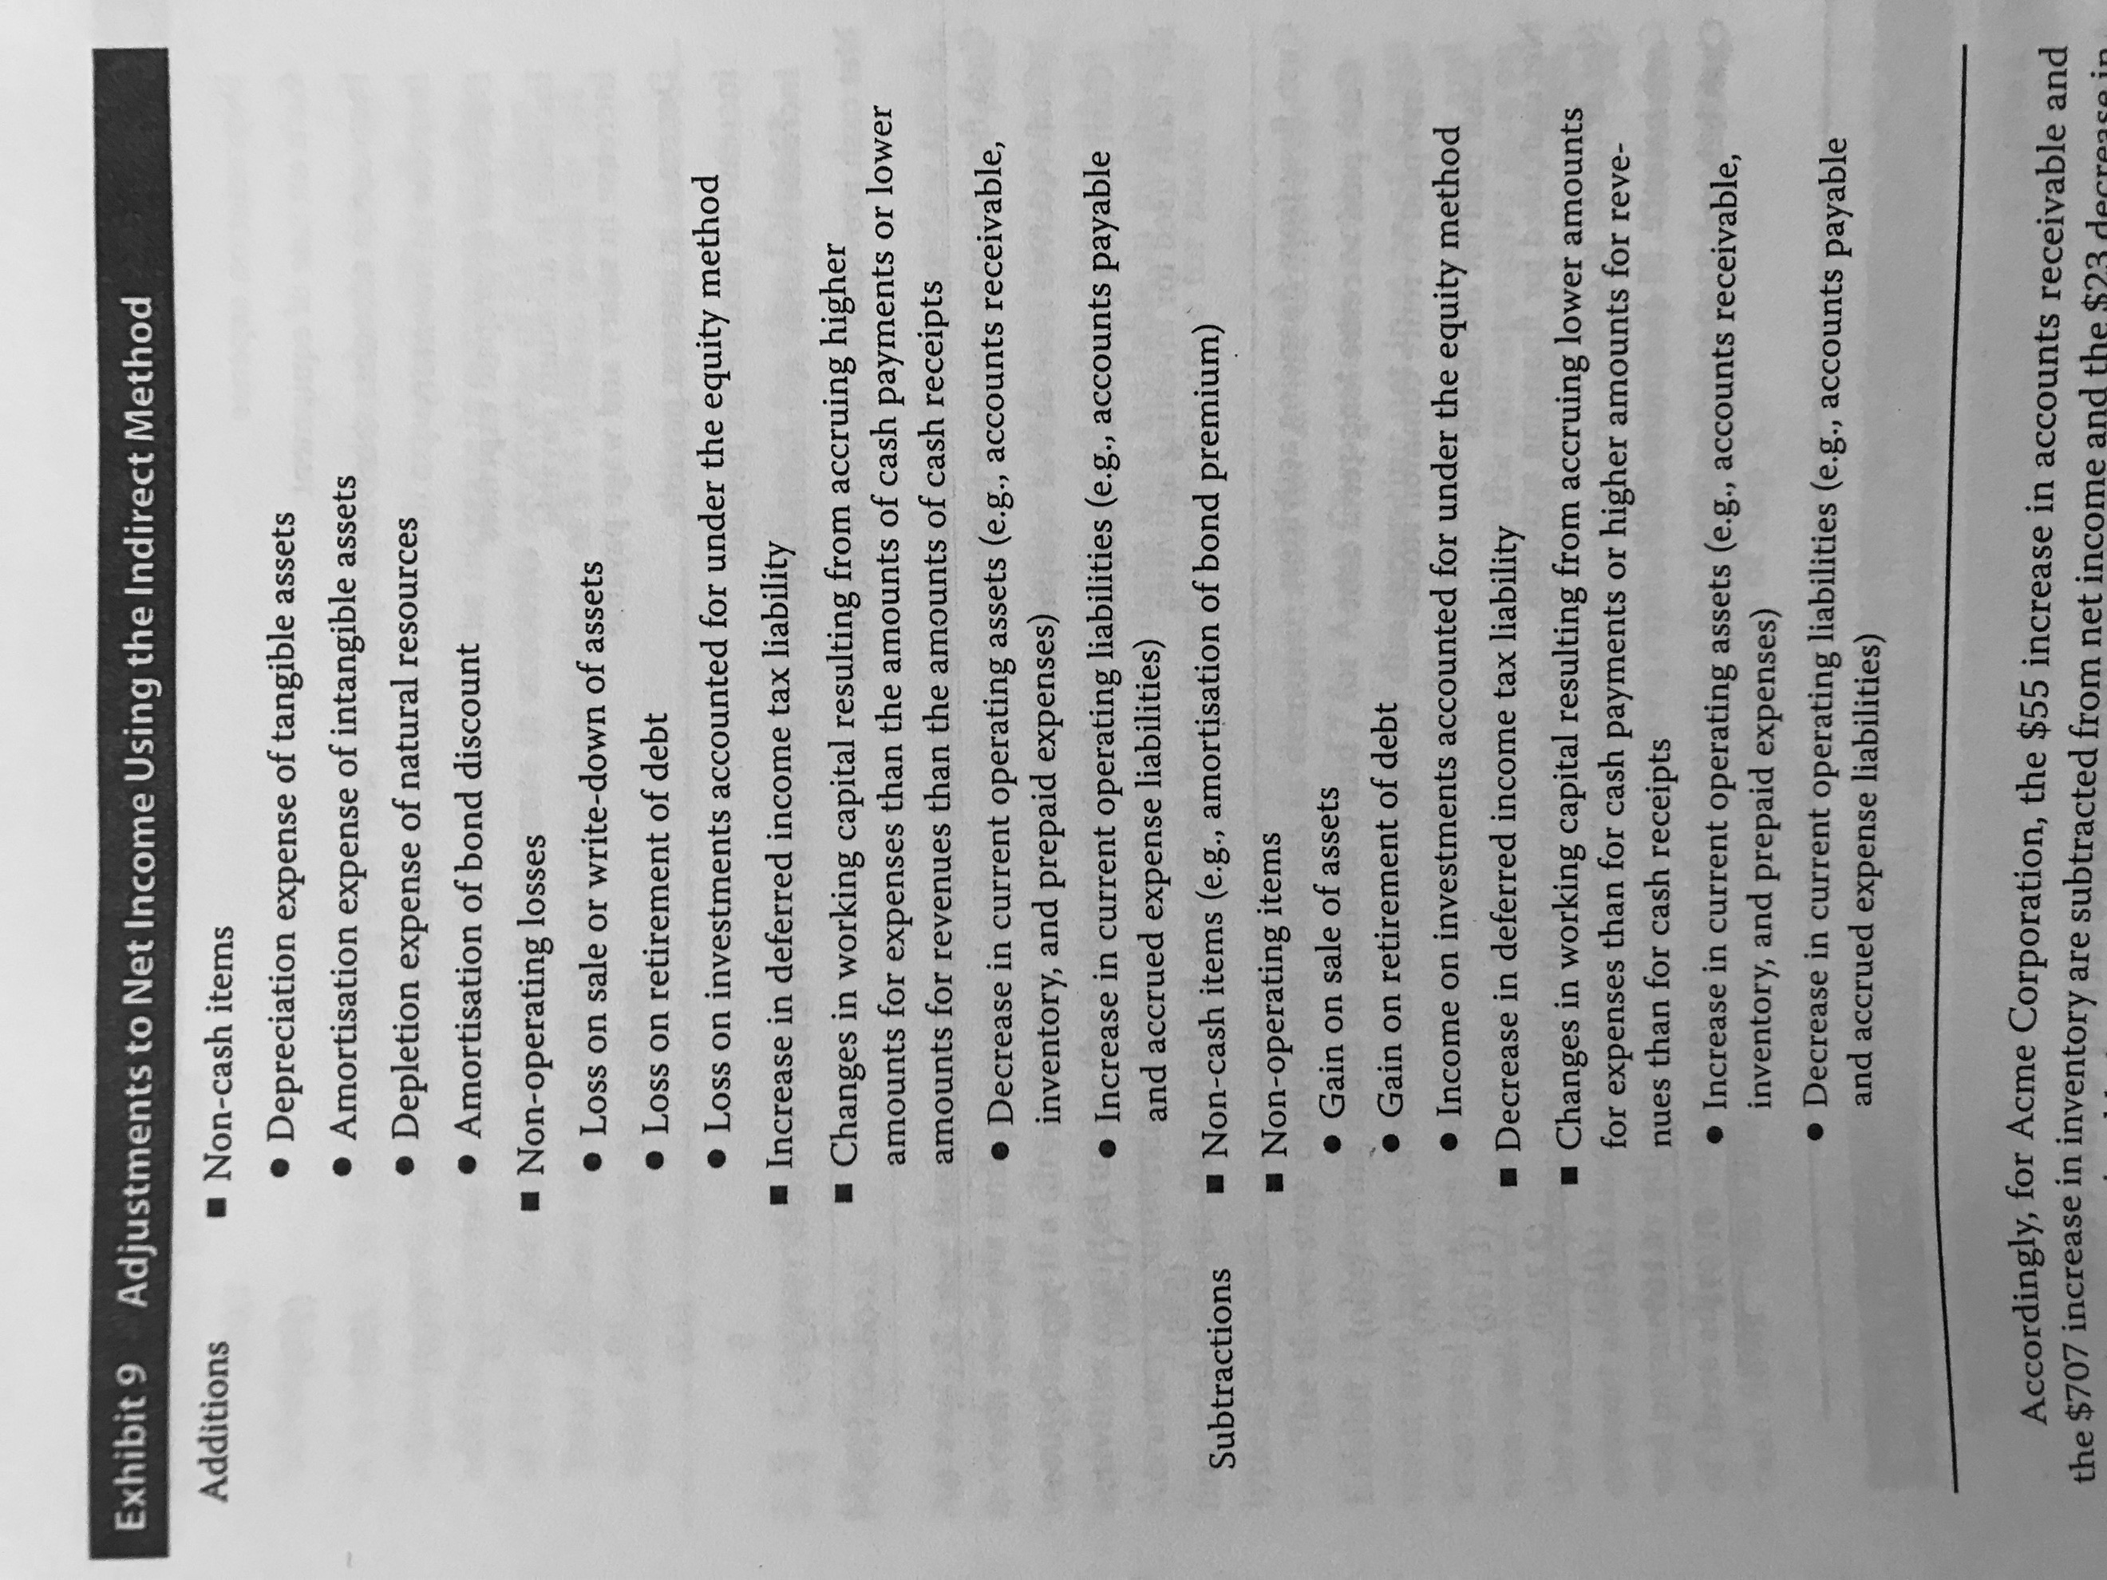

3.3 Conversion of Cash Flows from the Indirect to the Direct Method: The steps to make an estimate of the direct method from the indirect method are:

1. Disaggregate the net income into total revenue and total expenses.
2. Remove any non-operating and non-cash items.
3. Convert accrual amounts of revenues and expenses to cash flow amounts and receipts and payments by adjusting for changes in working capital accounts.

## 4. Cash Flow Statement Analysis

4.1 Evaluation of the Sources and Uses of Cash: The assessment involves four steps:

1. **Evaluating where the major sources and uses of cash are between the different categories:**

It is expected, in a mature company, that operating activities are the major source of cash flow. It should be positive and sufficient to cover capital expenditures.

1. **Evaluate the primary determinants of operating cash flow:**

It is useful to compare operating cash flow and net income. If the company is mature, the operating cash flow should exceed the net income, it is a sign of earnings quality. Also, consistency of cash flows should be checked.

1. **Evaluate the primary determinants of investing cash flow:**

It is important to consider where is the money coming from to finance investment activities. Also, it is important to look at purchases and sells of assets to evaluate their impact in the company.

1. **Evaluate the primary determinants of financing cash flow:**

Look for the nature of the financing items as well as to determine if the company is repaying capital or raising it.

4.2 Common-Size Analysis of the Statement of Cash Flows: There are two ways to perform it, the first one is expressing each inflow (outflow) as a percentage of total inflows (outflows) or, the second one, will be by presenting every item as a percentage of the total revenue. IN THE INDIRECT METHOD, HOW DOES IT WORK??

4.3 Free Cash Flow to the Firm and Free Cash Flow to Equity: Free cash flow is the excess of cash flow over capital expenditures. FCF to the firm is the flow available to suppliers of debt and capital:

$$FCF to the Firm=NI+Dep+Int \left(1-t\right)-CAPEX-NWC$$

$$FCF to the Firm=CFO+Int \left(1-t\right)-CAPEX$$

FCF to equity is the cash available for owner and is expressed like this:

$$FCF to Equity=CFO-CAPEX+Net Borrowing$$

$$FCF to Equity=CFO-CAPEX-Net Debt Repayment$$

4.4 Cash Flow Ratios:

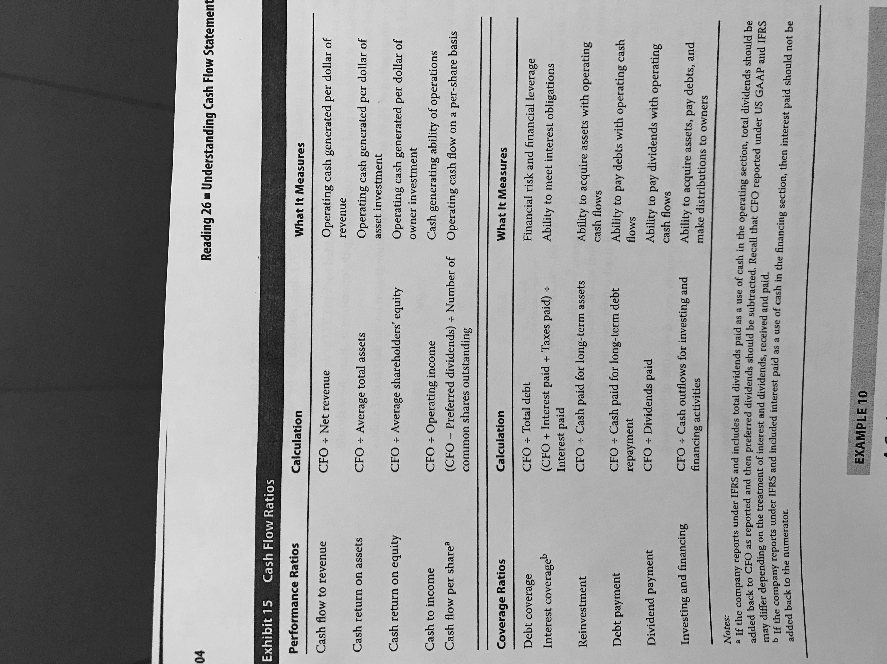

# Reading 27: Financial Analysis Techniques

## 2. The Financial Analysis Process

2.1 The Objectives of the Financial Analysis Process: In order to start a financial analysis process, the analyst must clarify the purpose and context of the study by answering the following:

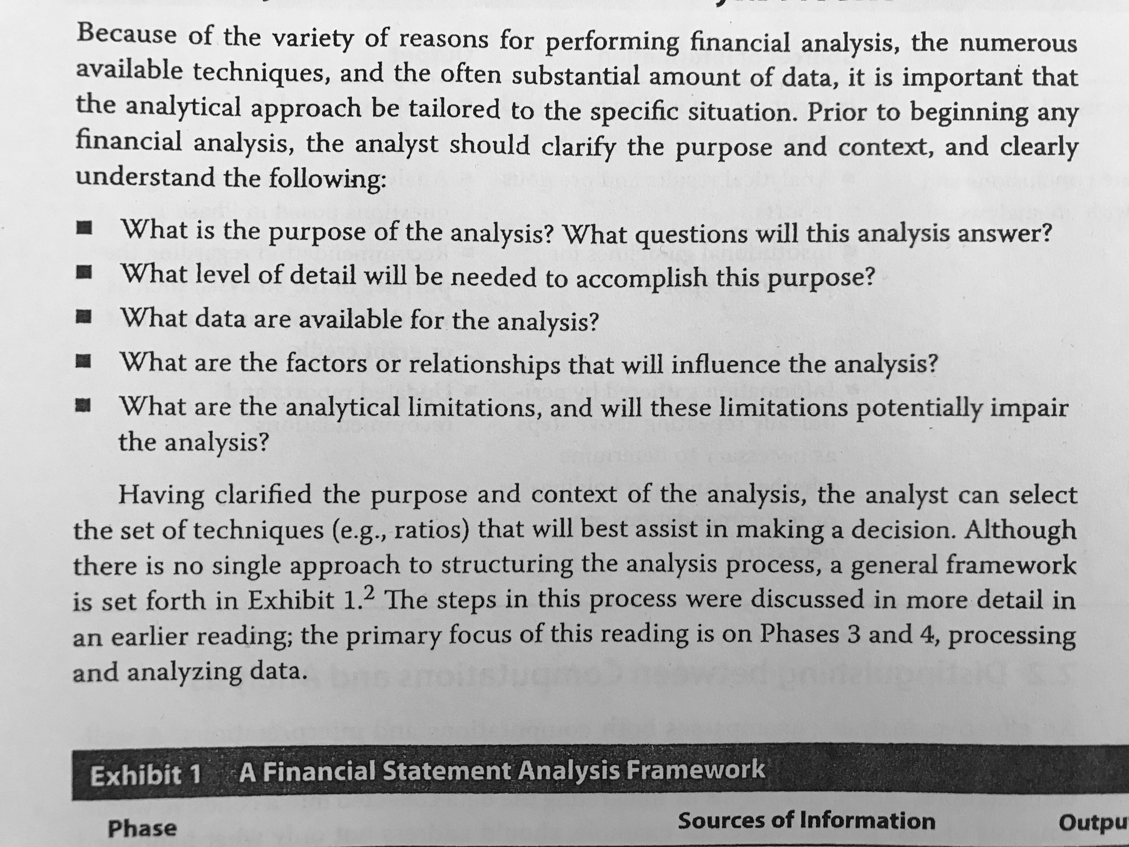

The steps in performing the analysis are (as seen in a past reading):

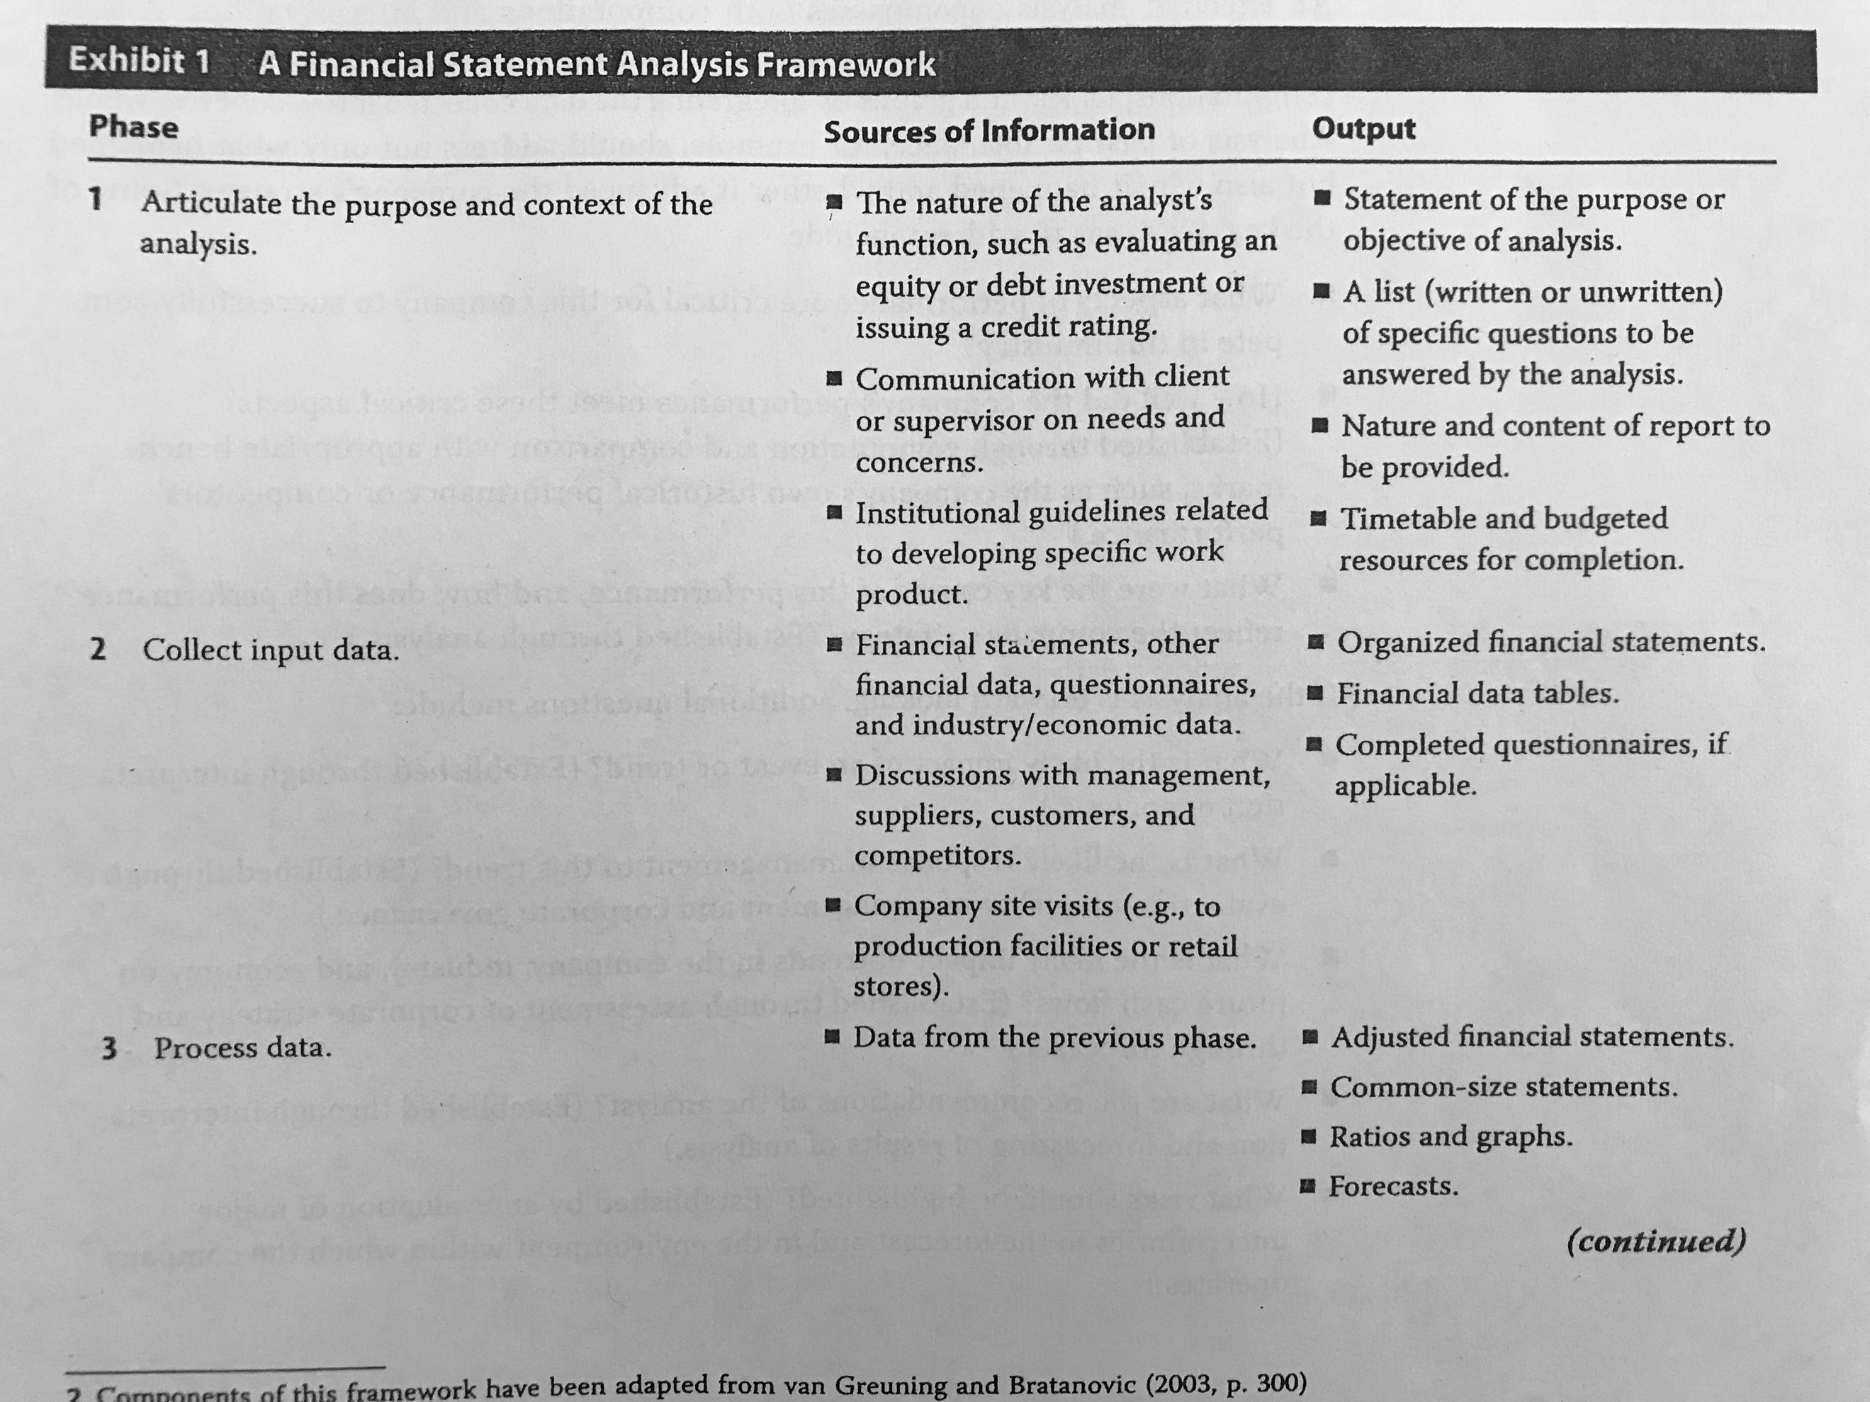

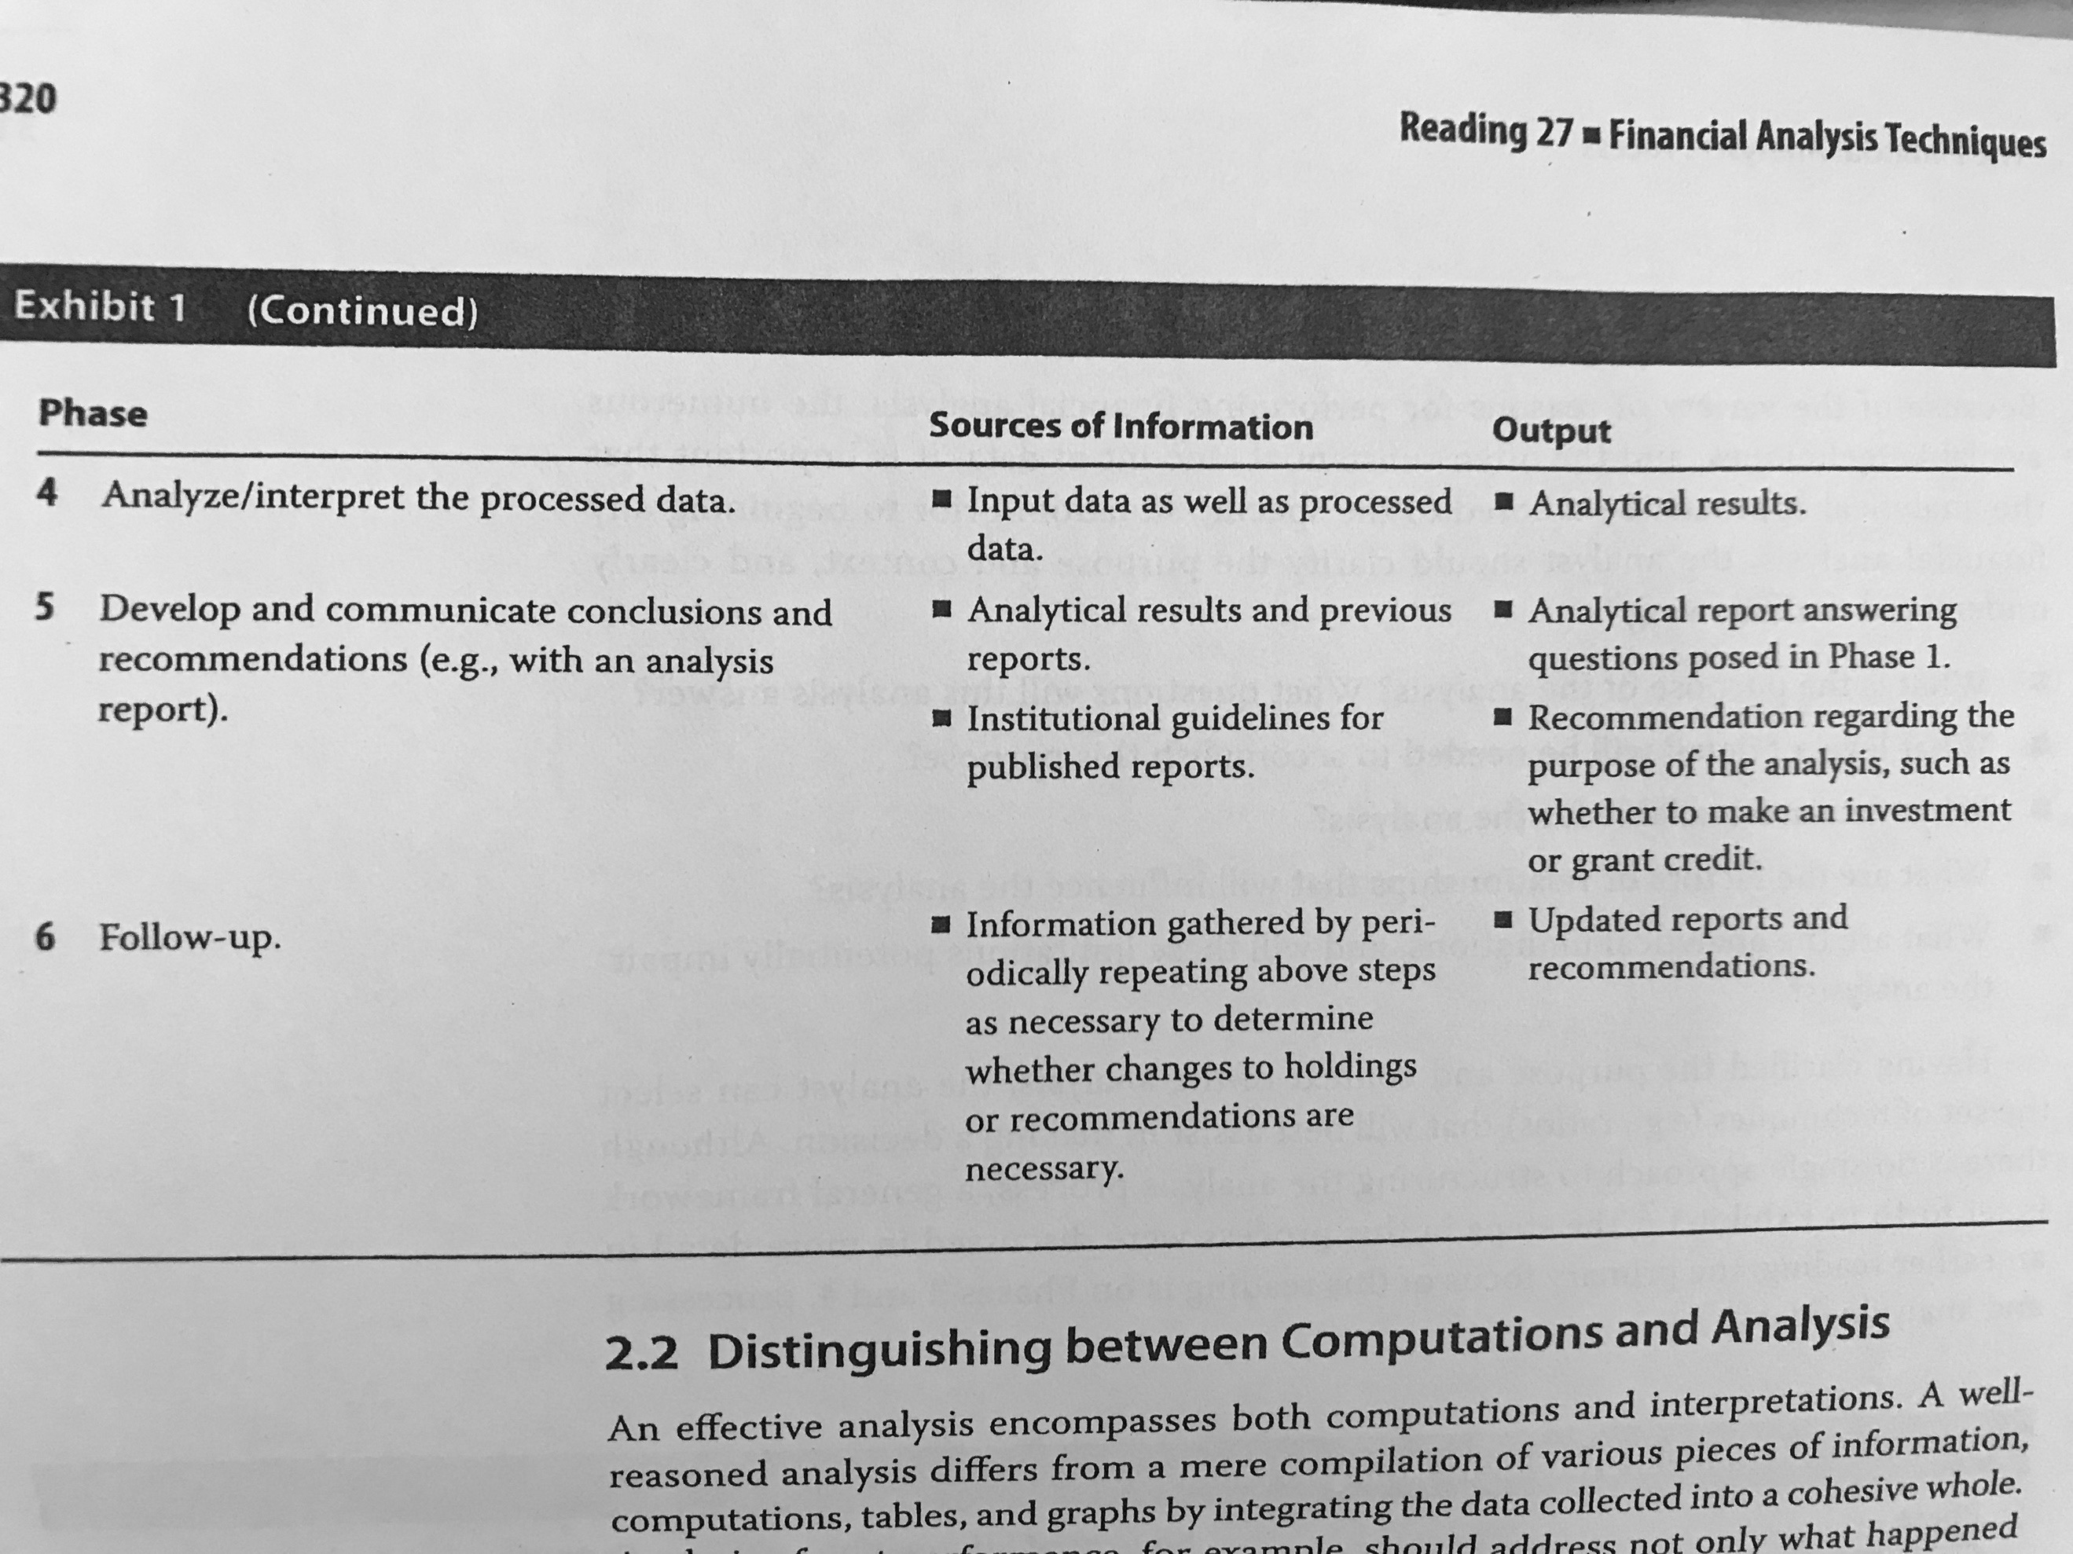

2.2 Distinguish between Computations and Analysis: Some of the questions that must be answer are:

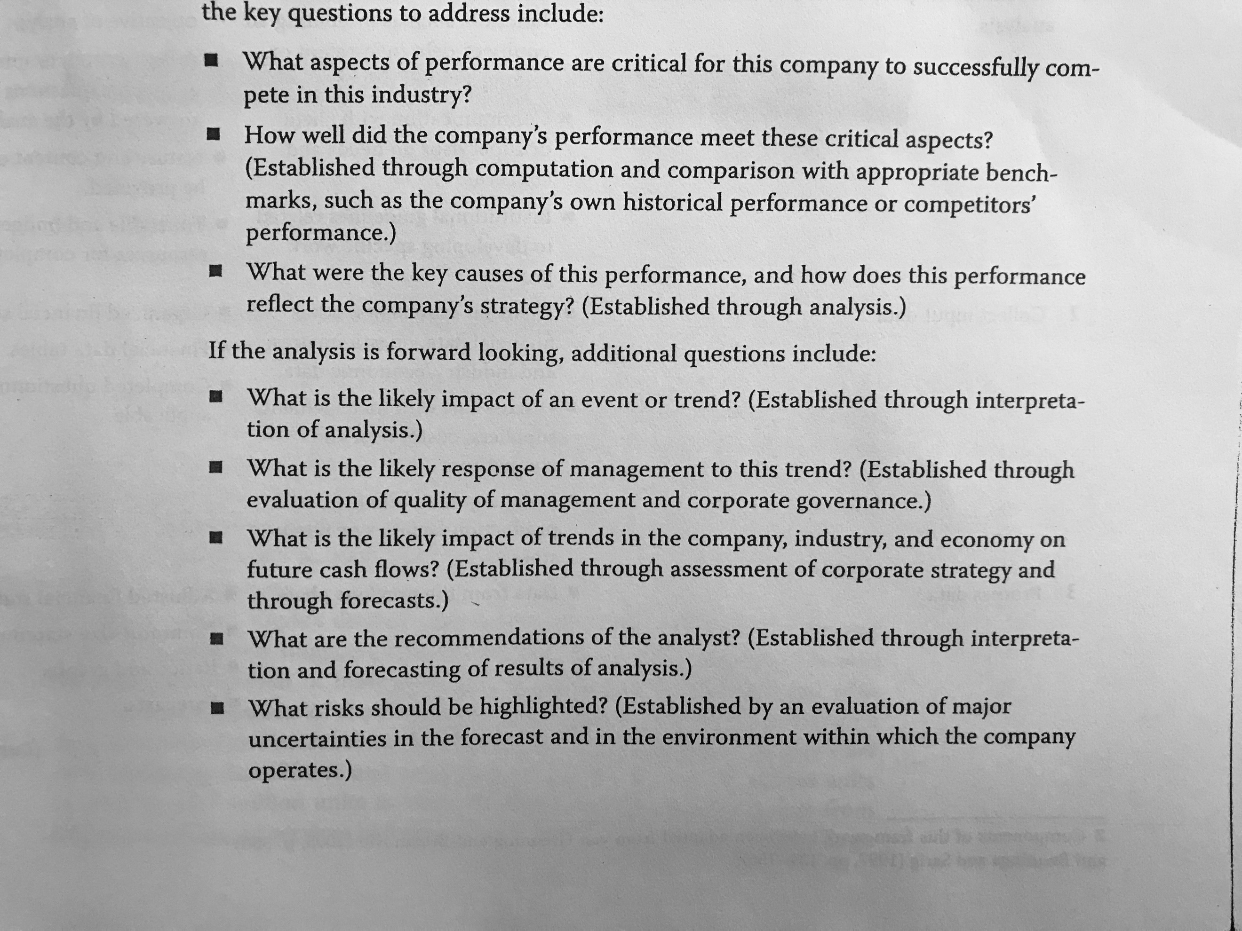

So, an analyst must understand the “why” of things, not only compute things for the sake of doing it. If the findings must be reported, the report could follow a structure similar to this one:

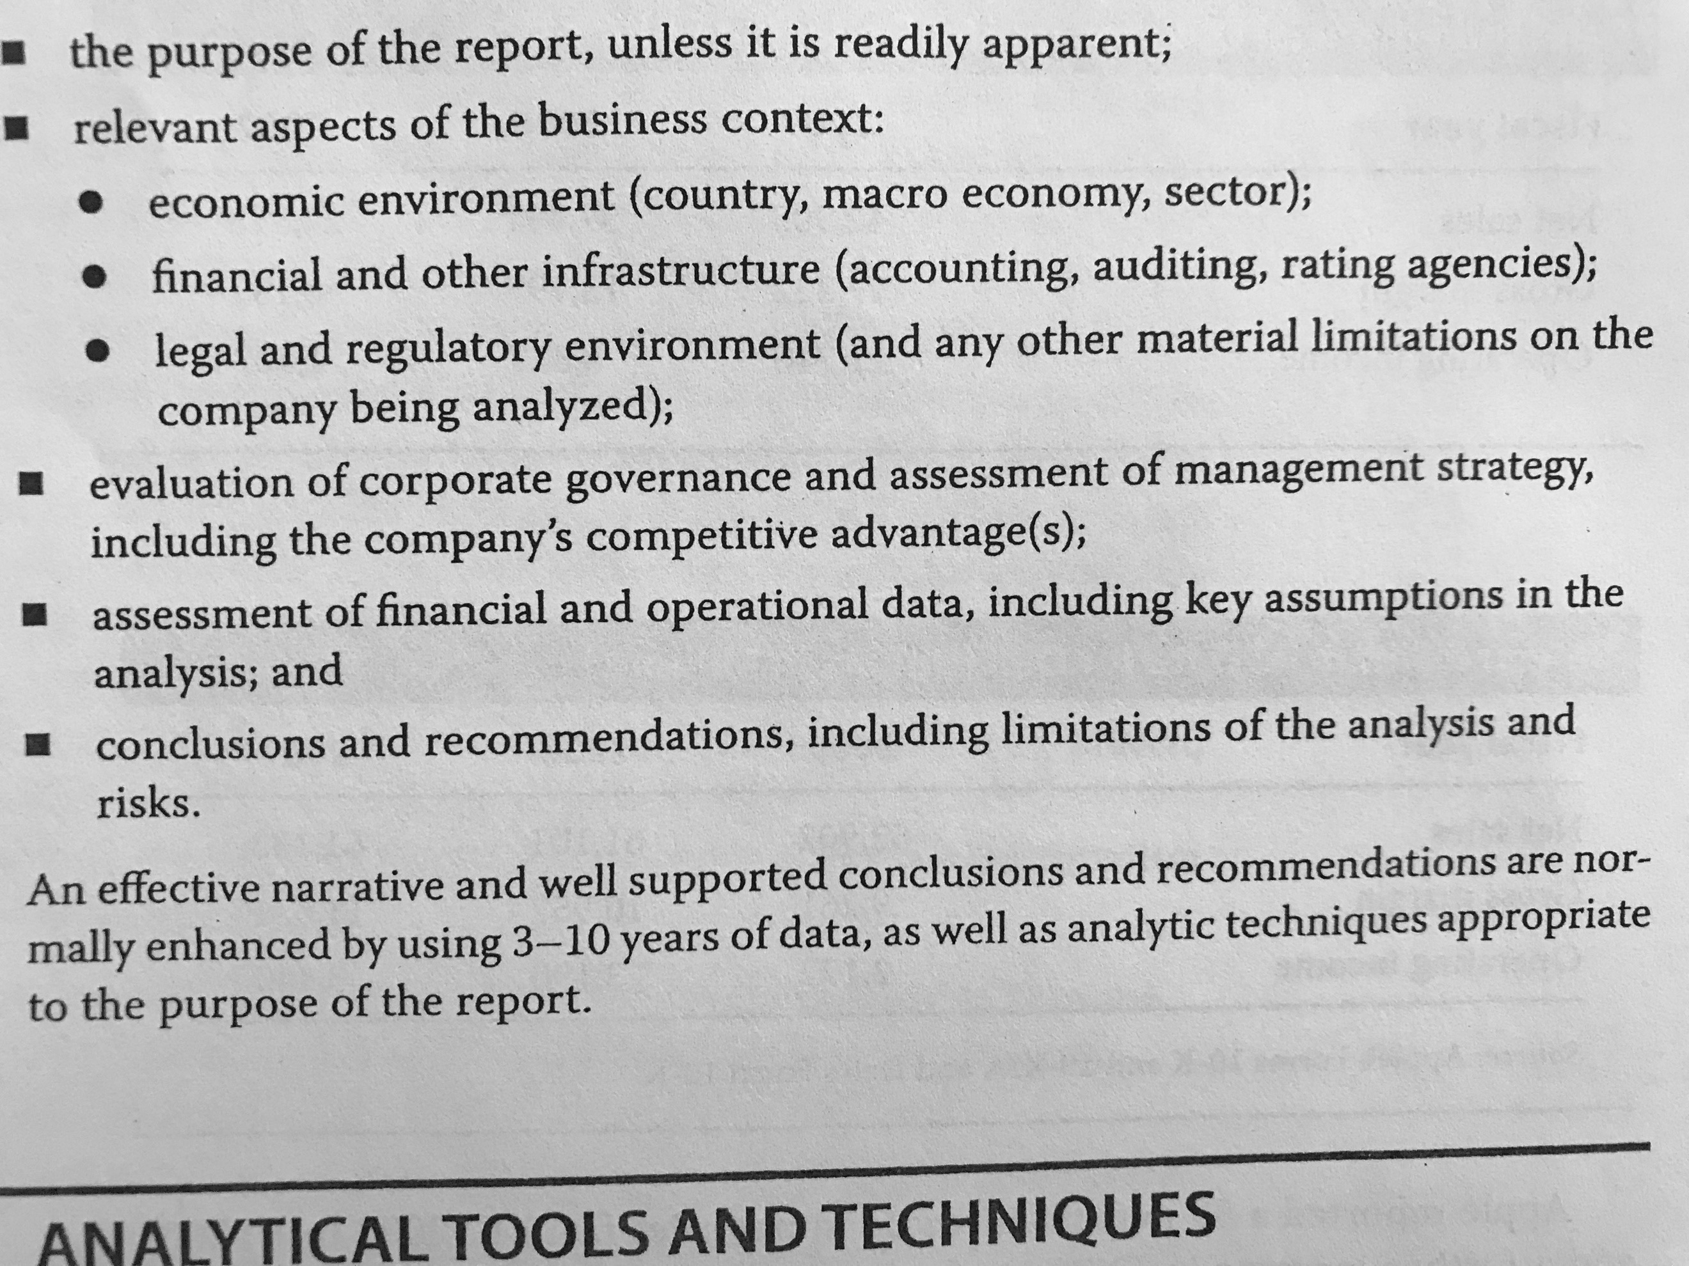

## 3. Analytical Tools and Techniques

3.1 Ratios: It is important to bear in mind that the ratio by itself is not likely to answer any valuable question. Further investigation will define why the ratio is how it is (which is what the analyst should be looking for).

3.1.1 The Universe of Ratios: There are many ratios so, when facing a ratio for the first time, the formula needs to be studied and understand in order to establish what is the ratio explaining.

A good rule of thumb is that when the numerator comes from the income statement and the denominator comes from the balance sheet, then the denominator should show the average of the period.

3.1.2 Value, Purposes and Limitations of Ratio Analysis: It enables the analyst to evaluate past performance, asses the current financial position and gain insights useful for projecting future results.

Some of the limitations of ratio analysis, however, include:

* The heterogeneity or homogeneity of a company’s operating activities.
* The need to determine whether the results of the ratio analysis are consistent.
* The need to use judgement.
* The use of alternative accounting methods.

3.1.3 Sources of Ratios: As the analysis depends of judgement, analysts should be aware of checking how were the ratios calculated (to check if there is any need for adjustment) and try to use the same source of data when conducting an analysis (so that the data is as consistent as possible).

3.2 Common-Size Analysis: Involves expressing all the lines of the income statement using as a base a single item.

3.2.1 Common-Size Analysis of the Balance Sheet: It can also be made in a horizontal basis comparing the compositions from period to period and finding the causes of these changes.

3.2.2 Common-Size Analysis of the Income Statement: In the case of financial institutions, the base used can be the total assets.

3.2.3 Cross-Sectional Analysis: Also called relative analysis, compares ratios or items of a company with the one of another company (or group of companies).

3.2.4 Trend Analysis: In order to look at trends, it is important to take into consideration macroeconomic effects that might be distorting these trends. This helps to develop expectations.

The Horizontal Common-Size consists in expressing the history of an item based on a specific period of that item (which will then be equal to one). The horizontal Common-Size can also refer to the “normal” horizontal analysis.

3.2.5 Relationships among Financial Statements:

3.3 The Use of Graphs as an Analytical Tool: Are useful because it highlights changes visually. It is also useful when dropping conclusions of the analysis.

3.4 Regression Analysis: Stablishing relationships between variables of the company with other internal or external variables is useful to understand the actual and the possible future behavior of the business.

## 4. Common Ratios Used in Financial Analysis

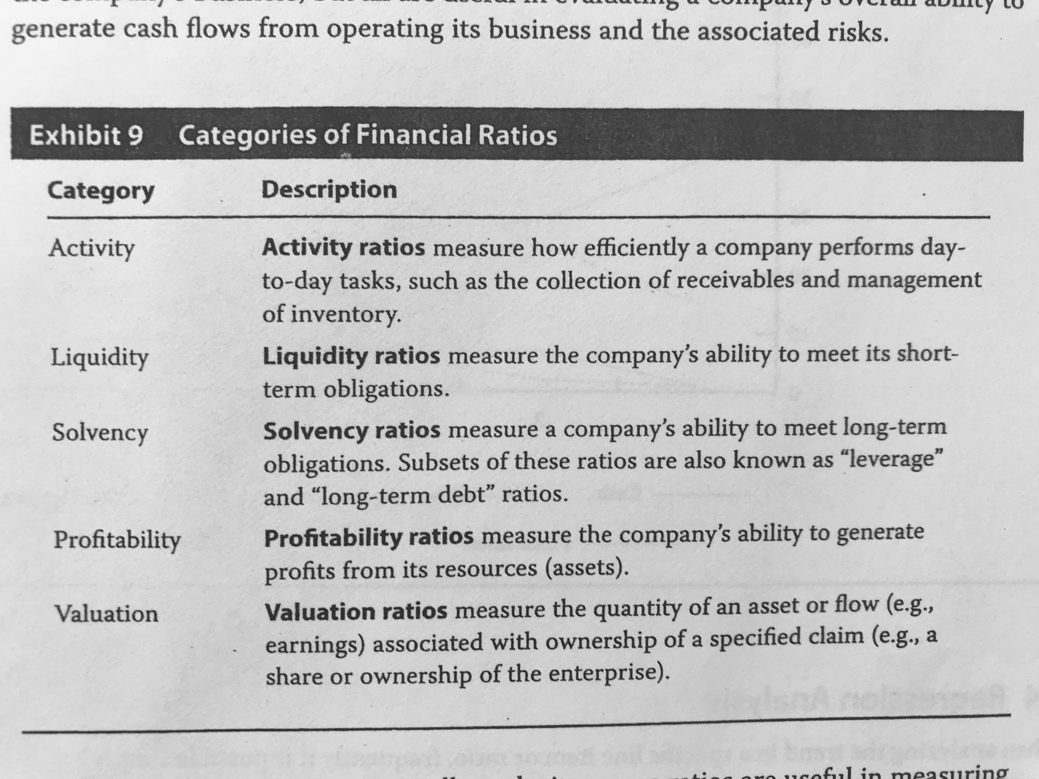

4.1 Interpretation and Context: Ratios need to be analyzed in a trend and a cross-sectional basis evaluated based on the following:

* **Company goals and strategy:** Ratios can be used to evaluate if the objectives of the company are being met and if they go with the strategy of the company.
* **Industry norms:** Stablishing comparisons with other companies of the industry.
* **Economic conditions:** Considering this aspect is especially important in cyclical companies.

4.2 Activity Ratios: Are also known as asset utilization ratios or operating efficiency ratios. This category of ratios tries to determine how efficiently are assets managed.

4.2.1 Calculation of Activity Ratios:

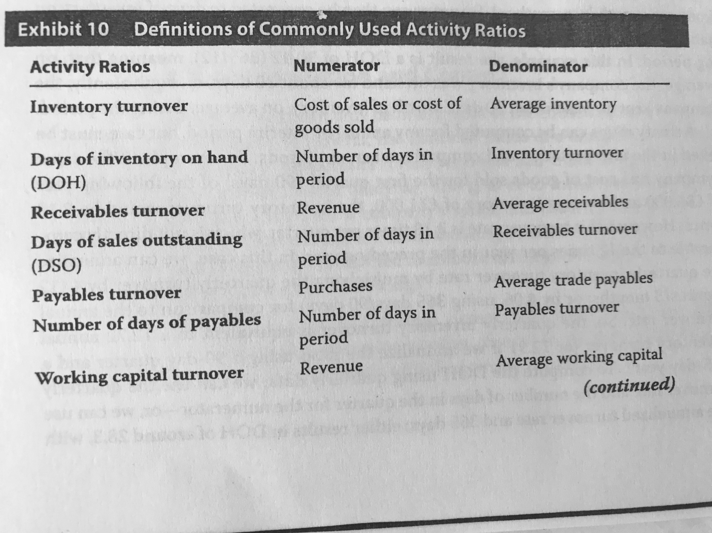

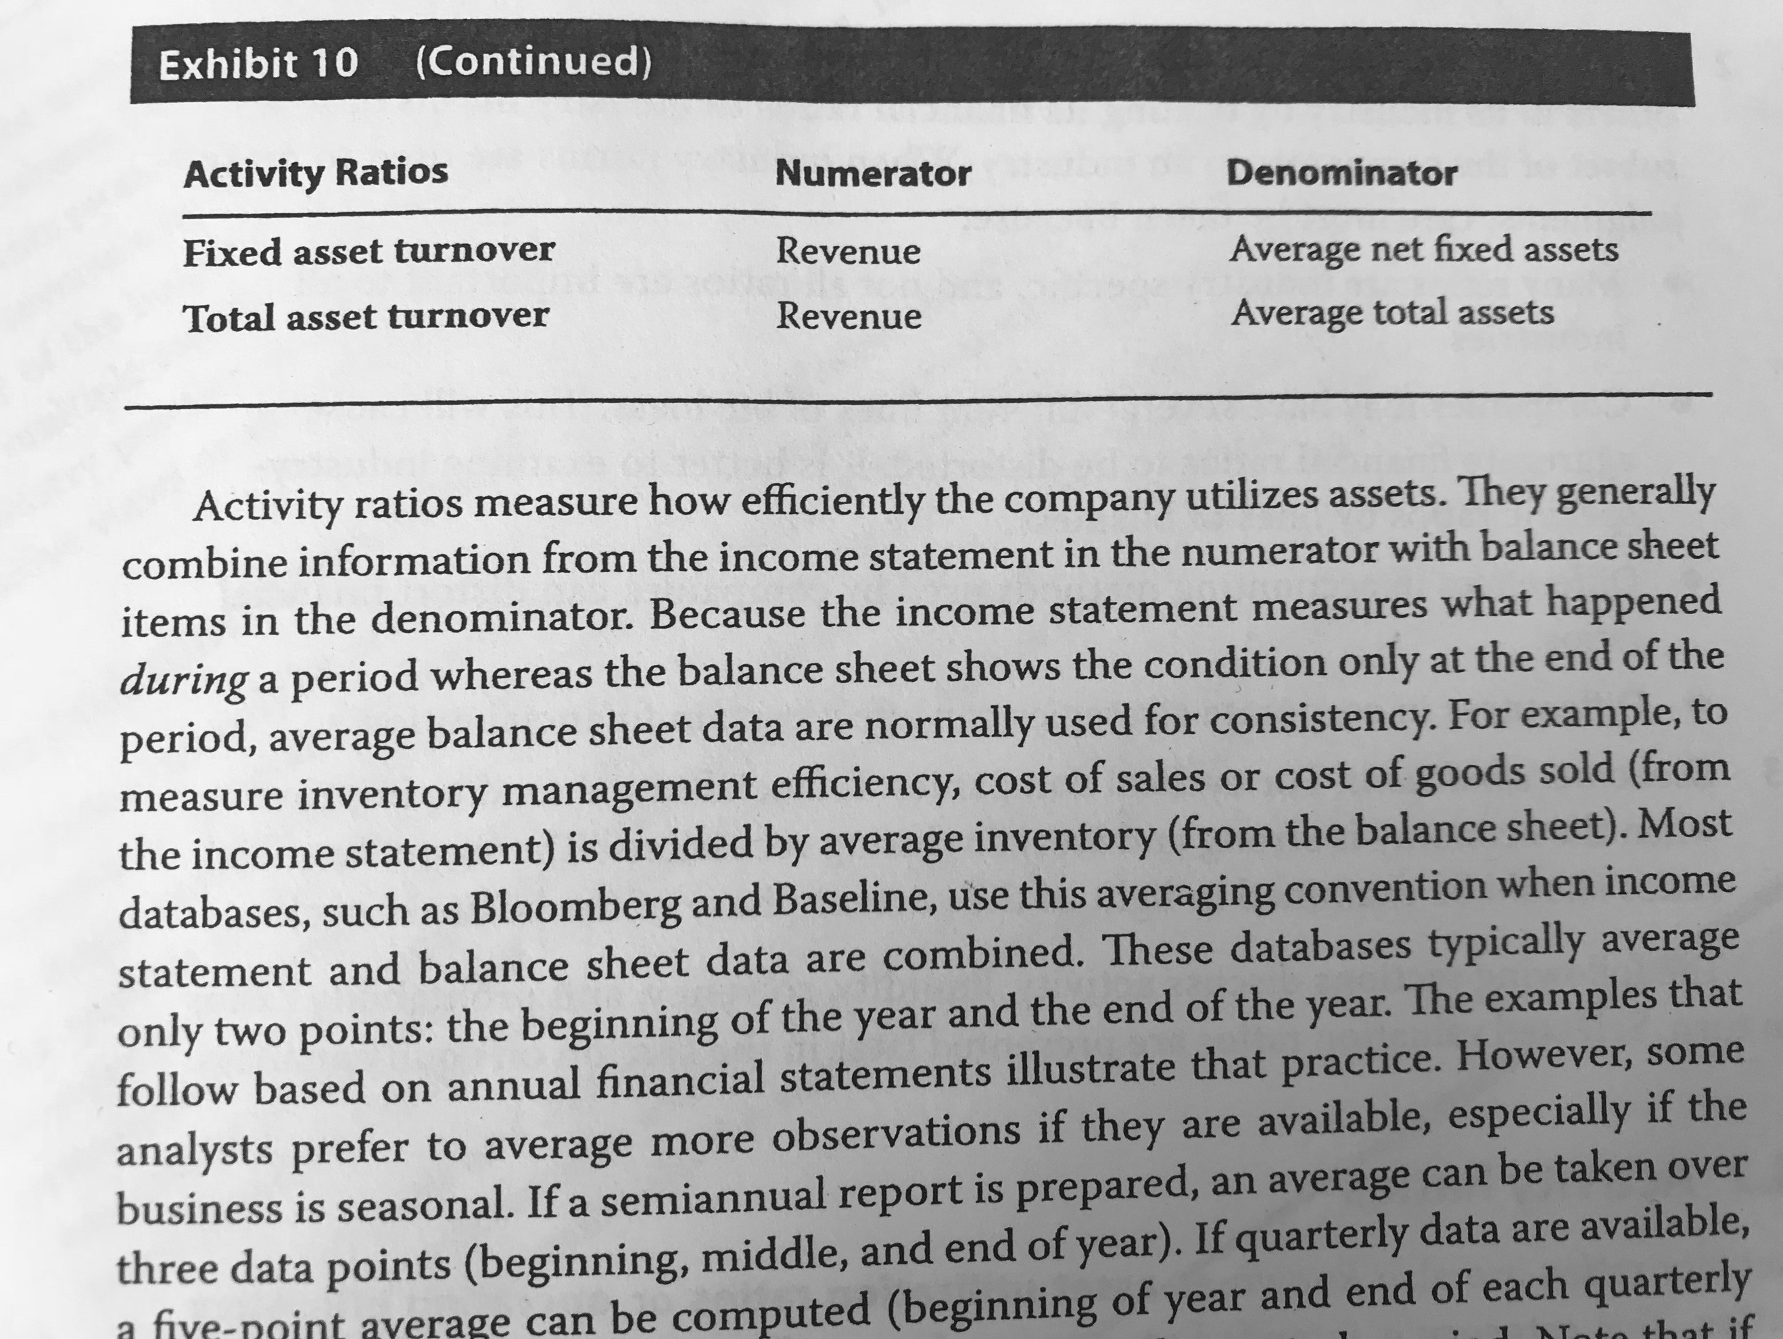

*When using an average for the balance sheet accounts, the analyst can use more than just the starting and the ending point of the information.

**Inventory turnover:** It measures how many times the inventory was sold in the year. It can be turned into days by dividing the length of the analyzed period in days between the ratio.

*Whenever the analyst wants to determine the number of days of inventory on hand at the end of the year, the end of year inventory should be used.

4.2.2 Interpretation of Activity Ratios:

* **Inventory turnover and DOH:** A high inventory turnover shows a more efficient inventory management or might be that the quantity of inventory is too low for the business. To understand what is happening, the analyst should always look at the revenues growth (if they are growing and inventory turnover is higher, then it means that the company is managing its inventory well).
* **Receivables turnover an DSO:** If the numerator is limited to the sales made on credit, it would be more appropriate. A high turnover could mean that the company is efficient collecting cash or, it could also mean that its credit policies are way too tight. Again, looking at the sales growth, could solve the issue of not knowing which case is the one of the company.
* **Payables turnover and days of payables:** Again, if the numerator could only use the purchases made using credit the ratio will be more reliable. Purchases are then simply calculated as COGS - Beg. Inv. + End. Inv. When this ratio is high, it could mean that the company is not making a good use of the credit facilities, unless the company is taking advantage of early payment discounts. If it is really low, it could indicate good use of the supplier credit terms, unless it is due to problems making payments. However, if liquidity shows that the company can meet its short-term obligations, then it can be concluded that the company is using credit facilities wisely.
* **Working capital turnover:** It shows how efficient is the company’s working capital management in term of generating revenue. When it is lower than one, it is quite difficult to interpret.
* **Fixed asset turnover:** Efficiency in terms of handling fixed assets. Whenever a company is in its early stages, this ratio might be low as its assets are not being fully used. This ratio is not always as reliable as changes in fixed assets, does not immediately reflect changes in revenue. Also, depreciation affects this ratio.
* **Total asset turnover:** It shows the efficiency of all of the assets. The thing is that it can be distorted by inefficiencies on a specific set of assets.

4.3 Liquidity Ratios: Liquidity measures how quickly are assets converted to cash and the ability to pay short-term obligations.

4.3.1 Calculation of Liquidity Ratios:

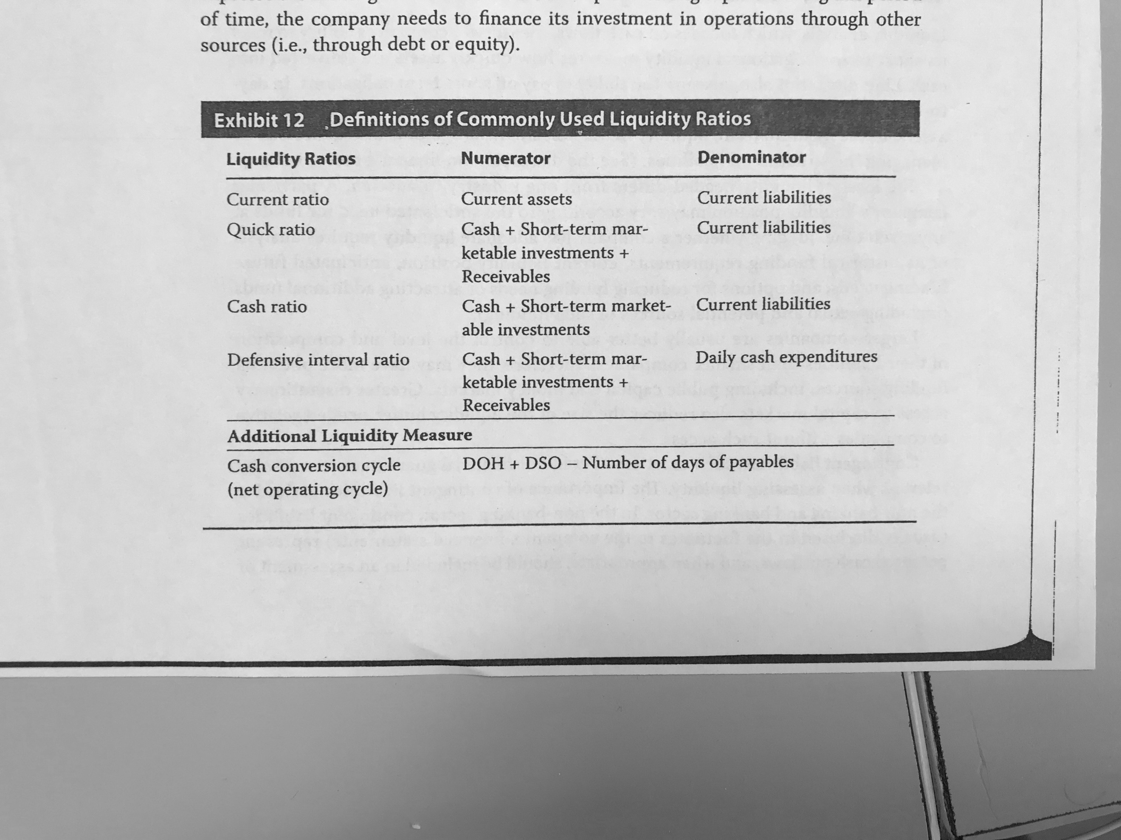

4.3.2 Interpretation of Liquidity Ratios:

* **Current ratio:** If the ratio is low, it can mean that the company relies on operating cash flow and outside financing to meet its short-term obligations.
* **Quick ratio:** It assumes that there are some assets that cannot really be turned into cash as easily (like prepaid expenses). Inventory is also not included as sometimes it is not as liquid and in the case that it needs to be sold immediately, probably, it would not be sold at its carrying value.
* **Cash ratio:** It is more conservative.
* **Defensive interval ratio:** This ratio measures how long the company can cover its expenses from its existing liquid assets without consider the existence of any other cash inflow. The ratio output is then the number of days.
* **Cash conversion cycle:** When this ratio is lower, it means that the company is more liquid and requires less time to finance its current operations.

4.4 Solvency Ratios: Refers to the ability that the company has to cover its long-term obligations. The ratios are useful to test the company’s leverage (both leverage happen in the long-term, with fixed assets and long-term debt):

* **Operating leverage**: Results from the use of fixed costs in order to increase revenues.
* **Financial leverage**: Using debt usually lowers the funding cost of the company, making its return higher.

4.4.1 Calculation of Solvency Ratios:

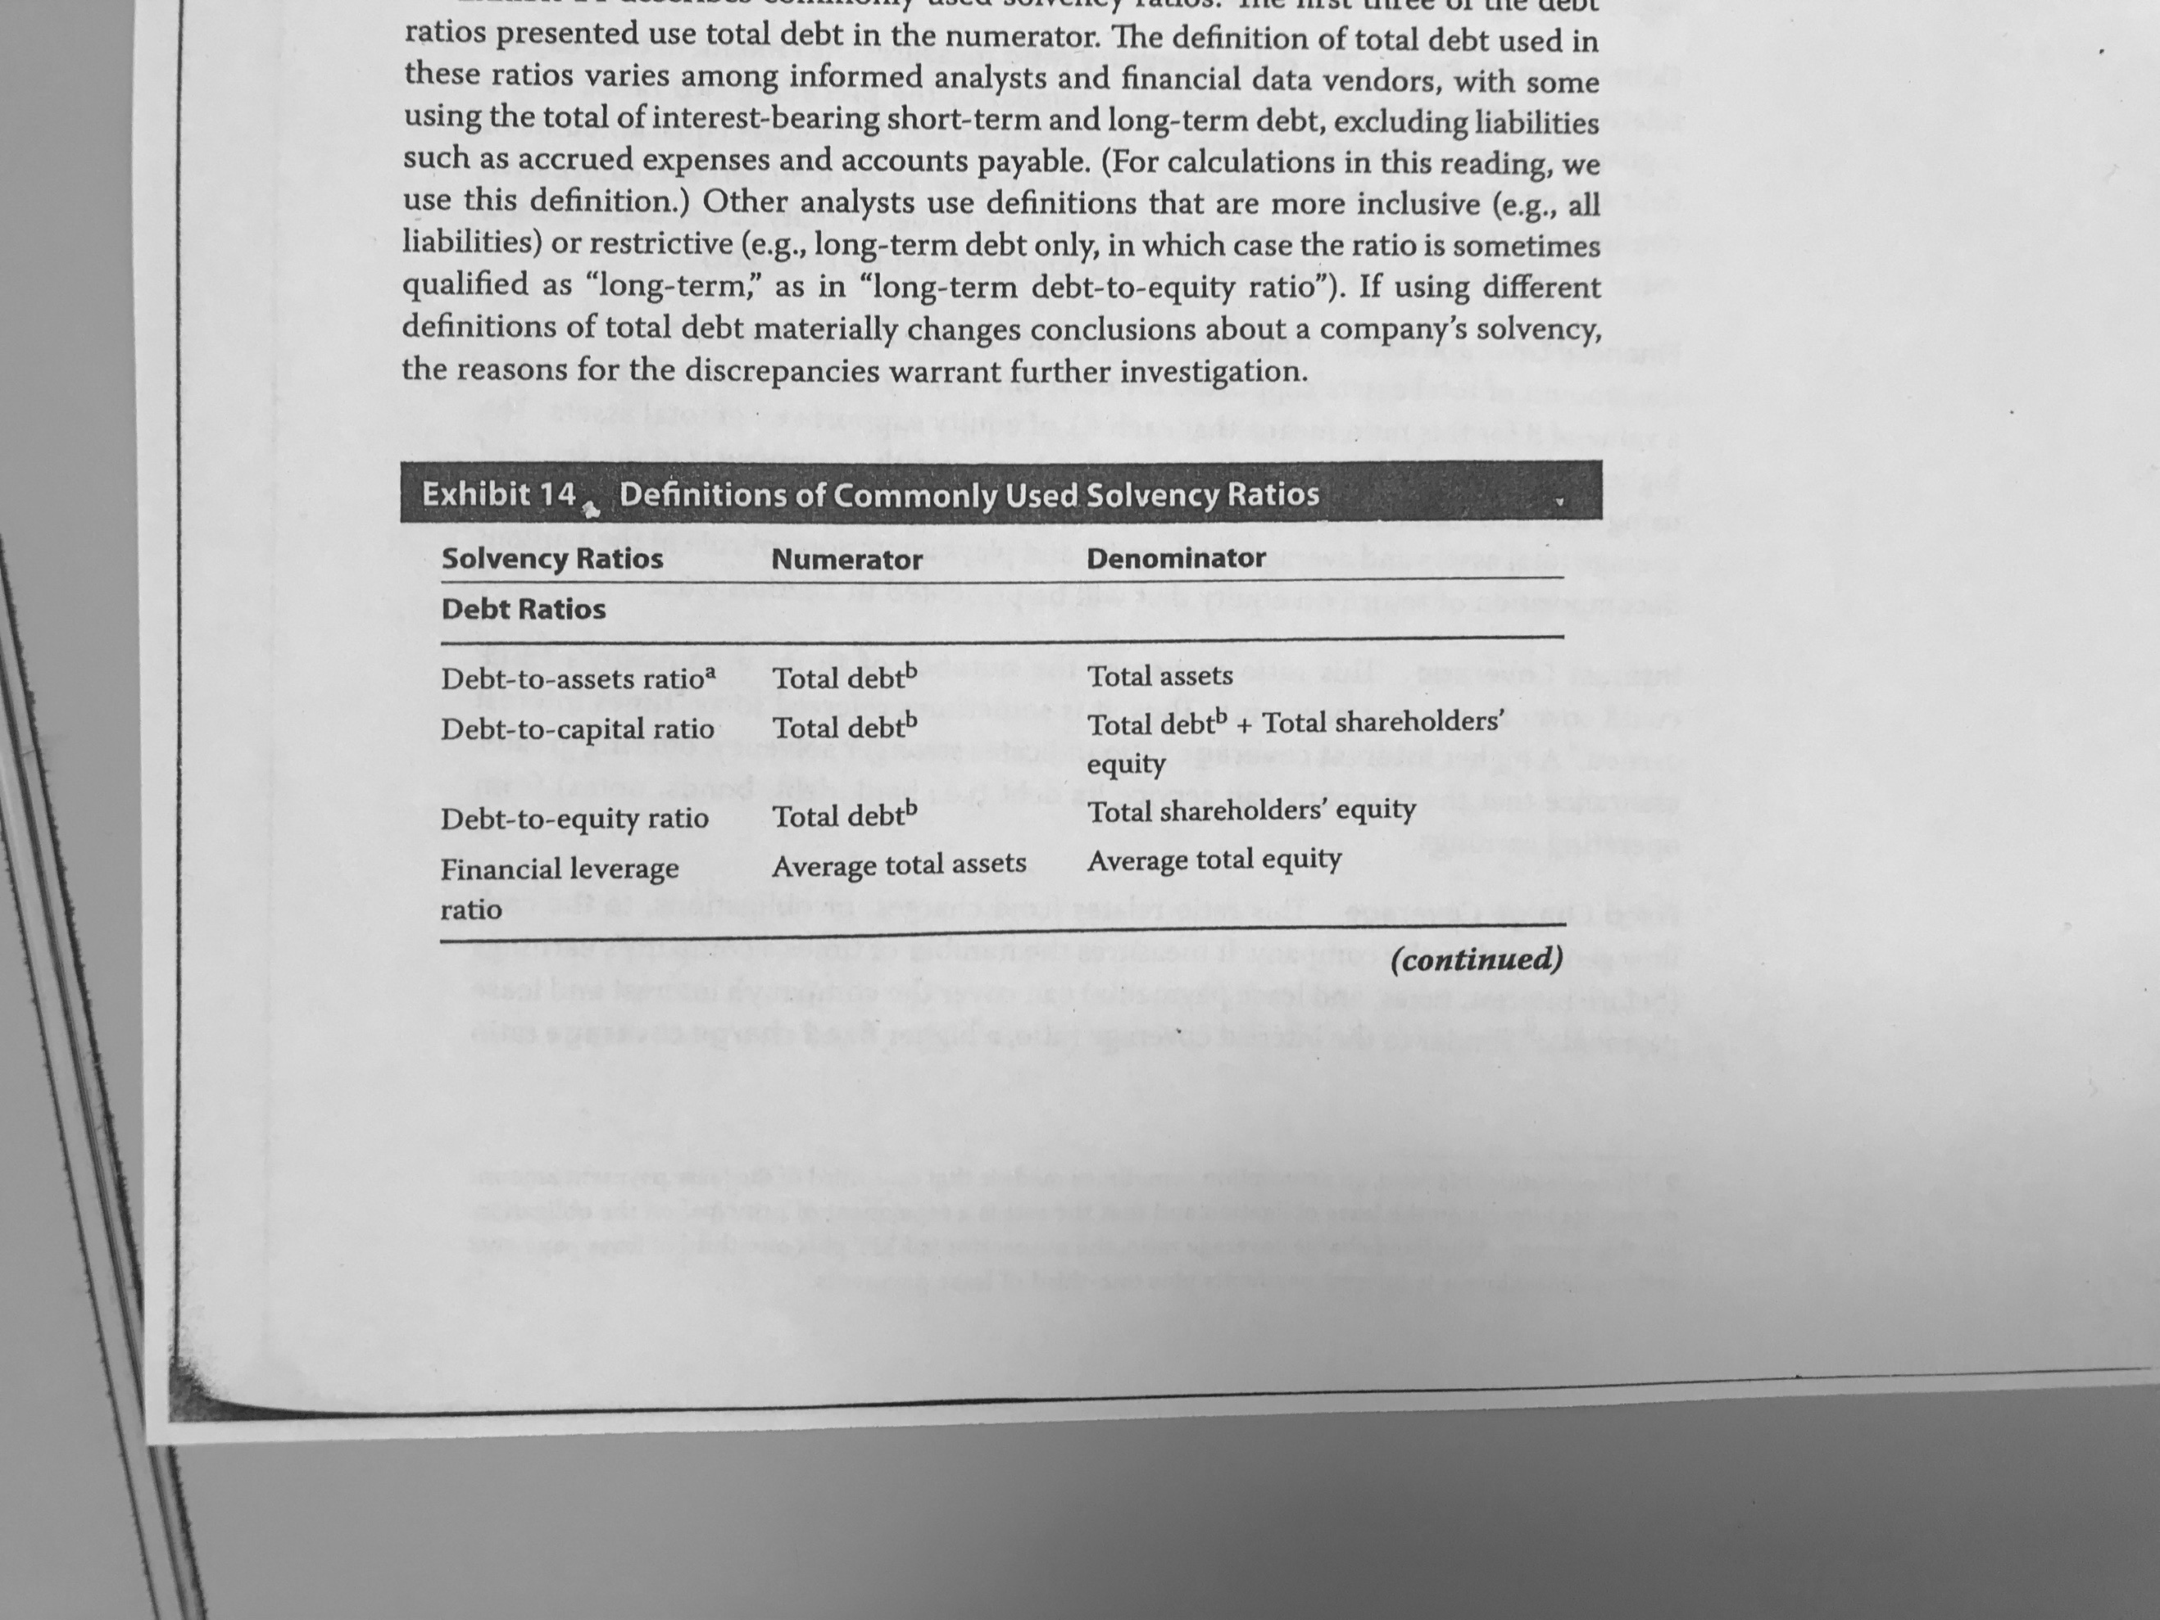

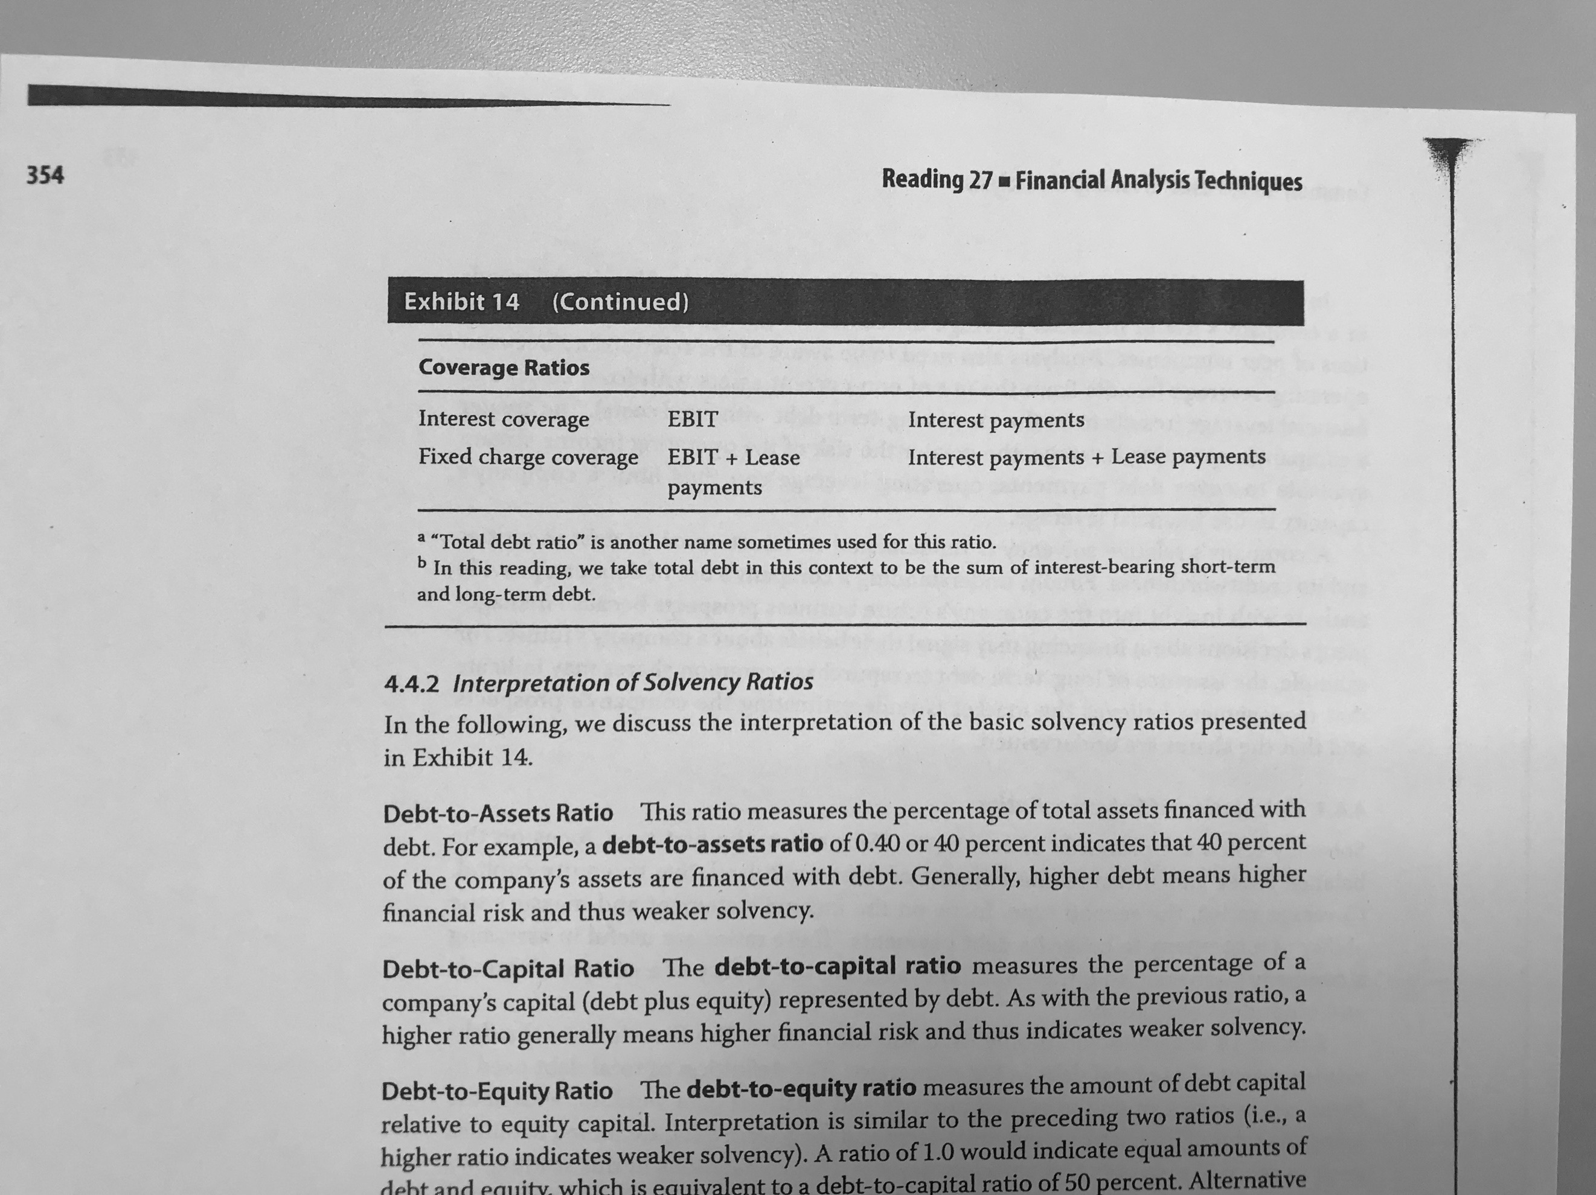

4.4.2 Interpretation of Solvency Ratios:

* **Debt-to-assets ratio:** When it is higher, there is usually a higher risk and lower solvency.
* **Debt-to-capital ratio:** Again, a higher ratio can mean higher risk and lower solvency.
* **Debt-to-equity ratio:** It can also be calculated using the market value of equity and debt.
* **Financial leverage ratio:** A higher ratio will imply that assets are more financed by liabilities than by equity.
* **Interest coverage:** It shows how many times the EBIT could cover the interest payments. Again, if it is higher, it means a higher solvency.
* **Fixed Charge Coverage:** Is the same as the interest coverage but it includes lease payments.

*It is important to consider the nature of the business, as it might handle more or less leverage without meaning that there is an existence of insolvency.

4.5 Profitability Ratios: Ability to generate profit over invested capital.

4.5.1 Calculation of Profitability Ratios:

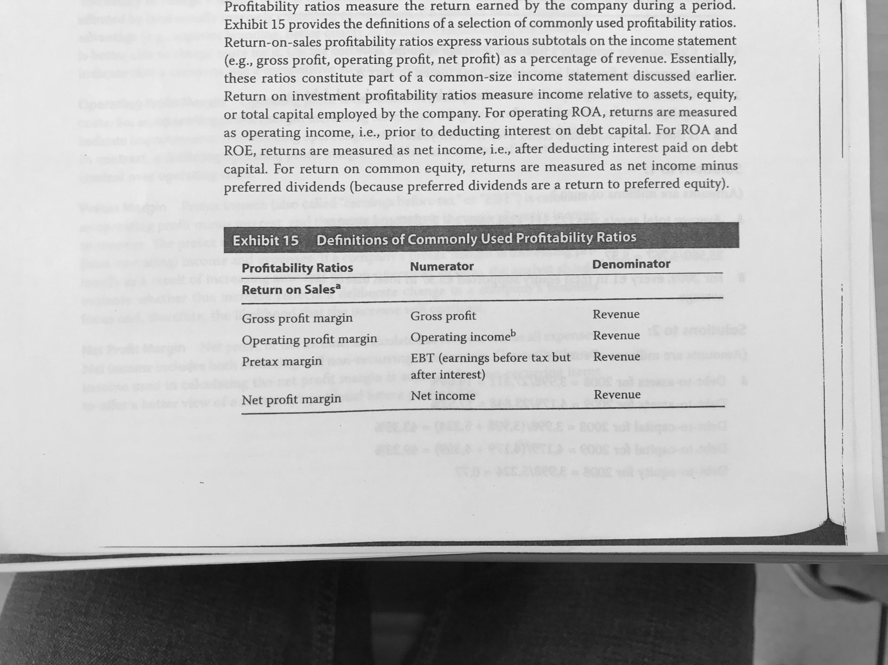

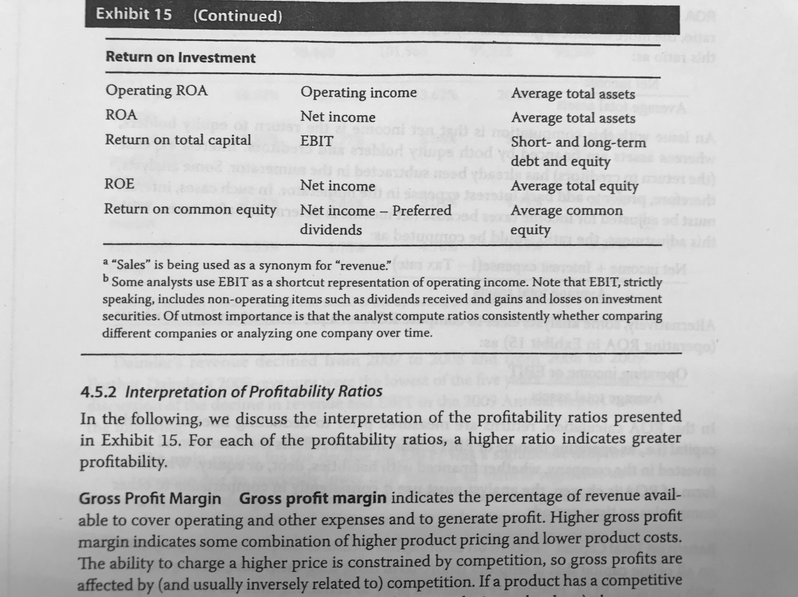

4.5.2 Interpretation of Profitability Ratios:

* **Gross profit margin:** Gross profit margins are usually affected by competition, as they depend on the fact that accompany is able to charge more or less for its products. A high gross profit margin could then mean an existence of a competitive advantage.
* **Operating profit margin:** When a company improves its operating profit margin faster than its gross profit, it will mean that the company is making improvements in managing administrative and selling expenses.
* **Pretax margin:** As the operating margin, the pretax margin shows the effect of other elements that are leverage expenses and other losses or income. A drastic change due to other items could be a reason for the analyst to check if the company is changing its focus.
* **Net profit margin:** Normally it is adjusted for non-recurring items.
* **ROA:** Some analysts consider that the ratio should use (net income + int. expense (1 – t)) in the numerator because assets are financed both by equity and debt, return of debt should not be subtracted from the numerators (such as dividends). Others simply use the operating profit or EBIT as the numerator.
* **Return on total capital:** It considers short-term debt, long-term debt and equity in the denominator.
* **ROE:** It includes minority interest, preferred equity and common equity.

4.6 Integrated Financial Ratio Analysis:

4.6.1 The Overall Ratio Picture: Examples:

4.6.2 DuPont Analysis: The Decomposition of ROE: This analysis helps to understand the drivers of ROE.

$$ROE= \frac{Net income}{Revenue}×\frac{Revenue}{Avg. total assets}×\frac{Avg. total assets}{Avg. shareholder^{'}s equity}$$

or:

$$ROE= \frac{Net income}{EBT}×\frac{EBT}{EBIT}×\frac{EBIT}{Revenue}×\frac{Revenue}{Avg. total assets}×\frac{Avg. total assets}{Avg. shareholder^{'}s equity}$$

The first term measures the effect of taxes, is the tax burden ratio and the higher the better. The second one the effect of interest (interest burden where the higher, the better) and the third one is the effect of EBIT on ROE (it is operating profitability). The operating margin could be also decomposed in (EBIT/Operating income) and (Operating income/Revenue).

## 5. Equity Analysis

Equity analysis includes the following steps:

1. Understand the business and the existing financial profile.
2. Forecast the company’s performance.
3. Select the appropriate valuation model.
4. Convert forecast to a valuation.
5. Make an investment decision.

5.1 Valuation Ratios:

5.1.1 Calculation of Valuation Ratios and Related Quantities:

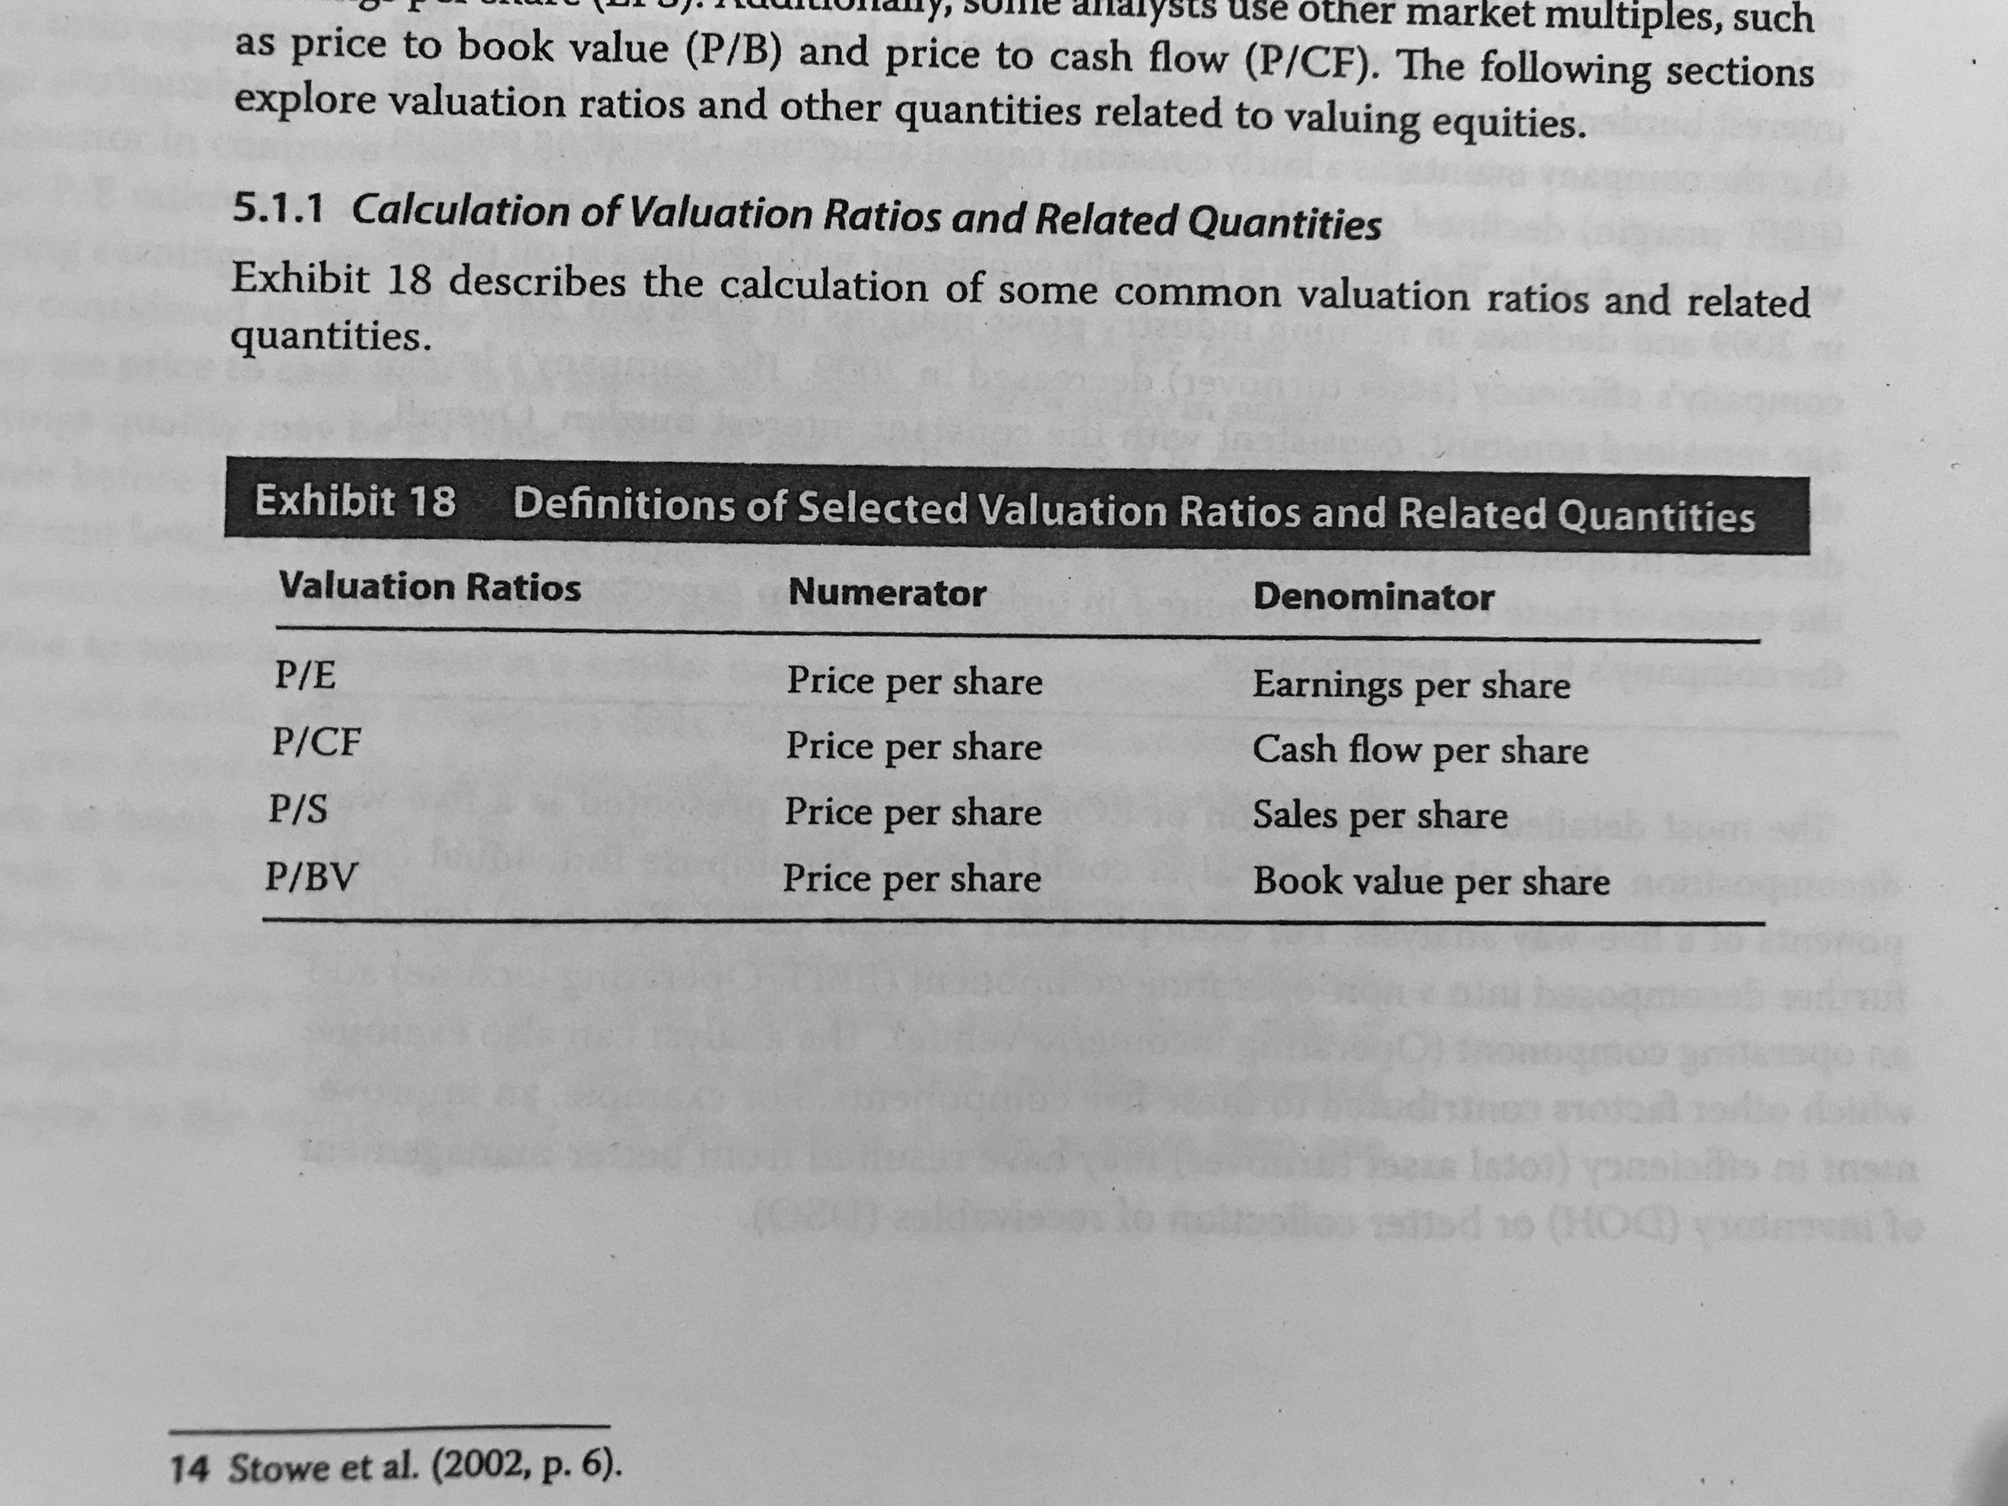

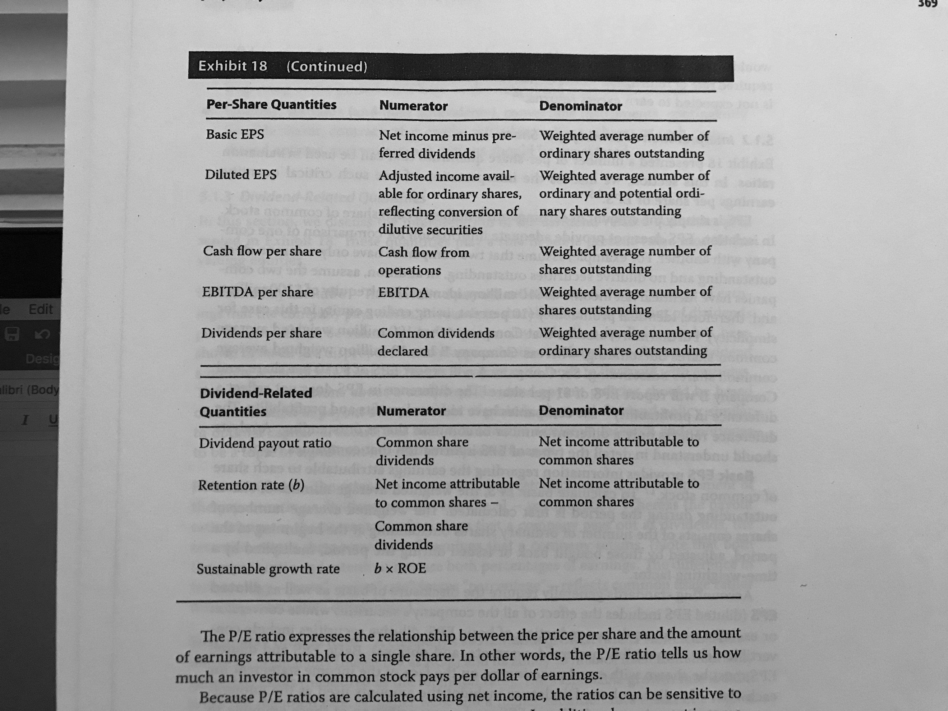

* **P/E:** How much does an investor of a common stock pays per dollar of earnings.
* **P/CF:** Is less susceptible to manipulation.
* **P/S:** It is normally used when the net income is negative.
* **P/B:** It helps analyst to know if the market is paying at list for the company’s book value. If it is higher than it is said that the future profitability is expected to exceed the require rate of return.

5.1.2 Interpretation of Earnings per Share:

* **Basic EPS:** It is not use as a comparable item.
* **Diluted EPS:** to calculate them, earnings are adjusted for the after-tax, potential dilutive shares are added (only if their conversion would decrease the net profit per share) and their conversion is at the beginning at the period or at the date that the instruments were issued. The instruments considered are options, warrants, convertible instruments, contingently issuable shares, contracts that can be settled in shares, purchased options and written put options.
* **Cash flow per share:** Simply shows the cash flow from operations attributable to each share.
* **EBITDA per share:** Again, shows the EBITDA divided between the weighted average number of shares.
* **Dividend per share:** Divides dividends declared between the weighted average number of shares.

5.1.3 Dividend-Related Quantities:

* **Dividend payout ratio:** This ratio normally fluctuates due to changes in net income, the amounts of dividend per share tend to be constant.
* **Retention rate:** Is the complement of the past ratio. Is the ability of the company to finance by its own.
* **Sustainable growth rate:** considers both profitability and the retention rate.

5.2 Industry-Specific Ratios:

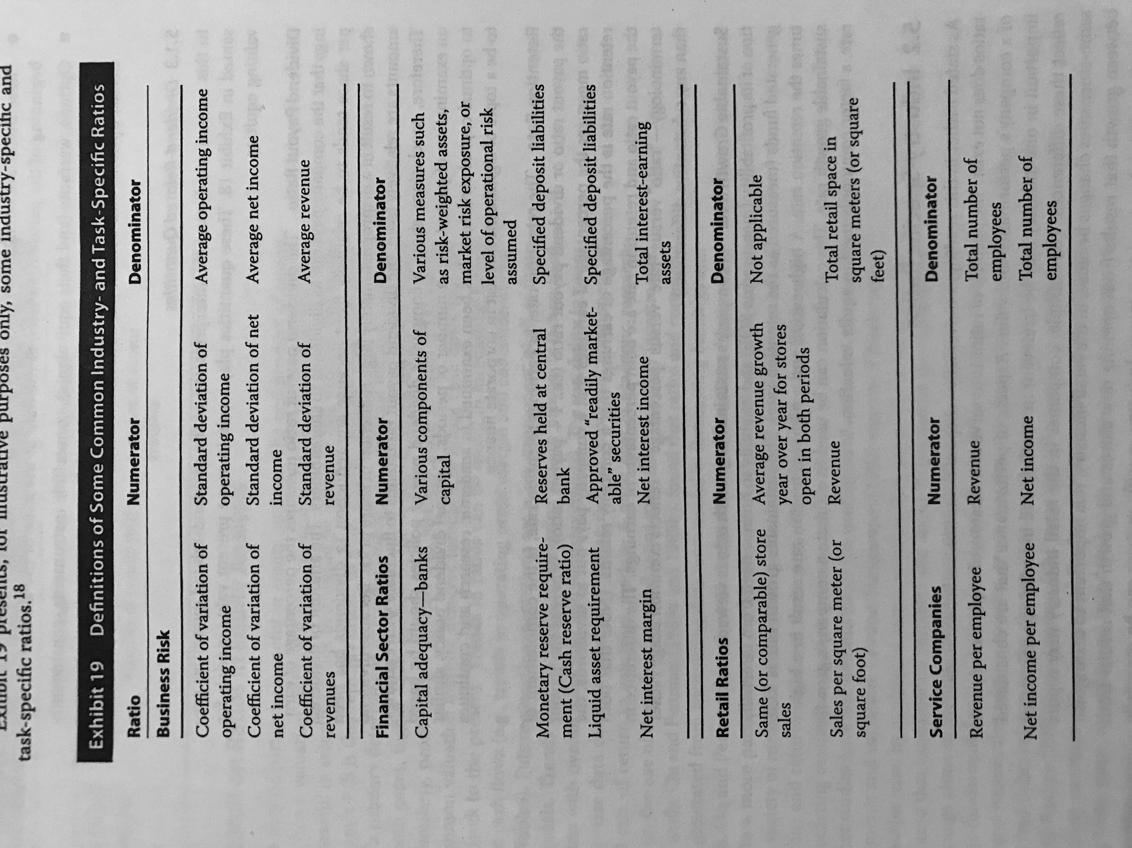

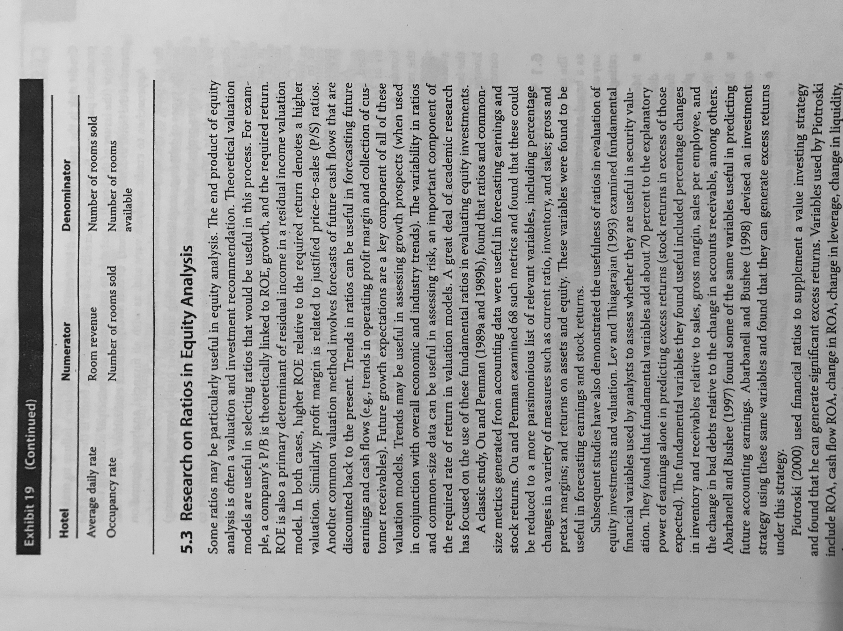

5.3 Research on Ratios in Equity Analysis: Ratios can be useful in predicting future earnings and returns as in explaining past history.

## 6. Credit Analysis

Credit analysis is the evaluation of credit risk.

6.1 The Credit Rating Process:

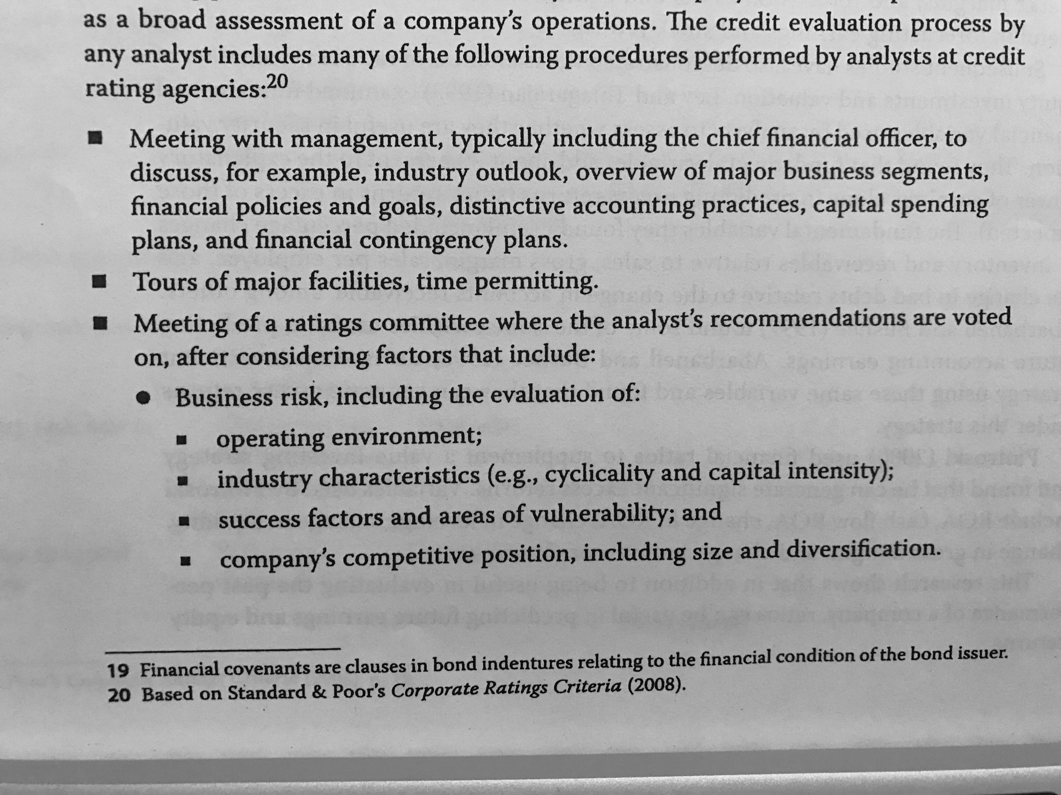

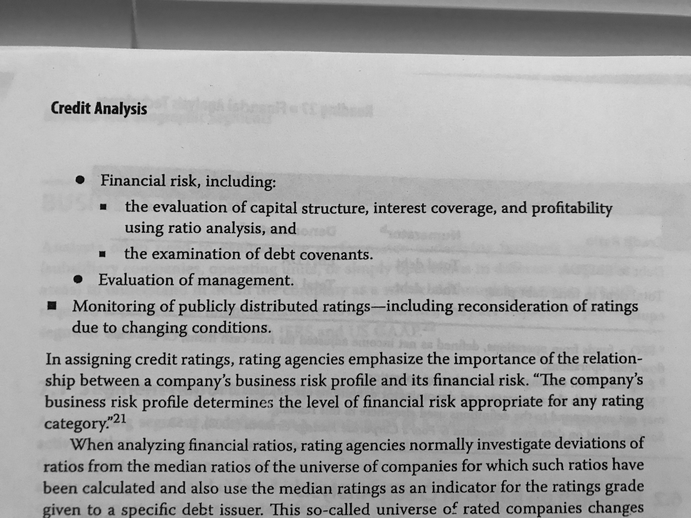

Credit ratios used by S&P:

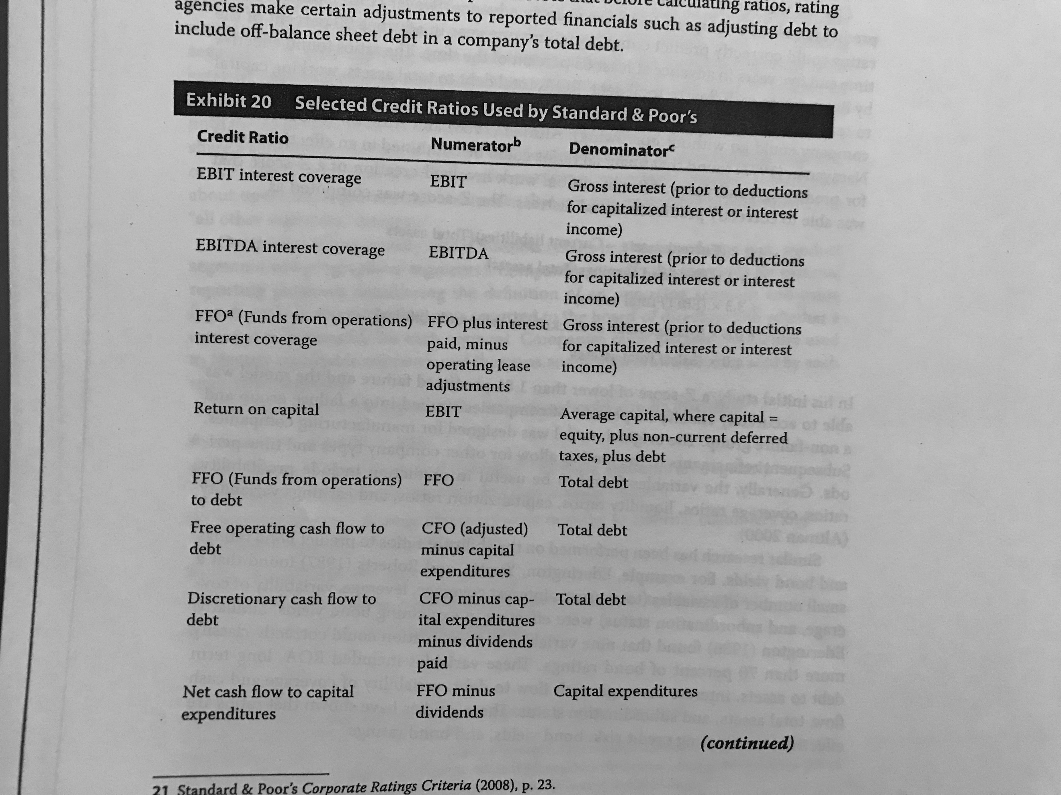

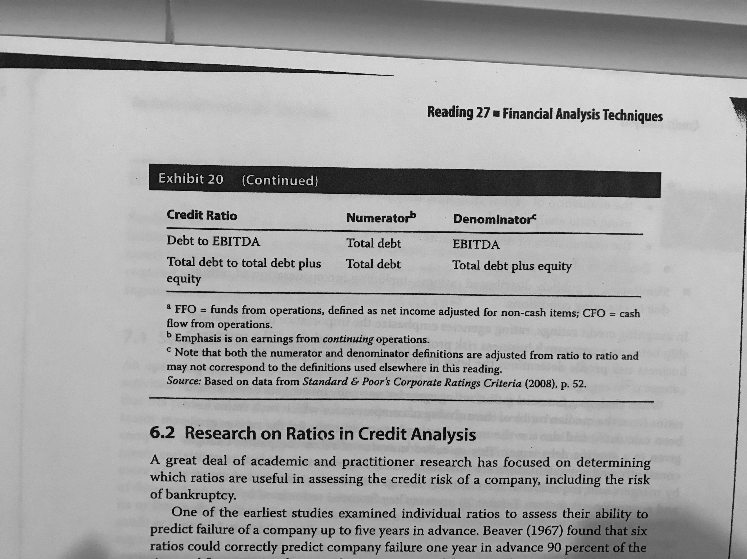

6.2 Research on Ratios in Credit Analysis: Altman created the Z-score that was able to correctly predict financial distress:

$$Z=1.2 ×\frac{Current assets-Current liabilities}{Total Assets}+1.4 ×\frac{Retained earnings}{Total assets}$$

$$+ 0.6 ×\frac{Market value of stock}{Book value of liabilities}+ 3.3 ×\frac{EBIT}{Total assets}+ 1.0 ×\frac{Sales}{Total assets}$$

The initial results showed that a score lower than 1.81 predict failure. The model was designed for manufacturing companies.

## 7. Business and Geographic Segments

7.1 Segment Reporting Requirements: An operating segment is a component of a company:

* That engages in activities that may generate revenue and create expenses (including start-up segments)
* Whose results are regularly reviewed by senior management.
* For which discrete financial information is available.

A company must disclose specific information about segments which, in terms of absolute value, its revenue, assets or profit (considering the total profit in terms of absolute value, including losses) represent 10% or more of the combined variables. If after meeting this criteria 75% percent of the combined revenue is not yet covered, the company needs to continue disclosing until it reaches the 75%. For each reportable segment, the following must be disclosed:

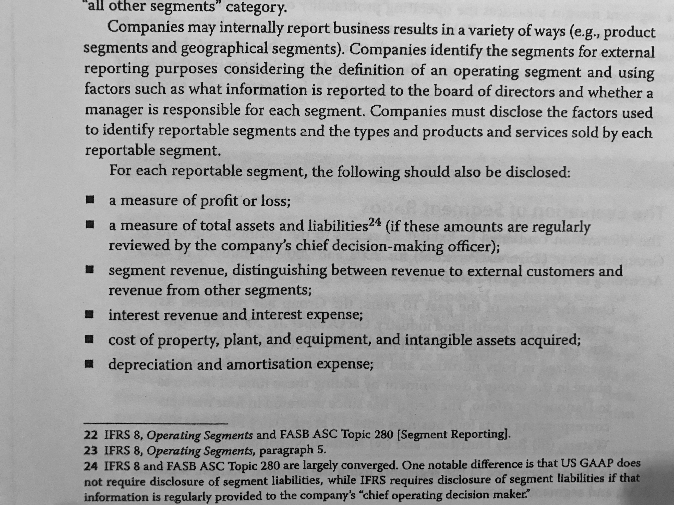

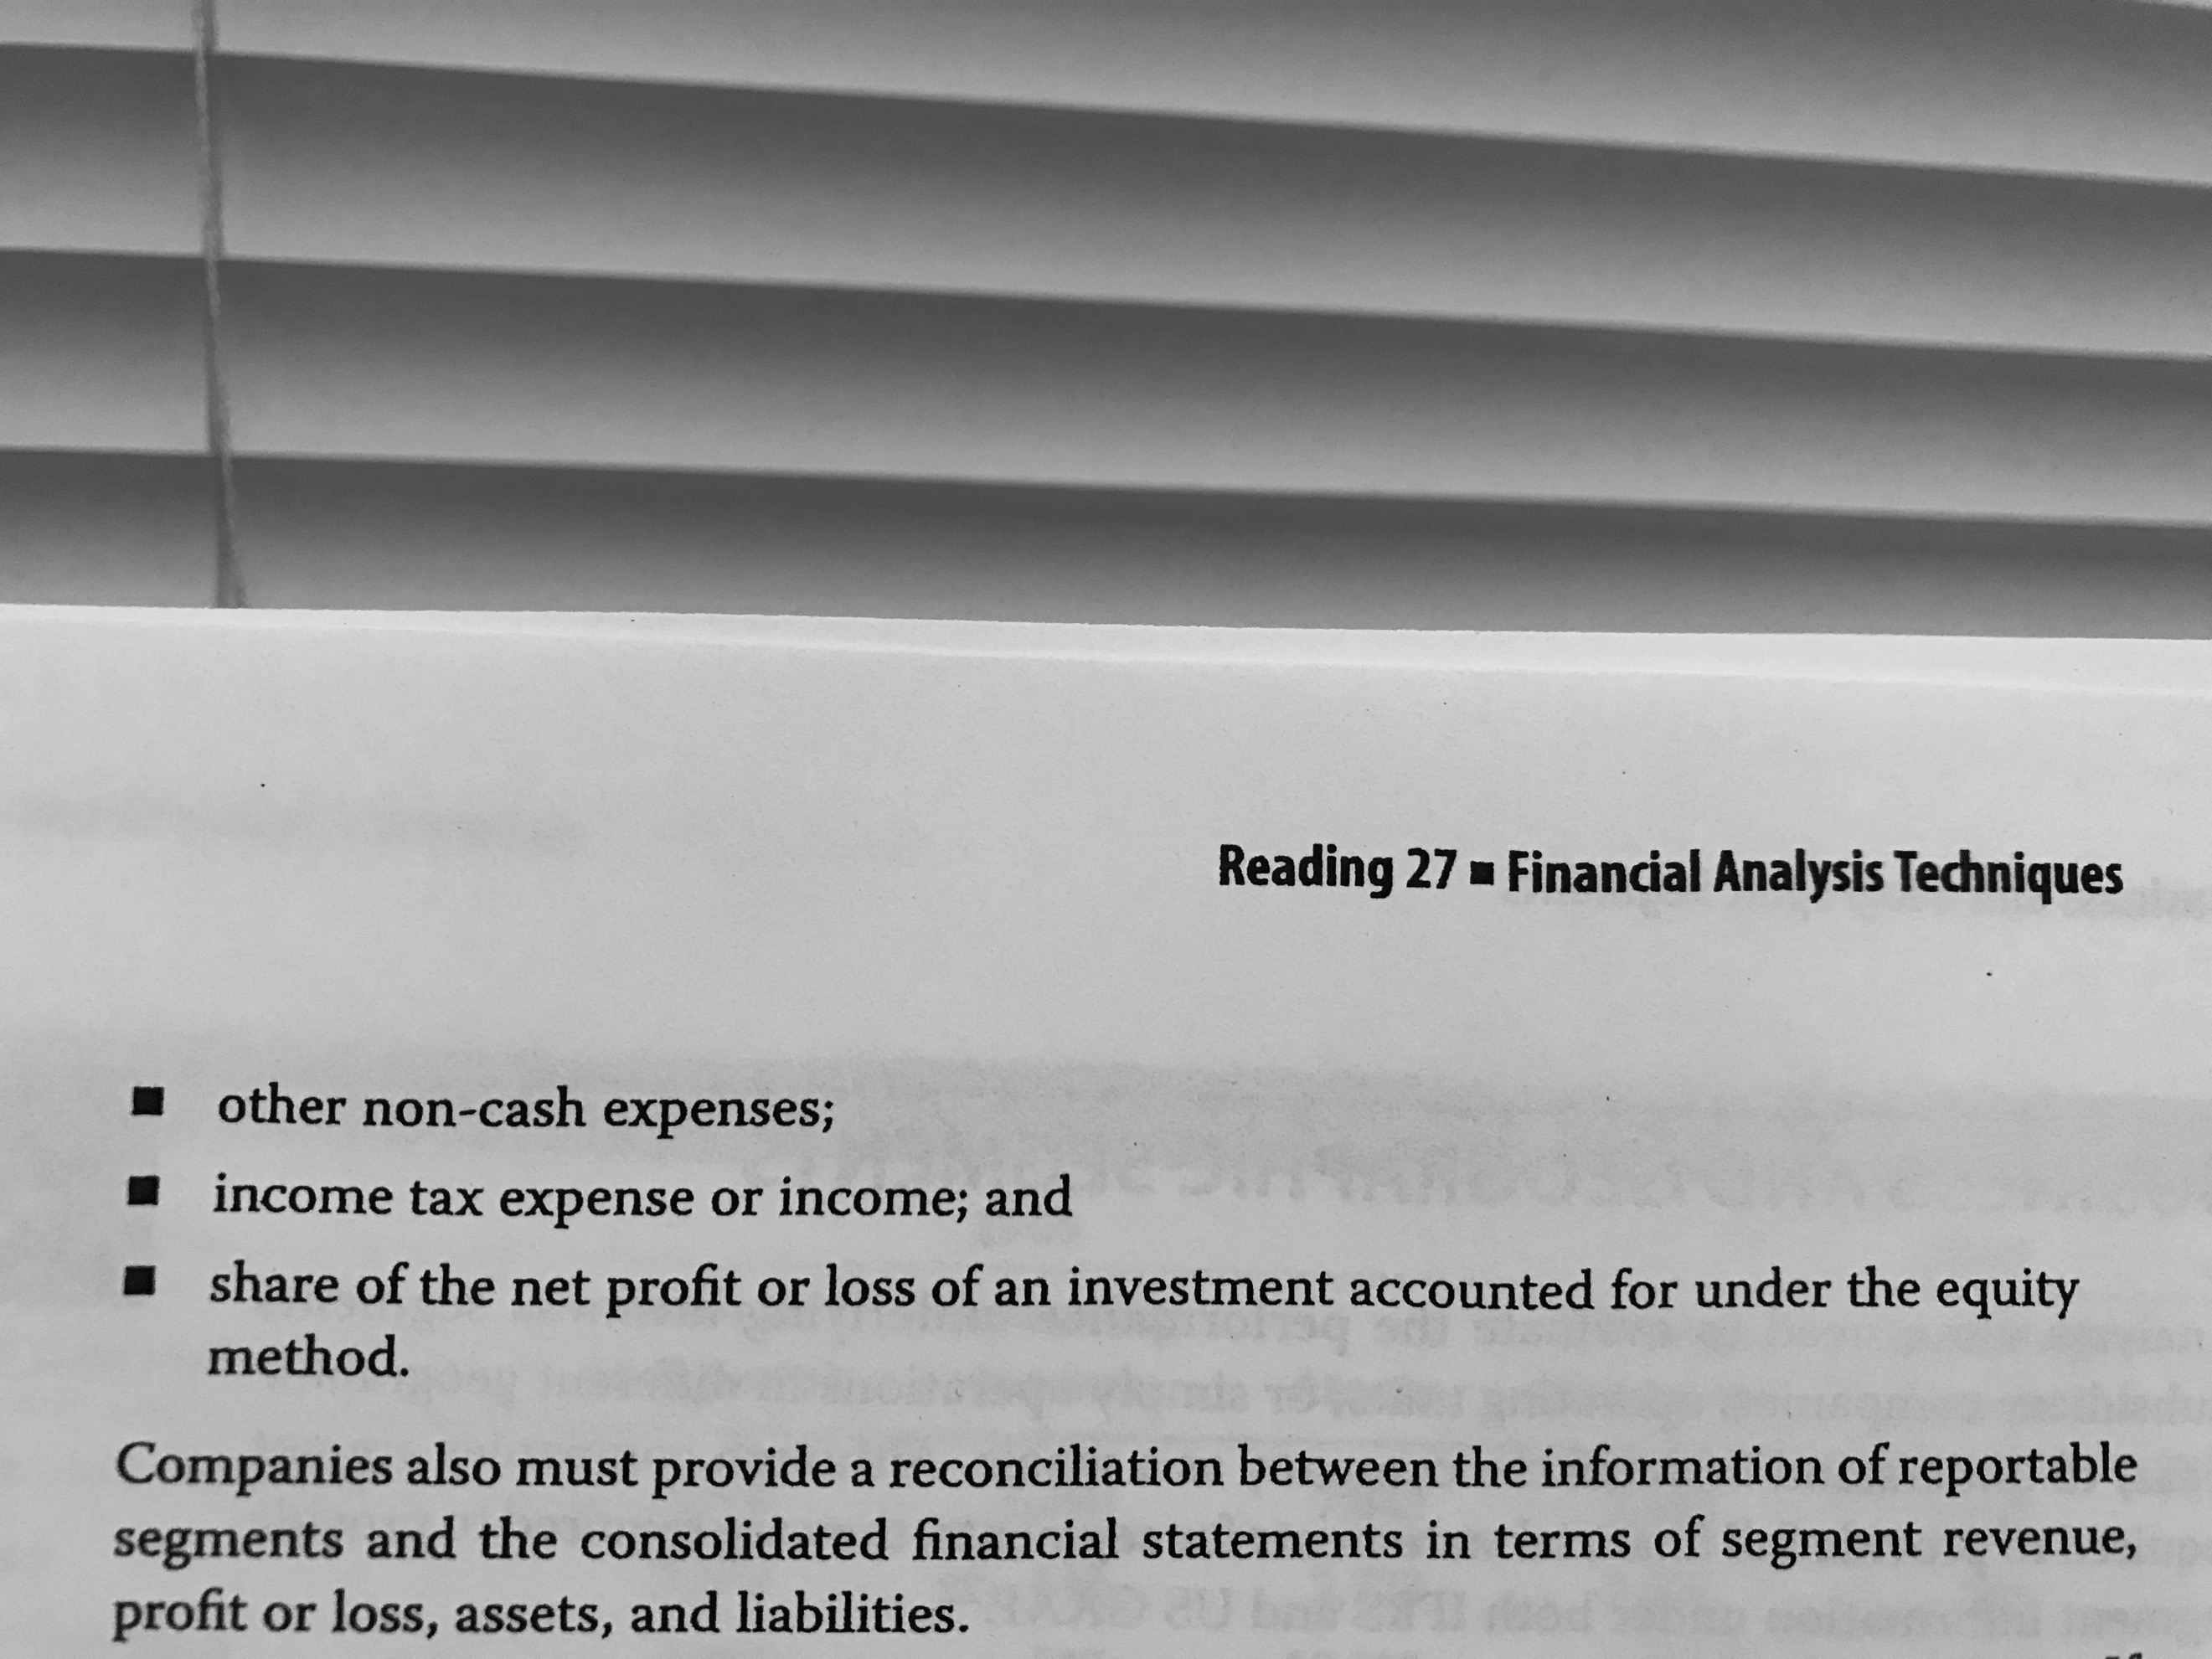

All the segments that are excluded need to be reported in an “all other segments” category.

A reconciliation must be provided between the segmented information and the consolidated financial statements.

Also, if a single costumer represents more than 10% of the total company’s revenues, it must be disclosed.

7.2 Segment Ratios:

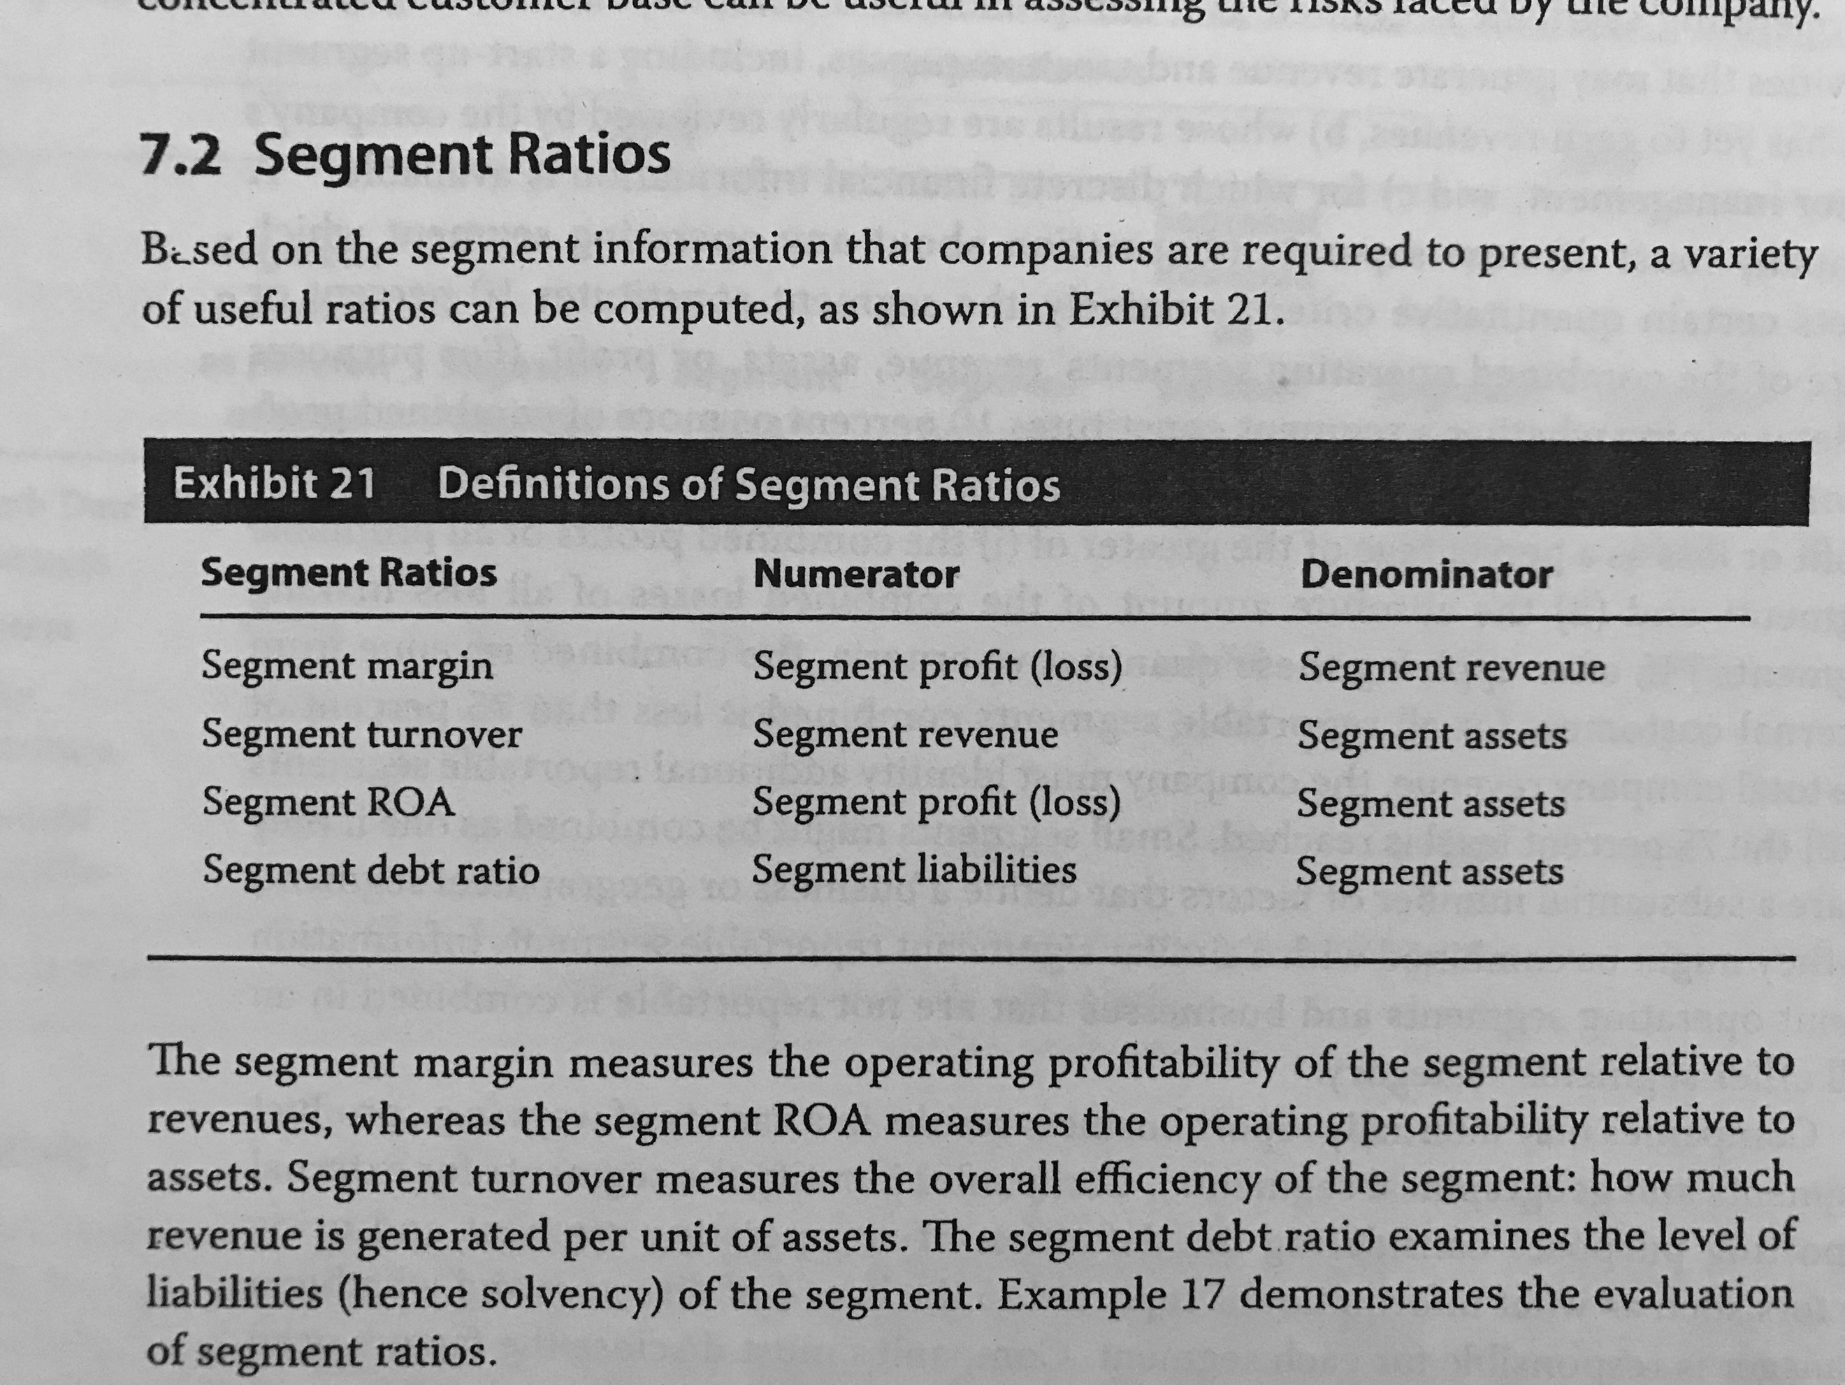

## 8. Model Building and Forecasting

Techniques to estimate different possibilities when making a forecasting model:

* **Sensitivity analysis:** It test the changes in the model by changing just one variable.
* **Scenario analysis:** Considers different economic variables that might affect the business and runs different models considering the modifications.
* **Simulation:** Uses the past two but through computer simulation based on probability models.

# Reading 28: Inventories

## 2. Cost of Inventories

Abnormal cost due to a waste of materials or labor, storage costs (unless required for the production) and all administrative and selling overhead cost are not consider as part of the cost of the inventory.

Production overhead cost = Costos Indirectos de Fabricación

## 3. Inventory Valuation Methods

Methods allowed by each accounting standards:

* IFRS: specific identification, FIFO and weighted average cost.
* US GAAP: specific identification, FIFO, weighted average cost and LIFO.

The company must use the same method for items of similar nature.

3.1 Specific Identification: It is used for specific products or expensive goods that are unique.

3.2 First-In, First-Out (FIFO): The oldest goods purchased or manufactured are sold first.

3.3 Weighted Average Cost: Assigns the average cost of the goods that are available for sale to the units sold as will to the units ending inventory.

3.4 Last-In, First-Out (LIFO): The oldest goods purchased or manufactured are sold first.

3.5 Calculation of Cost of Sales, Gross Profit and Ending Inventory:

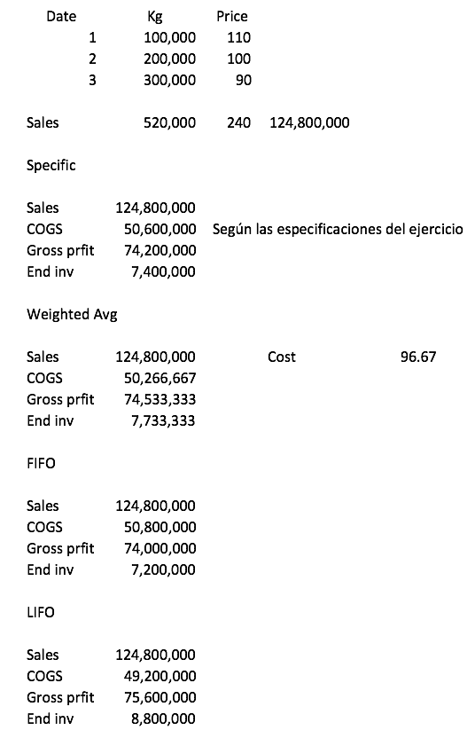

3.6 Periodic versus Perpetual Inventory Systems: Under a periodic inventory system, the inventory and COGS are valued at the end of an accounting period. Under perpetual systems, these values are updated continuously. FIFO and specific identification are not affected by either system. LIFO and weighted average method are affected.

3.7 Comparison of Inventory Valuation Methods: In a scenario were prices are increasing, FIFO will show a lower COGS and a higher ending inventory value.

It is important to be careful with these issues as the ratios can also change.

## 4. The LIFO Method

Some companies use the LIFO method in order to pay a lower amount of taxes when the cost of inventories is increasing.

4.1 LIFO Reserve: It is the difference between the LIFO carrying amount of inventory and the amount that would have been reported if FIFO method had been used (so FIFO amount – LIFO amount). This value can be used to adjust the inventory to its “FIFO amount” and be then comparable with other companies. COGS can be adjusted from LIFO to FIFO by subtracting the increase in the LIFO reserve during the period.

REVISAR EJERCICIO Page 408.

4.2 LIFO Liquidations: It happens when the units sold exceed the units manufactured in the period. As a result, gross profits increase drastically as the “excess units” that were hold in inventory have a lower carrying amount, making their registered unit cost to the COGS lower. This is called an inventory-related increase in gross profits. A decline of the LIFO reserve may indicate a LIFO liquidation.

## 5. Inventory Method Changes

Changes of inventory valuation methods is not so common. To do so, the company must justify that the change will provide a more reliable effect of the transaction in the financial performance and position of the company. The change needs to be applied to prior comparable periods as far back as is practicable. In US GAAP, the change needs to be thoroughly justified and, if it is from any method to LIFO, retrospective changes are not required.

## 6. Inventory Adjustments

Inventories, under IFRS, are measured and carried in the balance sheet at either the cost or the net realizable value (whichever is lower). Net realizable value is the estimated selling price minus the costs necessary to make the sale or get the inventory in condition to be sold.

This “test” is made either by item or by groups of similar items every period. If the net realizable value needs to be used, the decline of the value of inventory is recognized as an expense that can be reported in the COGS or separately.

If the inventory is reported at the net realizable value and for a reason, this value grows over the carrying value, a reversal needs to be made (where now the carrying value is used). This is recognized as a reduction of the COGS and it is known as a reversal write-down.

US GAAP specify to report either using the cost or the market value (whichever is lower). However, US GAAP prohibits the reversal write-down. The market value, which cannot exceed the net realizable, is the current replacement cost subject to upper and lower limits. The lower limit is the net realizable value less a normal profit margin. REPASAR PAGINA 419 – 425.

## 7. Evaluation of Inventory Management

7.1 Presentation and Disclosure: Disclosures concerning inventory under IFRS are the following:

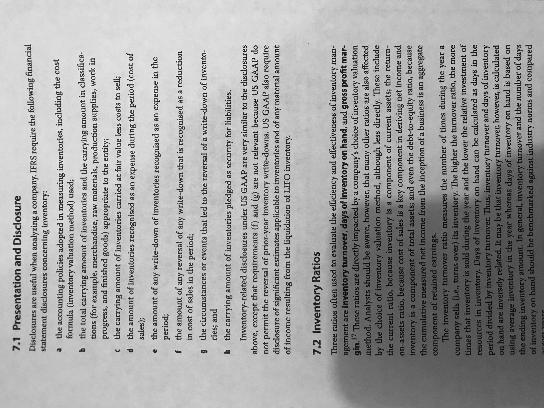

7.2 Inventory Ratios: To evaluate efficiency and effectiveness of inventory are inventory turnover, days of inventory on hand and gross profit margin.

7.3 Financial Analysis Illustrations: The reports must include the different categories into which the inventory is divided. Considering this, if, for instance, the inventory for raw materials and work in progress is declining and the one of finished goods is increasing, this would be a bad sign. If the first two were increasing and the last one is constant, maybe the company is anticipating a huge demand.

# Reading 29: Long-Lived Assets

## 2. Acquisition of Long-Lived Assets

2.1 Property, Plant and Equipment: When the asset is received through an exchange (non-monetary), then it is recorded at fair value, if a reliable measure of fair value exists. If there is not a reliable measure, it is valued at the carrying value at which it was given (so there will be no gain or loss).

When an asset is bought, the buyer must include the costs incurred to get the asset ready for operation as part of the cost of the asset.

A transaction is capitalized whenever it is needed to make the asset functional or when the transaction affects the useful life of an asset. Everything else will be expensed.

In the case of long projects that end with a fixed asset (a building construction), all the costs incurred will be capitalized without mattering if the asset will be sold or kept by the company.

If a loan is incurred, IFRS allows that if the company invest the proceeds of a loan related to the construction of the asset, its interest income can be capitalized, reducing the financial cost of the loan. Under US GAAP this cannot be done.

2.2 Intangible Assets: Under IFRS, identifiable intangible assets must be or should meet the following:

1. Identifiable.
2. Under control of the company.
3. Expected to generate future economic benefits.
4. It is probable that the expected future economic benefits will flow to the company.
5. The cost of the asset can be measured reliably.

2.2.1 Intangible Assets Purchased in situations Other Than Business Combinations: They are recorded at fair value, which should be similar to the purchase price.

2.2.2 Intangible Assets Developed Internally: This, in contrast to the case of tangible assets, are usually expensed while they are being developed. This means that the value in the balance sheet will be lower than when purchasing it and the cash flows related to the development will be operating and not investing flows.

Under IFRS, research costs are expensed and, when the future asset passes to a development stage, it can start to be capitalized. Under US GAAP, both are expensed although, some software development costs must be capitalized (when the software is going to be sold or for internal use?).

2.2.3 Intangible Assets Acquired in a Business Combination: When a company acquires another company, the acquisition method of accounting is used where the acquirer allocates the purchase price to each asset acquired and each liability assumed on the basis of its fair value. The remnant obtained after doing this process is known as goodwill. Under IFRS, if an item cannot be recognized as a tangible or as an identifiable intangible asset using the acquisition method, then it is recognized as goodwill.

Under US GAAP, an intangible asset should be separated from the goodwill if the item arises from contractual or legal right or if the item can be separated from the acquired company (for example: patents, copyrights, franchises and licenses).

2.3 Capitalizing versus Expensing: Impact on Financial Statements and Ratios:

* Capitalizing: an expenditure increases the assets and appears as an investing outflow. In the subsequent period, depreciation is assigned, reducing the net income and the value of the asset without any impact in the cash flow.
* Expensing: an expenditure reduces the net income in its after-tax amount. This will be an operating outflow and there will not be any effect in subsequent periods.

Both are different but, at the end, compensate. For instance, capitalizing reflects higher profitability in the current period (or all of the following subsequent periods were the CAPEX exceeds the depreciation expense) but lower in subsequent periods while expensing behaves in the opposite way. It happens the same with the amount of equity (higher on the early years when capitalizing). Capitalizing, then, is driven by profitability-enhancing motivations while expensing is driven by profit trend-enhancing motivations.

Companies tend to prefer capitalizing the expenditures, as it would result in a higher operating cash flow.

2.4 Capitalization of Interest Costs: When capitalizing the interest cost caused due to an expenditure either for sell or internal use, the interest is then expensed through the COGS or through depreciation respectively. When doing ratio analysis like interest coverage, this must be taken into account in order to compute the ratios in the most accurate way possible. Also, it must be taken into account the effect of using this method on the companies’ cash flows.

2.5 Capitalization of Internal Development Costs: Expensing will result in a lower net income as long as it is higher than the amortization value that would have been reported in the case of capitalizing the expenditures. Also, the operating cash flows will be affected instead of the investing cash flows. For a company that capitalizes development expenses, adjustments can be made to make it comparable with a company which expenses these expenses:

* Exclude the amortization expense and include the software development expense in the income statement.
* Exclude the capitalized software from the balance sheet.
* Adjust the cash flow statement.

## 3. Depreciation and Amortization of Long-Lived Assets

The cost model indicates that the assets should be recorded at its purchasing costs and that the assets generate a depreciation expense, which is netted out of the carrying value of the asset.

The revaluation model which is only permitted under IFRS indicates that the company should report the assets at fair value (rather than acquisition cost) less the accumulated depreciation.

3.1 Depreciation Methods and Calculation of Depreciation Expense: Methods:

* Straight-line method: The cost is allocated evenly over the useful life. The expense it is calculated as the depreciable cost (assets value – residual or salvage value) divided by the estimated useful life.
* Accelerated methods: The cost allocated is greater in the earlier years. These methods can be used for just some years and then apply straight-line. For instance, the declining-method takes the rate of depreciation per period of the straight-line method, multiplies it by a factor and applies that rate to the carrying value of the period. The ending expense using these methods must adjust the value of the asset to its residual value.
* Units-of-production method: The cost allocated corresponds to the actual usage. It is calculated by dividing the depreciable value by the estimated units that the assets can resist and multiplied by the units of the period.

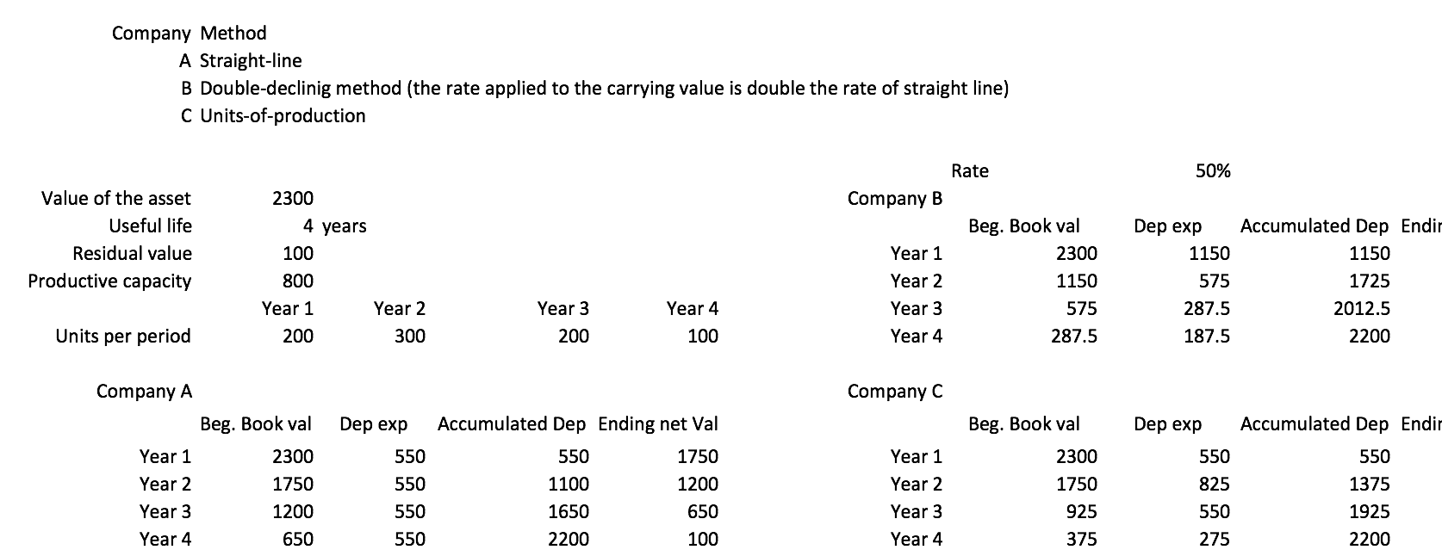

Companies should review the estimates of both residual value and useful life annually under IFRS.

In most countries, companies use the same method both for financial and tax reporting as required by the law. In the US, however, this is not required. Nevertheless, using one or the other, the total expense will still be recognized in other periods.

Under IFRS, it is required to depreciate separately significant components of an asset (in airplane, the engine for instance). Under US GAAP, this is allowed but not enforced.

The depreciation cost can be reported either as a COGS or an expense, it depends on what is the asset used for.

3.2 Amortization Methods and Calculation of Amortization Expense: The acceptable method for amortization are the same as the ones of depreciation (unless it has an indefinite useful life, when there is not foreseeable future in which the assets will stop generating cash flows. Also, assets with indefinite useful life could be the ones that require a minimum cost to renew it, like a license).

4. The Revaluation Model

It is not allowed under US GAAP. Carrying amounts are determined by the fair values (that must be measure reliably) at the date of revaluation less any subsequent accumulated depreciation. The most important difference with the cost model is that through this one, there might be increases of the value of the asset.

All of the assets of the same type must be reported using the same model.

For intangible assets, this model can only be used if there is an active market for the asset.

In the case that the revaluation initially decreases the value of the asset, it is recognized as a loss. If there is an increase that helps recover that loss, it is recognized as a profit. However, if the increases surpass the initial amount, the excess will go directly to an equity account of revaluation surplus. If the asset is disposed, the surplus is passed to retained earnings.

Using the revaluation model might “manipulate” the leverage ratio. On the other hand, it might decrease net income.

## 5. Impairment of Assets

Impairment refers to an unanticipated decline in the value of an asset. They are used in both IFRS and US GAAP but, nevertheless, only IFRS allows impairment reversals. Impairment happens when the carrying amount of an asset exceeds its **recoverable amount** (the higher between the fair value minus the cost for selling the asset and its **value in use** (which is a discounted measure of the expected cash flows)) under IFRS.

Under US GAAP, impairment losses are only recognized when the carrying amount is not recoverable, this is, when its carrying amount is higher than the undiscounted expected future cash flows.

5.1 Impairment of Property, Plant and Equipment: At the end of each reporting period, the company must check for asset impairment. If the recoverable amount is lower than the carrying amount, losses are recognized in the income statement and the carrying amount is reduced by impairment.

Under US GAAP, the test is made by comparing the carrying amount with its expected undiscounted future cash flows. If there is impairment, the loss is calculated not by the difference between these two measures but by the difference between the asset’s fair value and carrying amount (so the new carrying amount will be its fair value).

When impairment is found, a new depreciation schedule must be applied.

5.2 Impairment of Intangible Assets with a Finite Life: Impairment is tested when significant events suggest it (like significant decreases in the market price or legal or economic factors), which is determined at the end of the reporting period. The treatment of impairment is the same as with tangible assets.

5.3 Impairment of Intangibles with Indefinite Lives: In this case, impairment exist when the carrying amount of the asset exceeds its fair value.

5.4 Impairment of Log-lived Assets Held for Sale: Are assets that are going to be used but then would be surely sold (these types of assets are not amortized). At the time when these assets are reclassified, they must be tested for impairment. Impairment happens when the carrying amount exceeds the fair value less costs to sell, then the asset is written down to fair value less costs to sell and a loss is recognized.

5.5 Reversals of Impairments of Long-Lived Assets: Reversal impairment for losses (and losses only, not exceeding the previous carrying amount) is permitted under IFRS when the recoverable value increases, without mattering if the asset is held for use or for sale. Under US GAAP, impairment losses can only be reversed for assets held for sale when the fair value increases after an impairment loss.

## 6. Derecognition

Involves removing an asset from the financial statements and happens when it is disposed (selling, exchanging or abandoning it) or it is expected to provide no future benefits either from use or disposal (so they should be reclassified as held for sale).

6.1 Sale of Long-Lived Assets: The gain or loss is determined by the proceeds of the sale minus the carrying amount of the asset (net of depreciation and impairment). This gain or loss is adjusted from the net income (it is presented in the income statement in other gains and losses or separated if it is material) in the cash flow statement under the indirect method, to classify it as an investing activity.

6.2 Long-Lived Assets Disposed of Other Than by a Sale: These assets are classified as held for use until disposal. The accounting made when disposing the assets involves reducing the asset in the amount of its carrying amount and the loss reported will be equal to the asset’s carrying amount.

When an exchange is made, the carrying amount of the asset given up is reduced and the fair value of the received asset is added. Any difference is reported as a gain or a loss. The fair value of the acquired assets is the one of the given-up asset unless the one of the acquired asset is more clearly evident. If there is not a clear measure of the fair value, then the carrying amount of the given asset is used (so no gain or loss is reported).

7. Presentation and Disclosures

Tangible assets:

Under IFRS, for each class of property plant and equipment, it must be disclosed the measurement bases, the deprecation method, the useful lives used, the gross carrying amount and the accumulated depreciation and a reconciliation of the carrying amount at the beginning and end of the period. Also, it must be disclosed any contractual agreement to acquire assets of this class. Also, if the revaluation model is used, details of how the fair value was obtained, the carrying amount under the cost model and the revaluation surplus.

Under US GAAP, it must be disclosed the depreciation expense, the balances of the major classes, accumulated depreciation and a general description of the depreciation methods used.

Intangible assets:

For intangible assets, IFRS requires to disclose if the assets’ useful lives are indefinite or finite. If finite, the useful lives must be disclosed, the amortization methods, the gross carrying amounts and the accumulated depreciation at the beginning and end of the period, where is the amortization included in the income statement and the reconciliation of the carrying amount at the beginning and end. If It is indefinite, the carrying amount of the asset must be disclose as the reason to determine that it is indefinite. Disclosures of acquisitions or restriction should be made. If the revaluation model is used, the same disclosures are required as for tangible assets.

Under US GAAP, the gross carrying amounts, accumulated depreciation, amortization expense and the estimated amortization expense for the next five fiscal years need to be disclosed.

Impairment losses:

IFRS requires to disclose the impairment losses and reversals for each class of assets as well as where it is included in the income statement. The main classes of assets affected by the impairment losses and the main events that led to the recognition must be disclosed.

US GAAP demands a description of the impaired asset, what led to the impairment, the method of determining the fair value, the amount of impairment losses and where the loss is recognized in the income statement.

*Nature of expense method: expenses are aggregated according to their nature (purchases, depreciation, advertising costs…)

*Function of expense method: expenses are aggregate according to their function (COGS, SGAE…).

Page 507

## 8. Investment Property

Property owned for earning rentals or capital appreciation, without considering held for sale assets. In contrast, there are the owner-occupied properties. Under IFRS, these assets can be valued either using the cost model or the fair value model. Although the cost model is the same as the one used with property plant and equipment, the fair value model is different to the revaluation model because all the changes in the fair value affect the net income.

When using the fair value model, this one must be used until disposal. If the asset is reclassified to be an owner-occupied property and it is valued with the fair value model, the property fair value at the time of the change will act as its cost. If it is the other way around and for investment property a revaluation model is used, then the change from the depreciated carrying value to its fair value is treated as a revaluation. If the same thing happens but the asset comes from the inventory, the difference will be a profit or loss.

Under US GAAP, companies hold investment property by using the cost model.

## 9. Leasing

Contract between a lessor (owner of the asset) and a lessee that “purchases” the use of the leased asset (is a form of financing).

9.1 The Lease versus Buy Decision: Leases are often done at fixed rate and normally do not require down payments. Also, they reduce risks of obsolescence, residual value and disposition because the asset is not owned. It also has financial and tax reporting advantages.

Synthetic lease

9.2 Finance versus Operating Leases: A financial lease is the equivalent to purchase an asset that is financed by the lessor, it is reported as an asset and an obligation is recorded equal to the present value of future lease payments. For this case, the rental payments will be interest expenses and depreciation must be considered. An operating lease, instead, works as a rental, it is not reported as an asset and the rental paid is reported as an operating expense and no depreciation is recognized.

Under IFRS, if all the risks and rewards incidental to ownership are passed to the lessee, then it is a financial lease and it is reported as a leased asset and a lease obligation. Otherwise, it is operating lease.

US GAAP includes four specific requirements to make the difference, by only meeting one, it will be financial. However, this will no longer be valid.

9.2.1 Accounting and Reporting by the Lessee: For financial lease (also known as capital lease), the initial value in the balance sheet is the lower value between the fair value or the present value of the future payments. In the income statement, an interest and depreciation expense is recognized. In the cash flow, it affects operating activities only the part of the payment related to the interest expense. The rest goes as a financing activity.

For operating lease, similar to rent, here the lessee records the expense as an operating expense, no asset nor liability is included, in the cash flow it affects operating activities.

Then, although higher profitability under the operating practice, the financing practice shows higher operating cash flows.

Under US GAAP, payments are disclosed for the first five years and then aggregated for the following years. Under IFRS, payments are disclosed for year one, then aggregated from two to five and then aggregated for the following years.

Review example 21

9.2.2 Accounting and Reporting by the Lessor: For operating leases, the revenue is recorded as it is earned and continues to report the asset on its balance sheet as well as the depreciation expense. When having a financial lease, a lease receivable is reported as the present value of future lease payments and the assets are reduced by the carrying amount of the asset leased. Then, the periodical revenues will be interest income.

Review example 22

US GAAP distinguishes two types of financial leases: page 530

* Direct financing leases: when the present value of lease payments equals the carrying amount of the leased asset.

# Reading 30: Income Taxes

## 2.Differences between Accounting Profit and Taxable Income

Deferred tax assets: when an excess amount is paid for income taxes (taxable income higher than accounting profit) and the company expects to recover the difference.

Valuation allowance: reserve created against deferred taxes. Based on the likelihood of realizing the deferred tax assets in a future period.

Deferred tax liabilities: when a deficit amount of tax is paid and the company expects to eliminate the deficit in the course of its future operations. Financial accounting income tax expense exceeds income taxes payable.

Income tax paid is what was actually paid, the outflow.

Tax payable is different.

The tax base is the amount at which the asset is valued for taxable purposes. This may also create a difference between the accounting profit and the taxable income.

Tax loss carryforward: Due to previous losses, the company might reduce the taxable income in later years.

2.1 Current Tax Assets and Liabilities: there exists a tax liability whenever the company has a tax payable and a tax asset if the company expects any sort of refund from previously paid taxes.

2.2 Deferred Tax Assets and Liabilities: Deferred tax assets referred to taxes that have been paid but not yet been recognized in the income statement. Deferred tax liabilities occur when the accounting income tax expense is greater than the regulatory income tax expense. These types of accounts are needed due to temporary differences created by the difference in the timing of taxes.

To calculate it in terms of assets, the difference between the carrying value and the tax base is calculated and multiplied by the tax rate. If the accounting carrying value is higher, then the result will be a deferred liability and will be added to the income tax payable (it would be the other way around for deferred assets).

Under IFRS, they are classified as noncurrent and in US GAAP it all depends of the underlying asset or liability.

The changes on deferred tax assets and liabilities are added to income tax payable to determine the company’s income tax expense.

Example 1

## 3. Determining the Tax Base of Assets and Liabilities

3.1 Determining the Tax Base of an Asset: The legal laws for depreciating the assets must be used to determine the depreciation to then subtracted from the asset value to get the tax base.

Example 2

3.2 Determining the Tax Base of a Liability: Under IFRS, for revenue received in advanced, the tax base would be the carrying amount less any amount of revenue that will not be taxed in a future date.

Example 3

3.3 Changes in Income Tax Rates: An increase of tax rates will increase the amount of deferred taxes assets and liabilities. Also, there will clearly be a change income expenses.

## 4. Temporary and Permanent Differences Between Taxable and Accounting Profit

Temporary differences refer to those that will be later reversed. Permanent differences imply that the changes will not revert their effect (is the case for income or expense not allowed by tax legislation and tac credit for some expenditures that directly reduce taxes). In this last case, no deferred tax item is created.

4.1 Taxable Temporary Differences: Are differences that result in a taxable amount in a future period when determining the taxable profit as the balance sheet item is recovered or settled. They result in a deferred tax liability when the carrying amount of the assets exceeds its tax base or the other way around for the case of liabilities.

4.2 Deductible Temporary Differences: Are difference that result in a reduction of taxable income in a future period, when the balance sheet item is recovered or settled. These differences result in a deferred tax asset when the carrying amount is lower than the tax base and the other way around for liabilities.

*Deferred tax items are only allowed if there is certainty of recoverability or settlement.

4.3 Examples of Taxable and Deductible Temporary Differences:

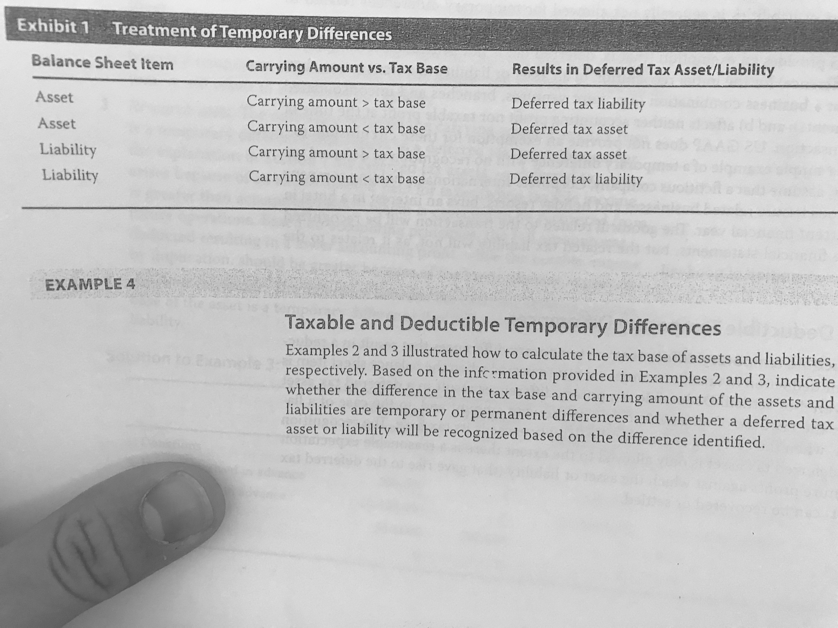

4.4 Temporary Differences at Initial Recognition of Assets and Liabilities: These differences may not be recognized as deferred tax assets or liabilities.

4.5 Business Combinations and Deferred Taxes: A temporary difference that results from business combination will affect deferred taxes.

4.6 Investments in Subsidiaries, Branches, Associates and Interests in Joint Ventures: Deferred tax liabilities will be recognized unless both of the following criterion are satisfied:

* The parent is in a position to control the timing of the future reversal of the temporary difference.
* It is probable that the difference will not be reverse in the future.

Deferred taxes will only be recognized if:

* The temporary difference will reverse in the future.
* Sufficient taxable profits exist against which the temporary difference can be used.

## 5. Unused Tax Losses and Tax Credits

Under IFRS, they can only be recognized if there is there is certainty of recovering or settling the item. US GAAP allows recognition but dictates to create a valuation allowance if it is more likely that the item will not be realized. For assessing the profitability of taxable profit, the following criteria can be used as guidance:

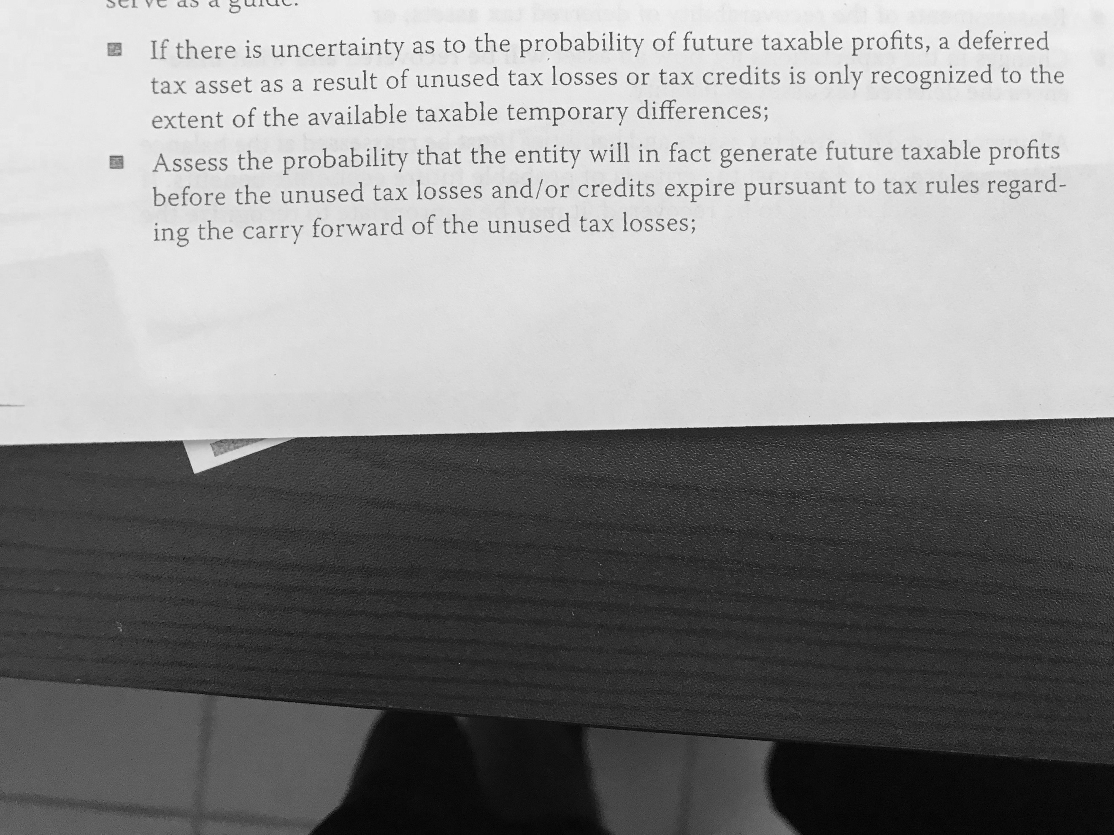

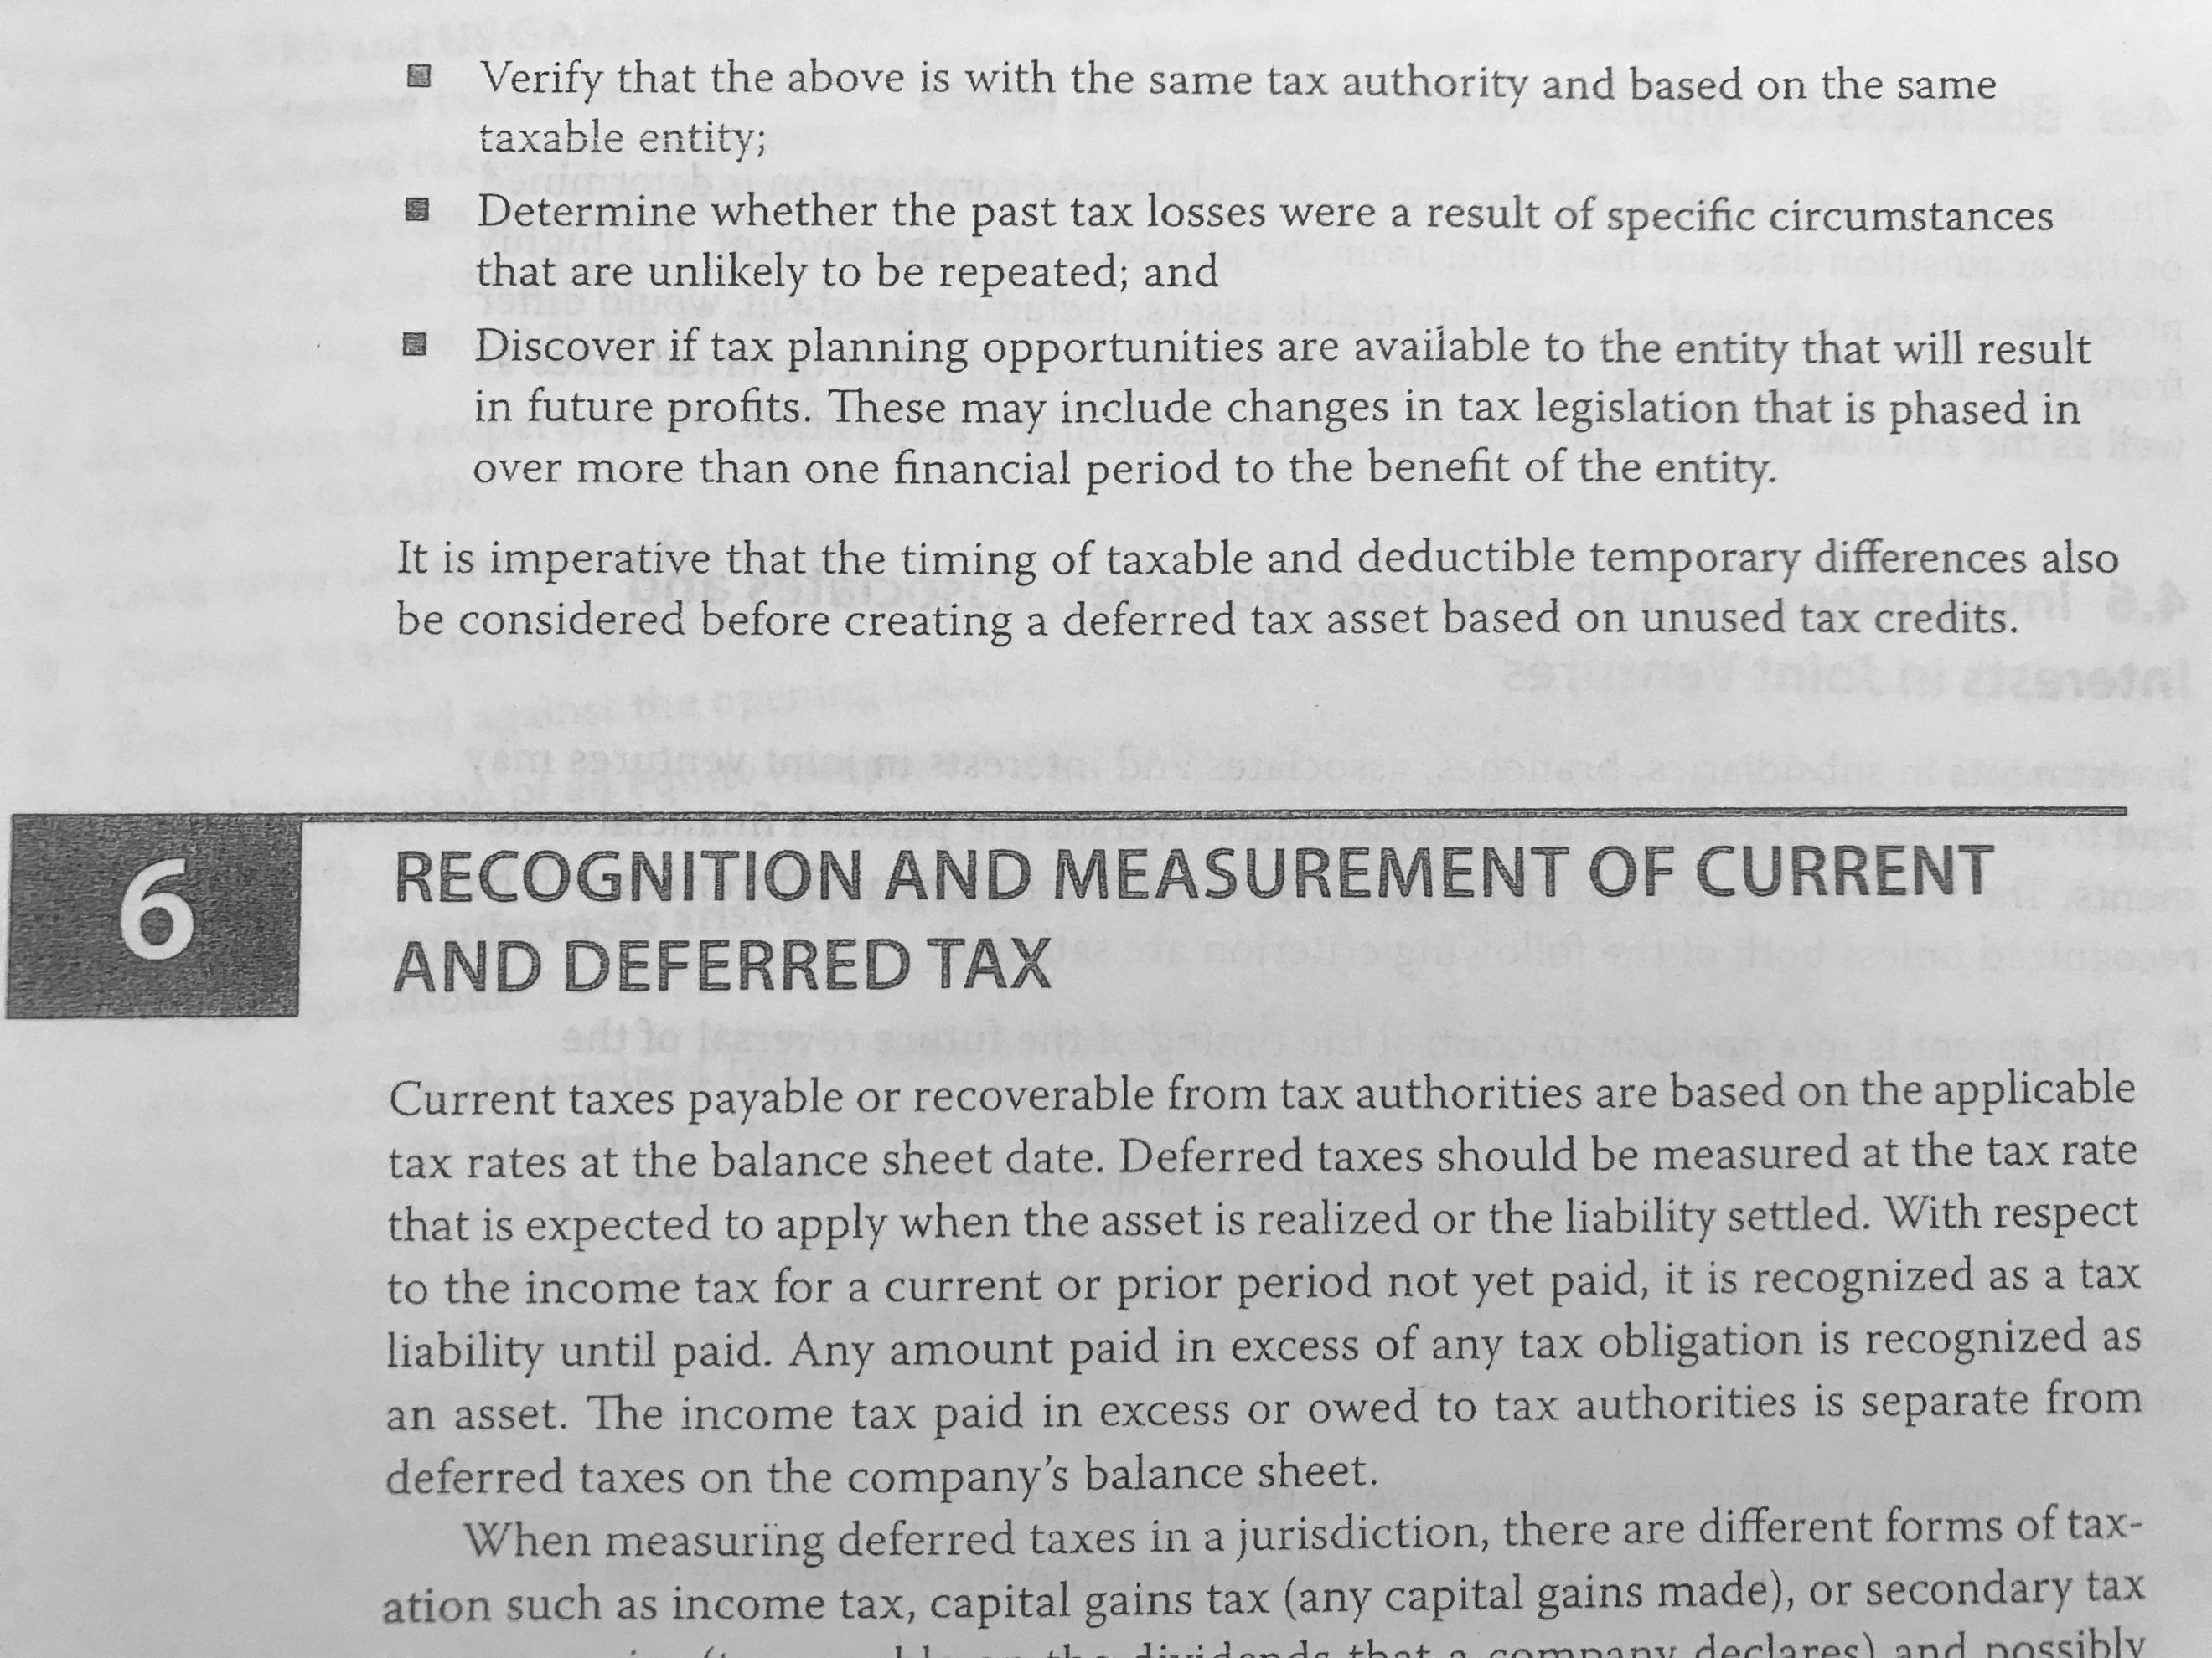

## 6. Recognition and Measurement of Current and Deferred Tax

Current taxes payable or recoverable are based on the applicable tax rate at the balance sheet date while deferred taxes are based on the expected tax rate when the asset will be settled or realized.

6.1 Recognition of a Valuation Allowance:

6.2 Recognition of Current and Deferred Tax Charged Directly to Equity:

## 7. Presentation and Disclosure

## 8. Comparison of IFRS and US GAAP

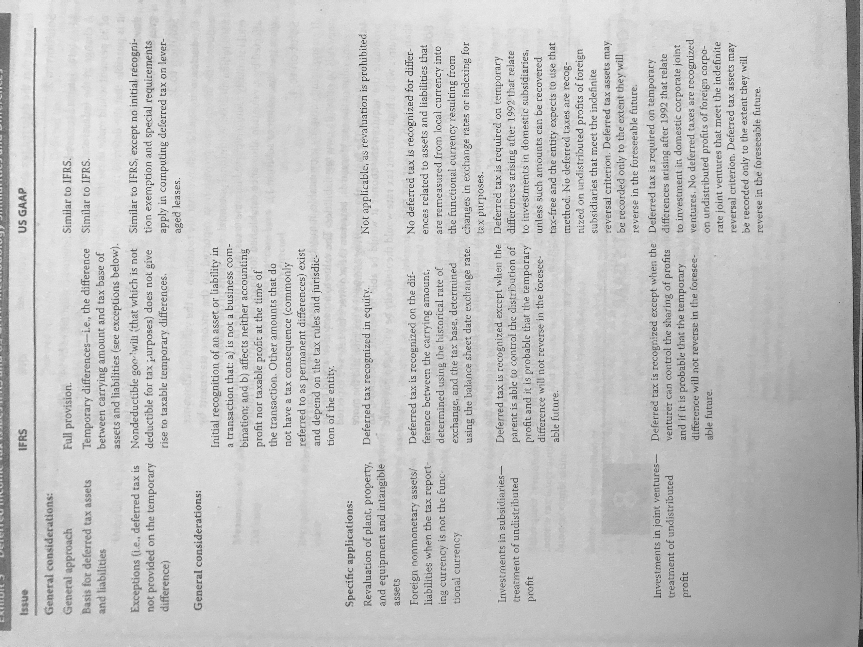

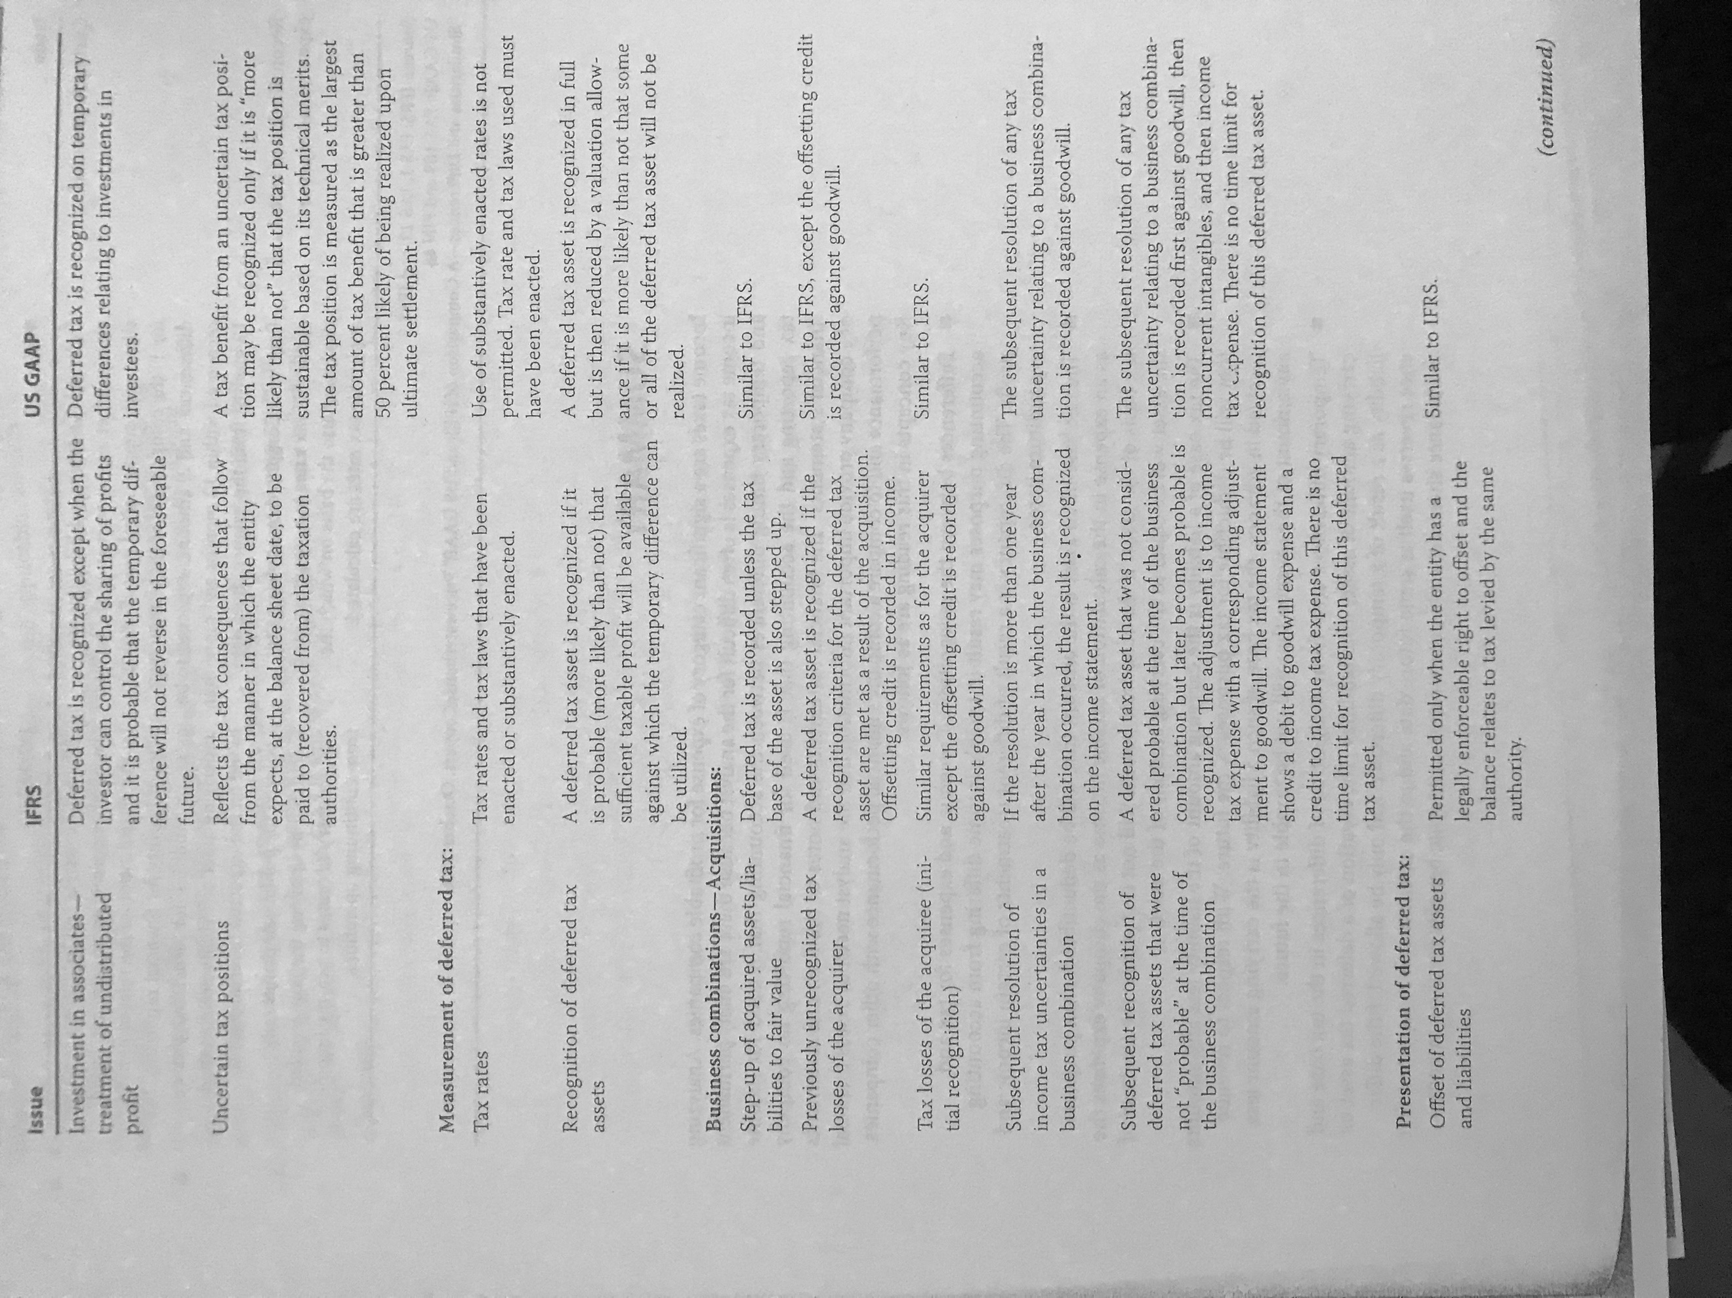

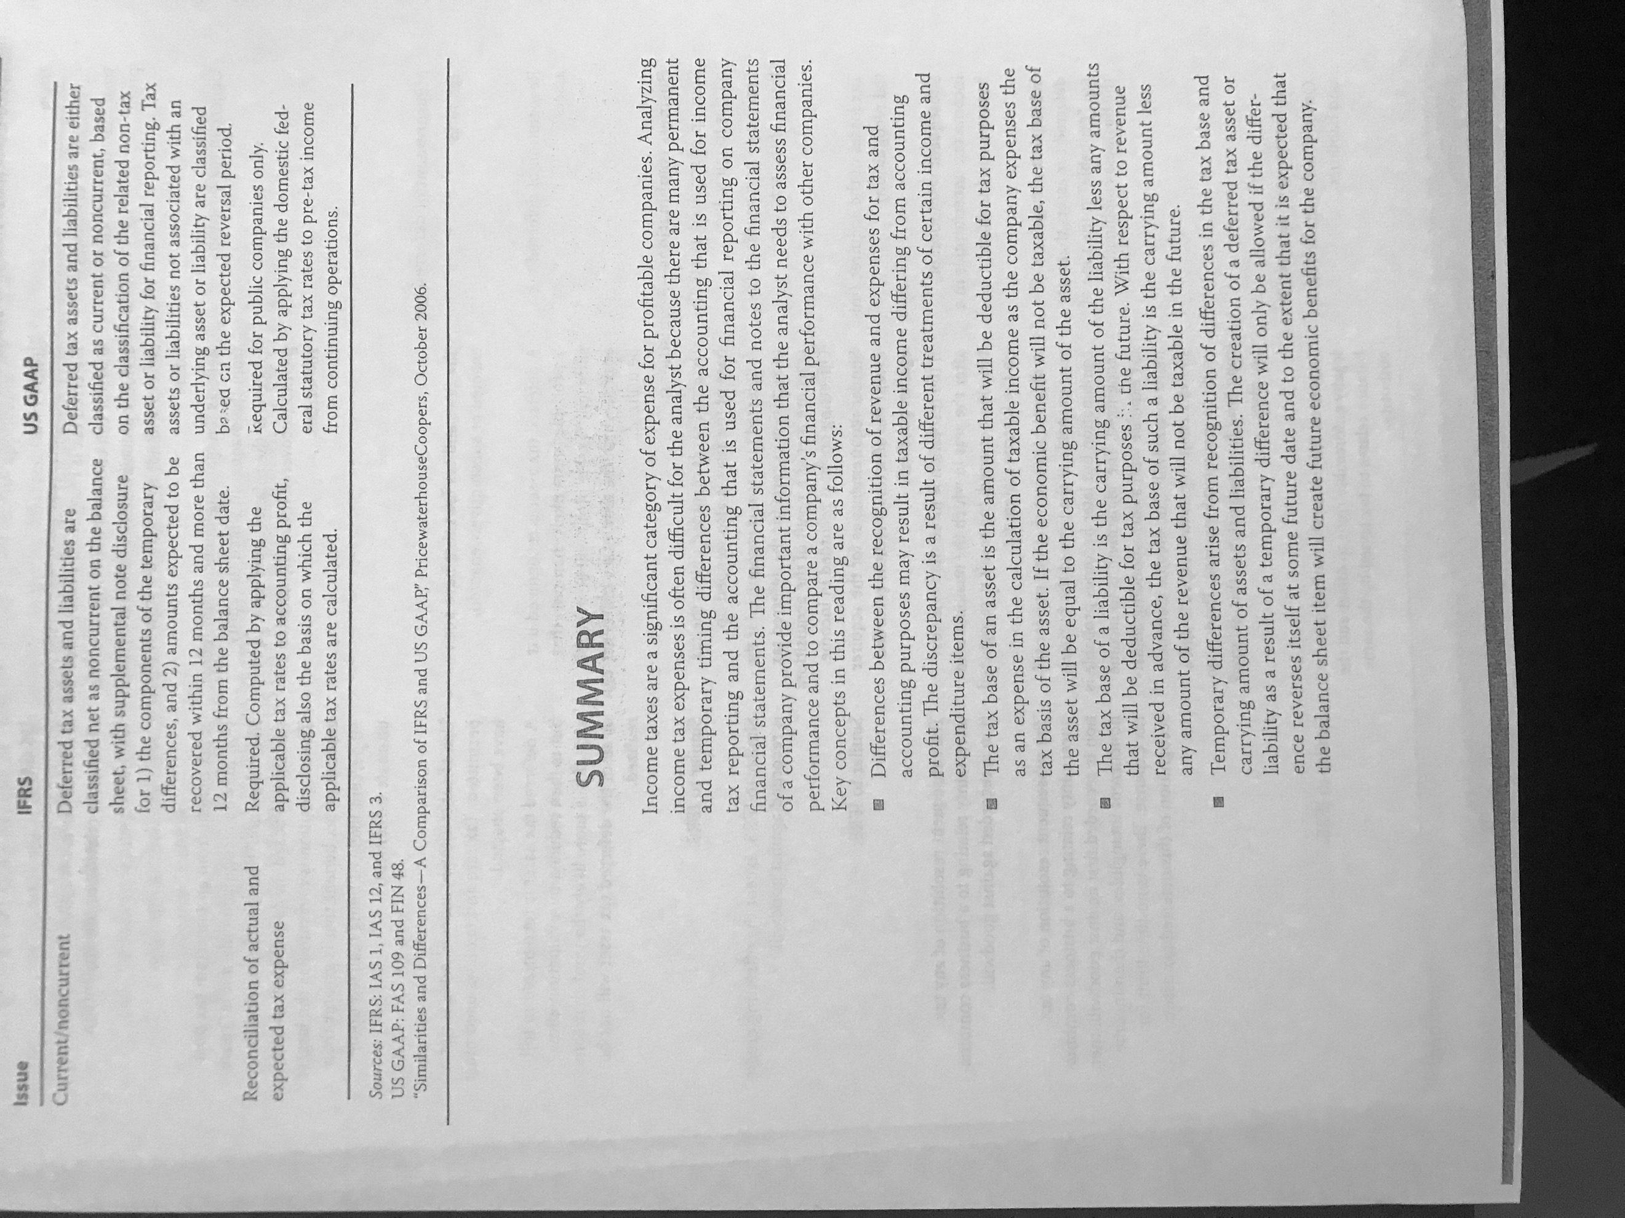

# Reading 31: Non-Current (Long Term) Liabilities

## 2. Bonds Payable

The term bond is used for a 10 year or longer maturity, from 2 to 10 years is note and lower terms are bills.

2.1 Accounting for Bond Issuance: Indenture is the document where the specifications of the instrument are detailed. Face value is also known as principal, par value, stated value or maturity value. The yield is also known as the market rate of interest. The effective interest rate will be the market rate at the time that the bonds are issued.

If: coupon rate > market rate, then the market value will be higher than the face value (the coupon is more interesting than the market rates).

Under IFRS, issuance costs are included in the measurement of the liability and are considered as a financing activity.

Under US GAAP, issuance costs are included as a deferred charge in the assets which is amortized on a straight-line method and they are considered as a financing activity

2.2 Accounting for Bond Amortization, Interest Expense and Interest Payments: Companies can report the bonds either at the historical cost net of amortization or at its fair value.

If the bond is issued at a premium to face value, the carrying amount will initially be higher than the face value as the premium is amortized (then it will decrease to its face value at maturity). The reported interest expense will then be lower than the coupon payment. For bonds at a discount of the face value, the dynamin is the other way around (the amortization will increase the carrying amount, kind of like negative amortization).

The methods for amortizing the premium or discount are the **effective interest rate method** (require by IFRS and preferred by US GAAP) and **the straight-line method** (accepted by US GAAP). For the effective interest rate method, the following steps are followed:

1. Take the market rate when the bonds were issued.
2. Applied it to the actual carrying amount (**this will be the interest expense for the period**).
3. The difference between the expense and the actual payment (face value times the coupon rate) will be the amortization of the discount or premium.

The straight-line method works the same as in depreciation.

Interest payments under IFRS can be operating or financing activities. In US GAAP, they are considered operating.

2.3 Current Market Rates and Fair Value Reporting Option: Financial liabilities can be reported at fair value only if they can be reliably measured.

2.4 Derecognition of Debt: When paying the bonds at maturity, the carrying amount (face value at maturity) is simply reduced by the face value and cash is reduced by the same amount. If bonds a redeemed before maturity, the difference between the carrying amount and the cash required to settle the debt is recognized as profit or loss due to extinguishment of debt (CUAL ES ESA CASH?). Under US GAAP, any unamortized debt issuance costs must be included in the gain or loss due to extinguishment.

2.5 Debt Covenants: Covenants protect the creditors by restricting the activities of the borrower. Affirmative covenants imply restrictions by requiring certain actions (like maintaining a certain ratio). Negative covenants require that the borrower not take certain actions (like not paying dividends). If the covenants are violated, the lenders might call their bonds and require certain premium in form of a penalty.

2.6 Presentation and Disclosure of Long-Term Debt: In the balance sheet, there is a line for long-term debt and note generally include effective interest rates, maturity rates, covenants and collateral pledged.

Convertible debt gives the holder to exchange the debt for equity. Bonds issued with warrants give the folder the right to purchase shares at a specific price.

## 3. Leases

Payments in Leases are done at the beginning of the period. So, since the first year, value of the liability (asset) is recorded at a lower value for the lessee (lessor).

3.1 Advantages of Leasing: The lease enables the lessee to use an asset for a certain period of time, paying a lease payment to the lessor in exchange.

The advantages for the lessee are:

* Lower financing costs.
* Little or no down payment at all.

The advantages for the lessor are:

* Tax benefits of ownership (depreciation and interests).
* A better position to value the risks associated with ownership (obsolescence, residual value and disposition of asset).
* Economies of scale.

As a result of these benefits, the lessor then offers cheaper rates that under a usual financial scheme for purchasing an asset.

A synthetic lease is the one that provides the company with tax benefits of ownership that do not appear as an asset in the financial statements.

3.2 Finance (or Capital) Leases versus Operating Leases:

* Financial leases: Is equivalent to purchasing an asset by the lessee. Under IFRS, if all the risks and rewards incidental to ownership are transferred, then it is a financial lease and the it is reported as a lease asset and lease liability in the balance sheet by the lessee. The lessor reports a lease receivable on its balance sheet and remove the leased asset.

Whenever the leased asset is transferable or if it is specialized (and only the lessee can use it), it is a financial lease. If the major part of the economic life is covered under the lease (even though there is no transfer) it is still a financial lease.

Under US GAAP, the lease must fulfil one of the following to be a capital lease:

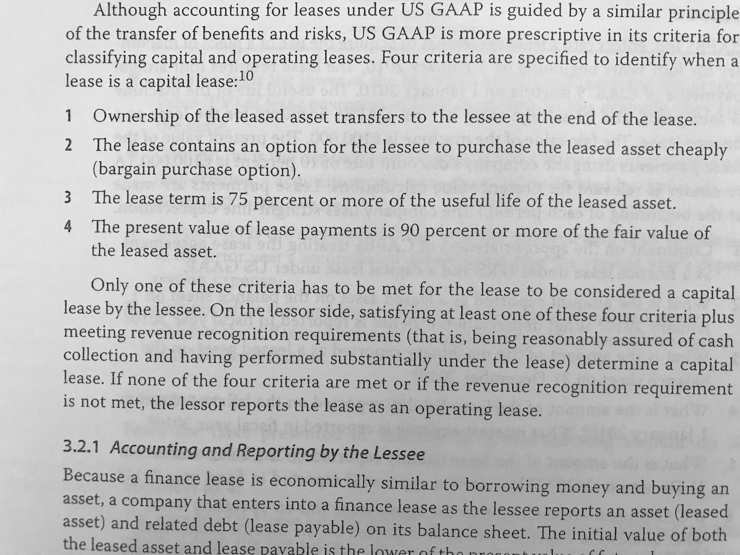

* Operating leases: Is, essentially, a rental. No asset nor liability is reported, only the lease expense.

3.2.1 Accounting and Reporting by the Lessee:

* Financial leases: An asset is reported (leased asset) and a related debt (lease payable) on the balance sheet. The initial value reported in both cases is the lower of the present value of future lease payments and the fair value of the leased asset (in many case, these are equal). In the income statement, interest expense is reported using the debt as a base and a depreciation expense if applicable. Only the portion related to interest payments is an operating activity. The portion of the lease payment that reduces the liability appears as financing activity (which is the part of the payment attributable to the payment of the principal in a normal debt).
* Operating leases: The lessee records a lease expense on the income statement during the period the asset is used, without recording any asset or liability in the income statement. This one is preferred by the companies as they show better profitability ratios. The whole periodical payment is reported as a disbursement and as an operating activity. CUAL ES LA BASE PARA CALCULAR EL EXPENSE? Según mi papá, es el valor del activo.

3.2.2 Accounting and Reporting by the Lessor: For distinguishing whether it is a financial or operative leasing, the criteria are the same that the ones used for the lessee. Under US GAAP, the only difference is that the revenue recognition criteria is added (The certainty of recollecting the payments).

Under IFRS and US GAAP, the lessor records the revenue of the lease when earned and continues to have the asset in its balance sheet as well as registering the appropriate depreciation expense.

Under IFRS, in a financial lease the lessor reports the receivable amount as the present value of the minimum lease payments receivable and any estimated unguaranteed residual value accruing to the lessor. The asset is derecognized by reducing the carrying amount of the leased asset. Initial direct cost incurred by the lessor are added to the receivable and reduced to the income recognized over the lease term. The lease payment works as a repayment of principal (reducing the receivable) and a finance income.

For the case of manufacturing or dealers that are the lessors, the initial costs are treated as expenses when the selling profit is recognized (typically at the beginning of the lease term). The sales revenue equals the lower of the fair value of the asset or the present value of the minimum lease payments. The cost of sale is the carrying amount of the leased asset minus the present value of the estimated unguaranteed residual value.

Under US GAAP, the financial lease is divided into direct financing leases and sales-type leases. On the first case, the present value of the lease payment (and thus the amount recorded as a lease receivable) equals to the carrying value of the asset. Since there is no profit by “selling” the asset, the nature of the revenue is financial. If the present value of the lease payments exceeds the carrying amount, then it would be a sales-type lease. Accounting in the balance sheet will be quite similar. In the income statement, however, the differences will be found: the direct financing lease will only show interest income while the sales-type will show a profit from selling the asset and an interest income from the fact that it is being financed. COMO SE TRATAN ESTOS CASOS UNDER IFRS

To sum up:

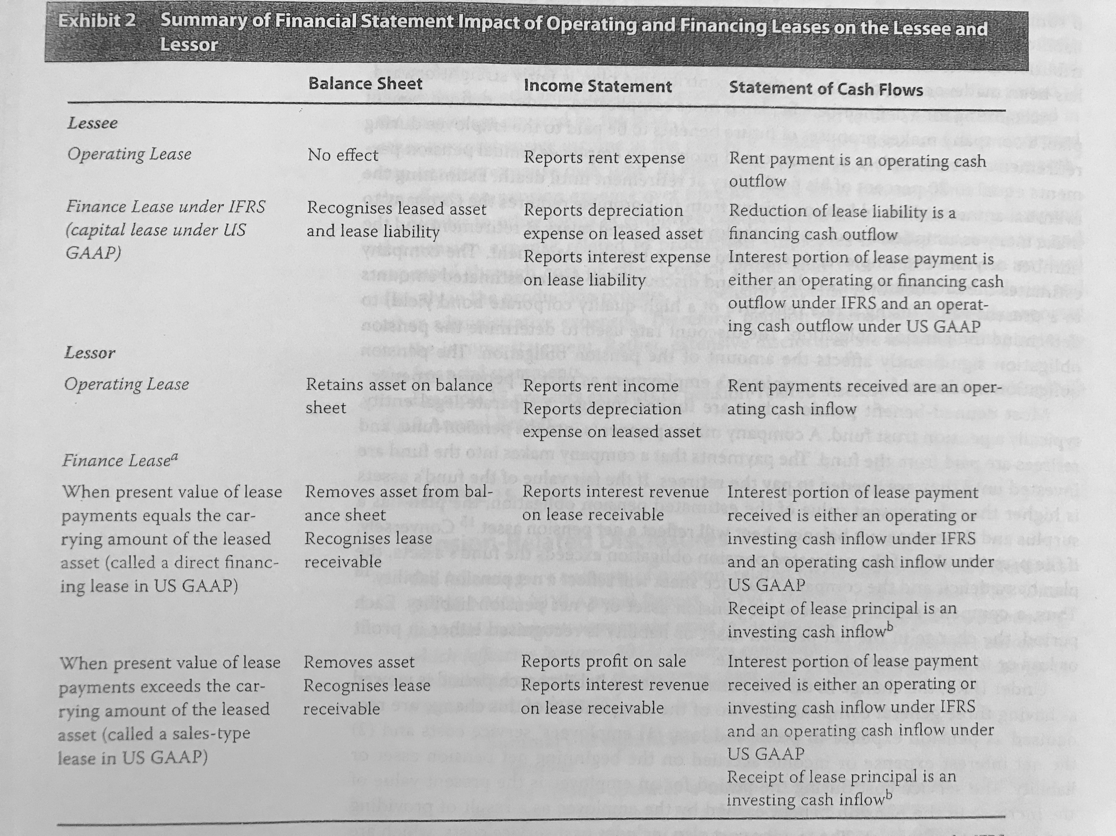

## 4. Introduction to Pensions and Other Post-Employment Benefits

These are referred to the benefits offered to employees following retirement. Common types of pension plans offered:

* Defined-contribution plans: The company contributes a defined amount into de plan, it is the pension expense and considered as an operating cash outflow. Whenever a portion of the agreed-upon amount has not been paid yet, a liability will be recognized.
* Defined-benefit plan: Through this plan, the company commits to pay a benefit during retirement that can be, for instance, a percentage of his salary before retirement. Complication arise when estimating this obligation due to the fact that the expected salary and the expected year of life that remains to the retired employee need to be projected. To determine the liability, the payments are estimated and brought to present value using a high-quality corporate bond effective rate.

This kind of plan are typically administrated by a pension trust fund. The company pays to the fund and the fund to the employees. The trust fund invests the money and any surplus (a positive difference between the fair value of the fund and the present value of the obligations) will be an asset for the company. In the case that it happens the opposite, a liability will be recognized.

Under IFRS, net pension asset or liability changes are recorded as pension expense in profit and loss for employees’ service costs (the present value of the increase in the pension benefit earned by the employee in the period) and net interest expense or income accrued on the beginning net pension asset or liability (net pension asset or liability times the discount rate used to determine the present value of the obligation). Remeasurements are recognized as other comprehensive income and are actuarial gains and losses (due to any changes in the assumptions to estimate the obligation) and the actual return on plan assets less any return included in the net interest expense or income. They are not amortized into profit or loss over time

Under US GAAP, employee’s service costs for the period, interest expense accrued on the beginning pension obligation and expected return on plan assets, which reduces the amount of expense recognized, are recognized in the income statement. Past service costs (which are recognized in the period they arise and amortized into pension expense over the future service period) and actuarial gains and losses (recognized when they occur and the amortized through time) are recognized as other comprehensive income.

The pension expenses for production employees are added in the inventory and expensed through the COGS. For other employees, the expense is included in salaries and other administrative expenses.

## 5. Evaluating Solvency: Leverage and Coverage Ratios

Solvency relates to the ability to meet long term obligations. Types of solvency ratios:

* Leverage ratios: Focus on the balance sheet and measure to what extent is leverage used over the equity.
* Coverage ratios: Focus on the income statement and cash flows and measure the ability to cover the debt-related payments.

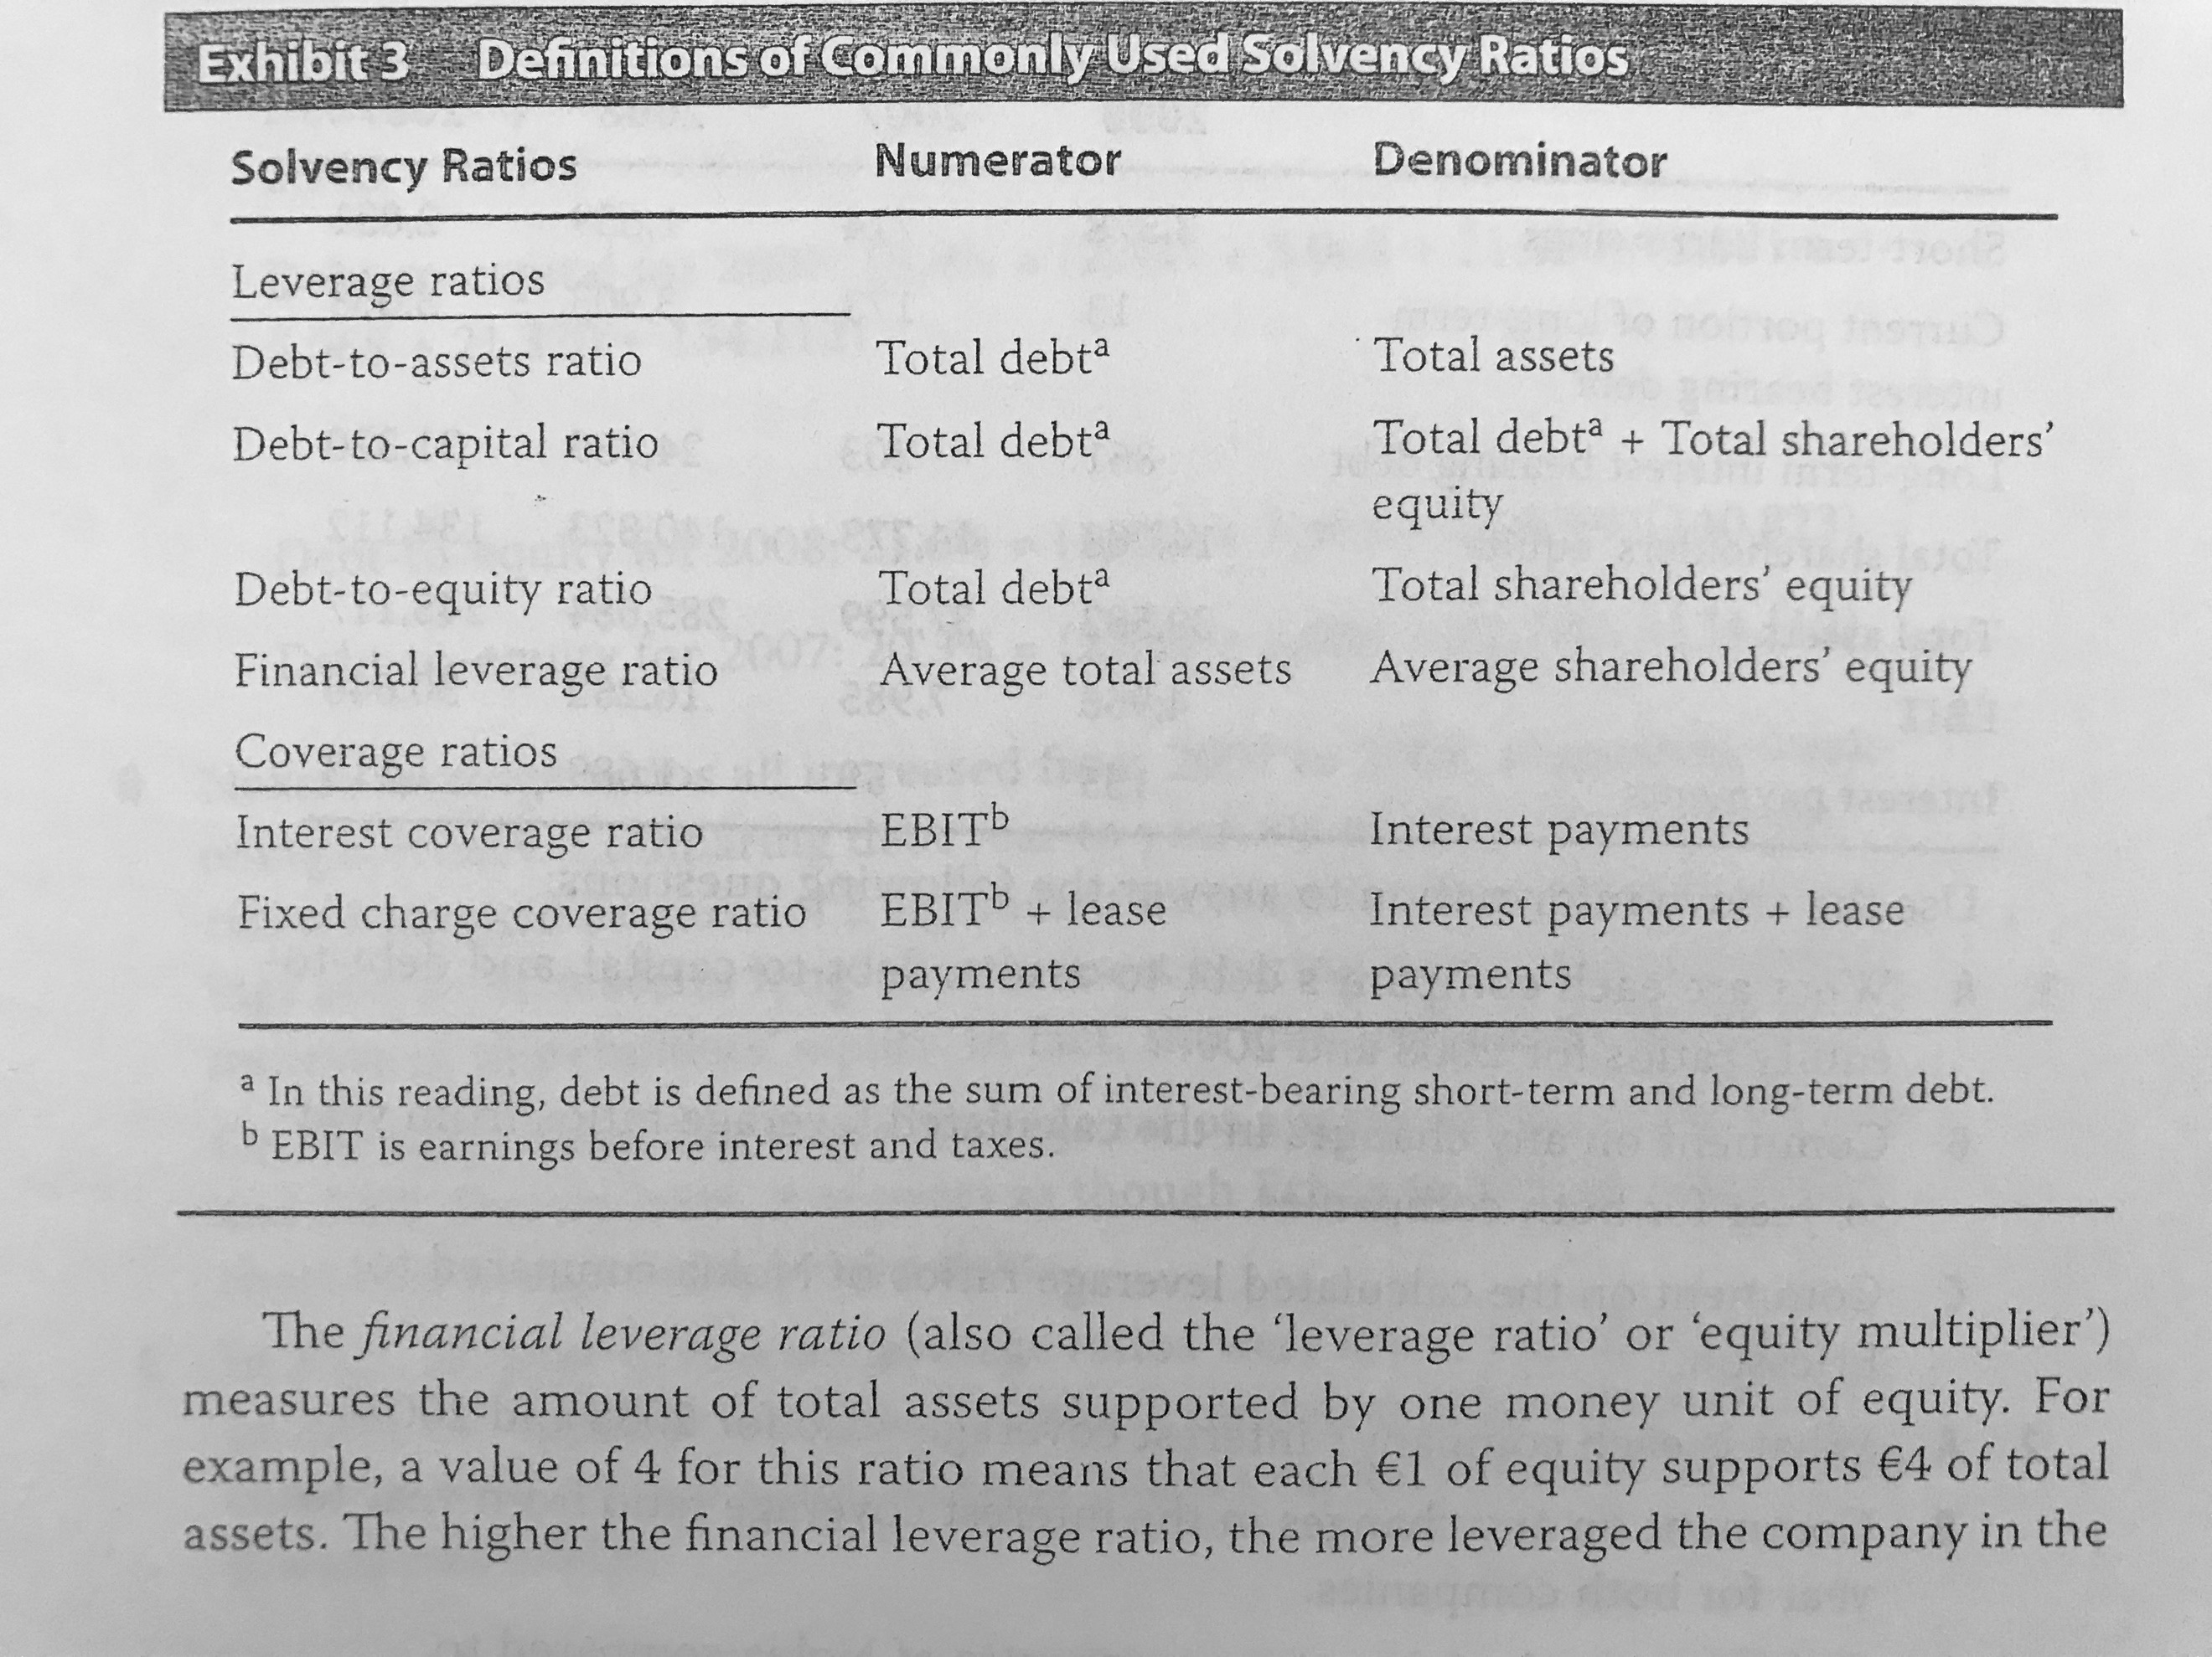

*Note that Capital refers to equity and interest-bearing debt and that must ratios are calculated only using interest-bearing debt.

The equity multiplier can be interpreted by saying that each 1 dollar of equity supports X (the value of the ratio) dollars of the total assets.

# Reading 32: Financial Reporting Quality

## Distinguish between financial reporting quality and quality of reported results (including quality of earnings, cash flow and balance sheet items)

Financial reporting quality: characteristics of the financial statements, adherence to GAAP, decision usefulness of the reports which includes relevance (is useful for users, must be material) and faithful (considerate completeness, neutrality and absence of errors) representation.

Quality of earnings: evaluated based on sustainability, referring to the proportion of earnings that can be expected to continue (changes due to exchange rates are not expected to continue while the ones due to efficiencies are), and their level (high enough to sustain operations and existence and to provide adequate return to investors).

Quality of cash flows and of balance sheet items also face issues of sustainability and level.

## Describe a spectrum for assessing financial reporting quality

A low reporting quality makes it impossible to assess the quality of the reported items.

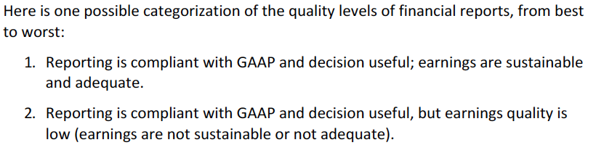

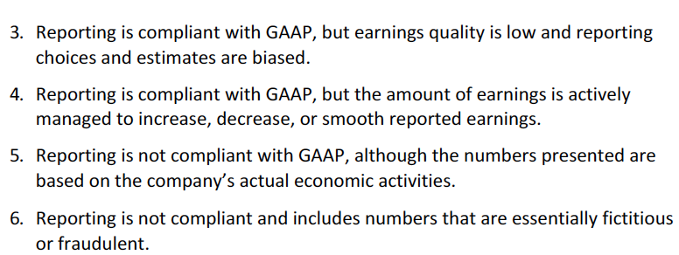

## Distinguish between conservative and aggressive accounting

Conservative: when the choices made within GAAP with respect to earnings tend to decrease the company’s reported earnings and financial position. Tend to increase future earnings.

Aggressive: choices that increase reported earnings or improve financial position. Often results in decreased earnings in the future.

These types of bias are used to reduce the volatility of earnings, in order to avoid the value of the company to be affected. This is called earnings smoothing and usually looks to adjust accrued liabilities based on estimates.

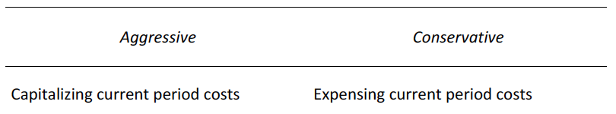

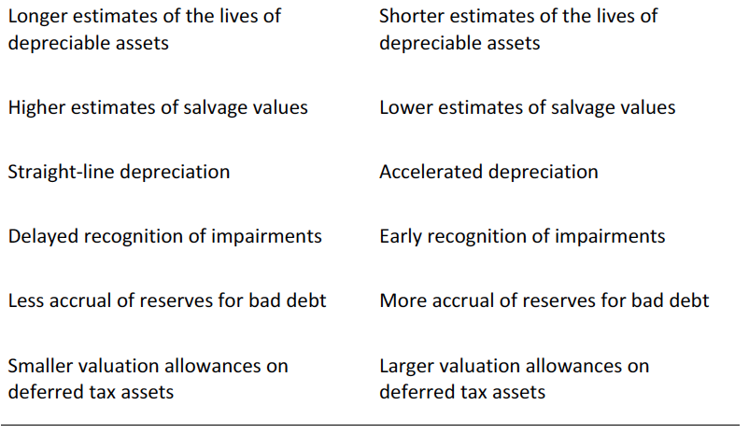

Companies may choose to disclose the information in way that the attention will be faced over positive results (providing minimal disclosure)

The best method is to be neutral. However, these biases are sometimes useful also to avoid litigations from users that may claim that they were misled.

## Describe motivations that might cause management to issue financial reports that are not high quality

* To improve their career and reputation.
* Incentives offered by the company.
* Gain credibility.
* Avoid debt covenants violation.
* Assure that future performance will be positive (conservative bias).

## Describe conditions that are conductive to issuing low-quality , or even fraudulent, financial reports

Three factors that are typically found when management provides low-quality reports are motivation, opportunity and a rationalization of the behavior (they justify breaking the rules with a story that is “worth it”).

## Describe mechanisms that discipline financial reporting quality and the potential limitations of those mechanisms

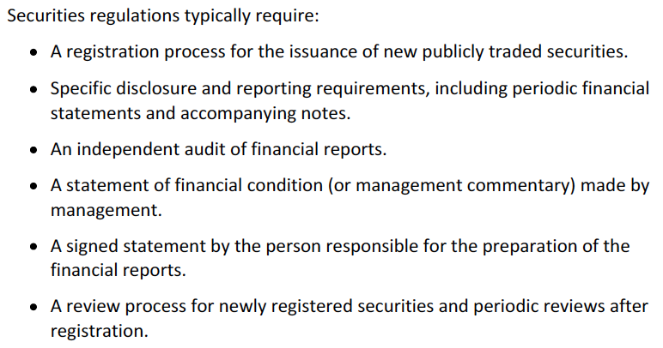

Enforcement actions include fines, suspension of participation in issuance and trading securities and public results of disciplinary proceedings. Also, criminal prosecution.

Audit and management opinion or assessment must be included, which helps to take a look at the quality of the reports.

Unqualified opinion means that the reports have been fairly reported with respect to the applicable GAAP (not a guarantee that there is no fraud).

In credit agreements, sometimes the way calculations need to be computed provide a way to make sure that the firm’s performance and position can be seen.

## Describe presentation choices, including non-GAAP measures, that could be used to influence an analyst’s opinion

Sometimes, non-GAAP measures are used to enhance the performance or position, using as justification that it is a one-timer, a non-operating cost, non-cash charge…

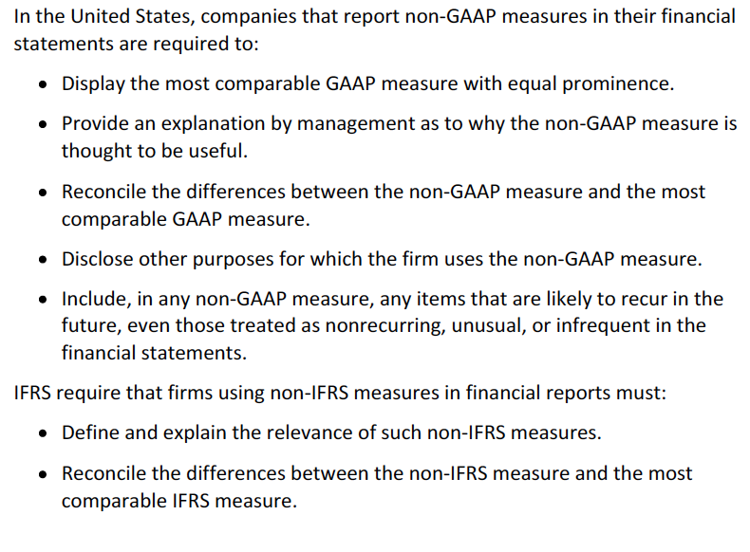

Overall, the use of non-GAAP measures imply an attempt to control metrics.

## Describe accounting methods (choices and estimates) that could be used to manage earnings, cash flow and balance sheet items

**Revenue recognition**

* The choice of whether in the shipping prices the customer actually takes the title of the good (this is known as free-on-board (FOB) at the shipping point. The alternative is FOB at the destination.
* Acceleration or delay of shipments.
* Discounts offered (offering more discounts in a period may increase the revenue).
* Channel stuffing -> overload a distribution channel with more goods than would normally be sold.
* Fictitious bill-and-hold transactions (where the goods are billed but kept within the firms facilities) may increase the current period’s revenue.

**Estimates of credit losses**

* Different estimating methods will result in a different net receivables balance. A reduction in the estimated credit losses may increase the net receivables, reduce expenses and increase net income. (why are expenses affected).
* The bad-debt reserve is sometimes adjusted to smoothen earning.
* Reserve for warranty expense can also be changed to manage reported earnings.

**Valuation allowance**

* Can be used to manage earnings.
* The effect is similar to the allowances for bad debt.
* Recall that valuation allowance reduces the carrying value of a deferred asset based on the probability that it will not be realized.

**Depreciation methods and estimates**

* Accelerated depreciation will increase expenses in the early years of an asset’s life. In the later years, it goes the other way around.
* Estimates of the useful life (if it is longer, periodic depreciation expenses are lower) and the salvage value (if it is higher, it slow depreciation) also affects. If the salvage value is higher than the actual price at which it is sold, a loss on the sale of the asset is recorded.

**Amortization and impairment**

* Amortization choices and estimates have similar consequences as with depreciation.
* Impairment decisions (recognizing or not) may also affect earnings.

**Inventory method**

* For rising prices, FIFO will report less COGS than weighted-average costing method and the inventory balance will be greater under FIFO.
* FIFO results in a more accurate balance sheet inventory values since the value is closer to the current replacement cost.
* Weighted-average reflects a more accurate COGS as they are closer to the current replacement cost, because it smoothens the effects of price variations (contrary to FIFO).

**Related-party transactions**

* This transactions can be used to distort the reported earnings of the involved firms.

**Capitalization**

* Capitalizing expenses allows the company to create an asset and impact the net income throughout the time through its amortization.
* This also affects cash flow, since the investing cash flow is the one that would be affected rather than the operating cash flow.

**Other cash flow effects**

* Stretching payables -> taking longer to pay to suppliers on purpose in order to increase cash flow.
* Capitalizing interest expense will decrease cash flow from investing and increase cash flow from operations. It will also affect the net income.
* In IFRS, the ability to classify interest and dividend paid as CFO or CFF and interest and dividend received as CFO or CFI.

## Describe accounting warning sign and methods for detecting manipulation of information in financial reports

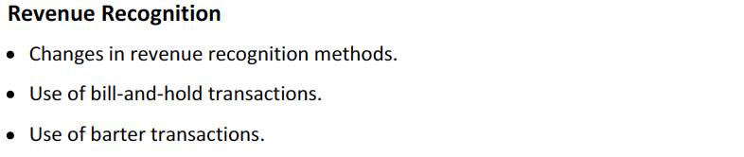

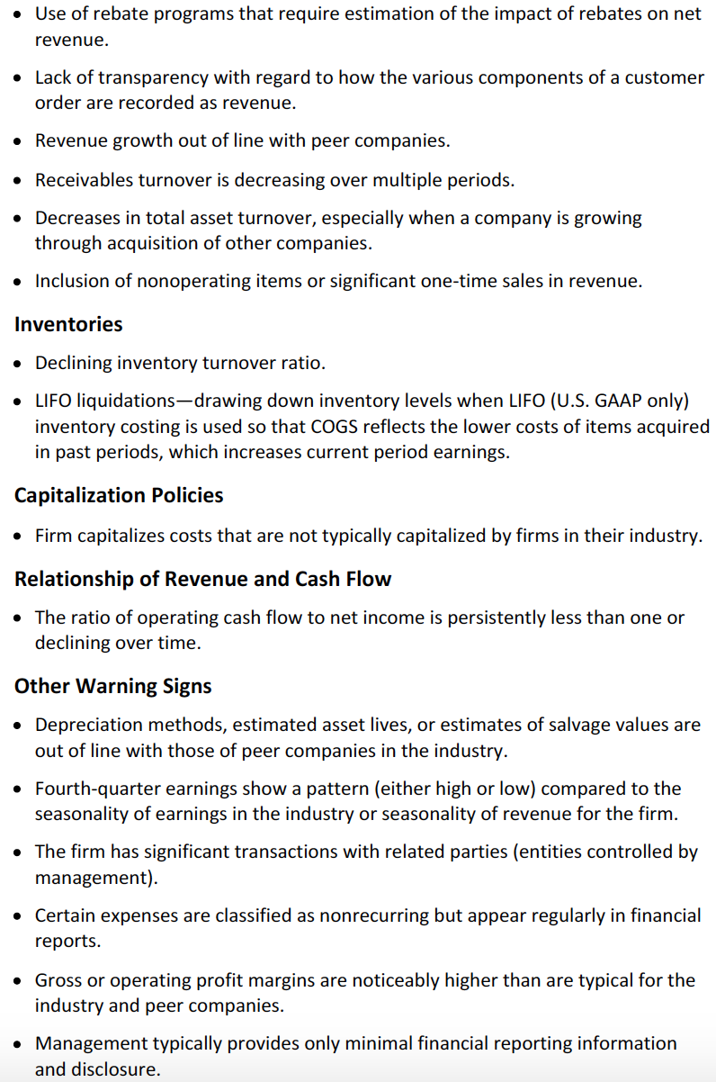

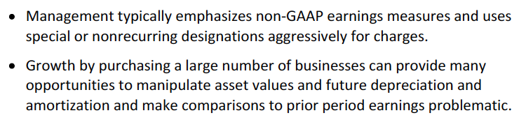

Impairment can be sometimes considered as good news as they may anticipate better financial performance. Analysts should take the impairment expense and diluted through the prior years, as it should be seen as some sort of corrections to previous earnings.

# Reading 33: Financial Statement Analysis Applications

## 2. Application: Evaluating Past Financial Performance

Past financial information can be useful both to do trend and cross-sectional analysis. Differences in reporting policies should be taken into account to make companies comparable through time.

## 3. Application: Projecting Future Financial Performance

3.1 Projecting Performance: An Input to Market-Based Valuation: Near performance is projected to obtain the inputs for relative valuation. In order to make sales projections, usually the analysts study the relationships that exists with other variables and use regressions to make the predictions. Sometimes, the sales of an industry are the ones that are projected and then, the projections are multiplied by the market share of the company. The rest of the income statement can be projected by estimating the margins or going item by item.

When projecting, events that are not likely to happen again should be taken out.

3.2 Projecting Multiple-Period Performance: It can be done when needed and also based in other forecasts. Items can be grouped for projections or estimated separately.

Scenario analysis or Monte Carlo (by assigning probability distributions to the variables) simulation is used to asses the risk of the forecast.

## 4. Application: Assessing Credit Risk

Review the ability of a company to pay to its creditors. The factors that are related with creditworthiness are:

1. Scale and diversification: Relates to the sensitivity of the company towards adverse events that may affect its debt-paying ability.
2. Tolerance for leverage: Refer to the capacity of the company to finance its operations using debt and depends of financial policies.
3. Operational efficiency: Relates to the cost structure, where a better cost structure implies a stronger capacity to meet debt-related commitments.
4. Margin stability: Relates to the stability of profit margins. A greater stability, a lower credit risk.

An important multiple widely used is retained cash flows to debt.

## 5. Application: Screening for Possible Equity Investments

Financial ratios are computed to make top-dowm and bttom-up screening that can be helpful for finding comparable companies. Other variables can also be part of this scrrening process.

## Evaluate a company’s past financial performance and explain how a company’s strategy is reflected in past financial performance

Ratio trends can be used. Also compered its levels with comparable companies.

The strategies implemented by the company should be consistent.

## Forecast a company’s future net income and cash flow

It often begins with a forecast of future sales. If it is for a short period, a top-down approach (forecast GDP, then determine its relationship with the industry growth and if the market share is expected to be the same for the company, apply this growth) can be used.

The income statement and balance sheet can be forecasted as simply forecasting certain key lines and account balances or by going into each of the items of the statement and forecasting them.

For cash flow, assumptions about future sources and uses of cash must be made.

## Describe the role of financial statement analysis in assessing the credit quality of a potential debt investment

Three Cs: Character (firm’s reputation and history of debt repayment), collateral and capacity.

Rating agencies usually use different types of ratios that evaluate the following:

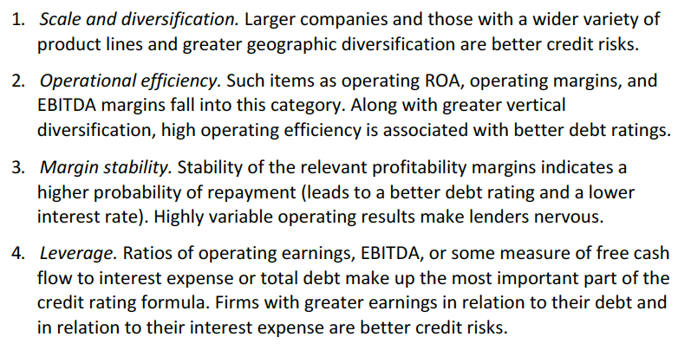

## Describe the use of financial statement analysis in screening for potential equity investments

Backtesting-> evaluating the past performance of a portfolio.

## Explain appropriate analyst adjustments to a company’s financial statements to facilitate comparison with another company

If the companies use different accounting standards of methods within the same standard, the analyst must adjust the statements.

Important differences between US GAAP and IFRS are the treatments of the effect of exchange rate changes, certain securities held by the firm and inventory cost flows.

The most common adjustments that should be made are:

**Investments in securities**

Because depending on the classification of the investment affects how they are recorded, this is an important issue to check (unrealized gains and losses on held-for-trading securities are recorded in the income while those on available for sale or held to maturity are not). Besides, unrealized gains and losses of held for trading and available for sale are reflected in the balance sheet values, held to maturity are not.

Whenever these issues generate an important difference, adjustments should be made using the information disclosed.

**Inventory accounting differences**

Using the LIFO reserve helps to adjust the results (adding it to the inventory balance and subtract the increase of the LIFO reserve to the COGS).

**Differences in depreciation methods and estimates**

Normally, disclosures are not enough to make adjustments. Nevertheless, adjustments can be made using estimations.

Average age of the firm’s assets = accumulated depreciation / depreciation expense. Simlarly, the average useful life and remaining useful life may be computed.

**Off-balance-sheet financing**

Debt ratios should include liabilities for capital and operating leases. To estimate the present value of operating lease liabilities, the ratio of the present value of capital lease obligation to the sum of these future payments may be used. Also, by using estimates and assumptions (check example).

**Goodwill**

Goodwill should be subtracted from assets when calculating ratios and impairment of goodwill in the current period should be reverted from the net income.

**Other intangible assets**

Considering the fact that in IFRS upward revaluation of intangible can be made while in US GAAP no, and adjustment should be made. So intangible assets should be reduced by the cumulative amounts of upward revaluations.

Another option is to use tangible book value ratios.